Alexander Mckie

Contents

High Level Overview 3
Level Goals 3
Design Considerations 3
Key Elements 6
Expected Player Experience 6
Map Overview 7
Consolidated Map Overlay 7
Mechanics Resonance Table 8
Bubblemap (see PACING and LEVEL DESIGN for more info) 9
Pacing 10
Player Pickups 11
Critical path 12
Optional path 13
Challenges 14
Conflict points (Combat) 15
Rewards 16
Aesthetics (Look and Feel) 17
Setting 17
Visual and Audio Affordance 18
Visual Development (Progression Screenshots) 25
4A’s amazing SDK… 62
4A’s redeemable qualities 66
Final Results 68
Balance 78
Considerations 78
Expected Issues 78
User Testing 79
Testing Plan and Considerations 79
Final thoughts and Critical Analysis 79
Sources and References 80

High Level Overview

Level Goals
The main goal of Waste removal is to slowly advance through the level and overcome its challenges to reach the end point, that being the safe room. Other optional goals of the level are to explore the map, engage with side mechanics such as crafting, and loot collectables hidden throughout the map.

Design Considerations
Research
To gather inspiration and affirmation for the level and its design, investigations were done into similarly designed linear levels from industry based single player games. Compared to my previous map, different genres were analyzed to get a better understanding of design conventions between industry-based content and Waste Removal.
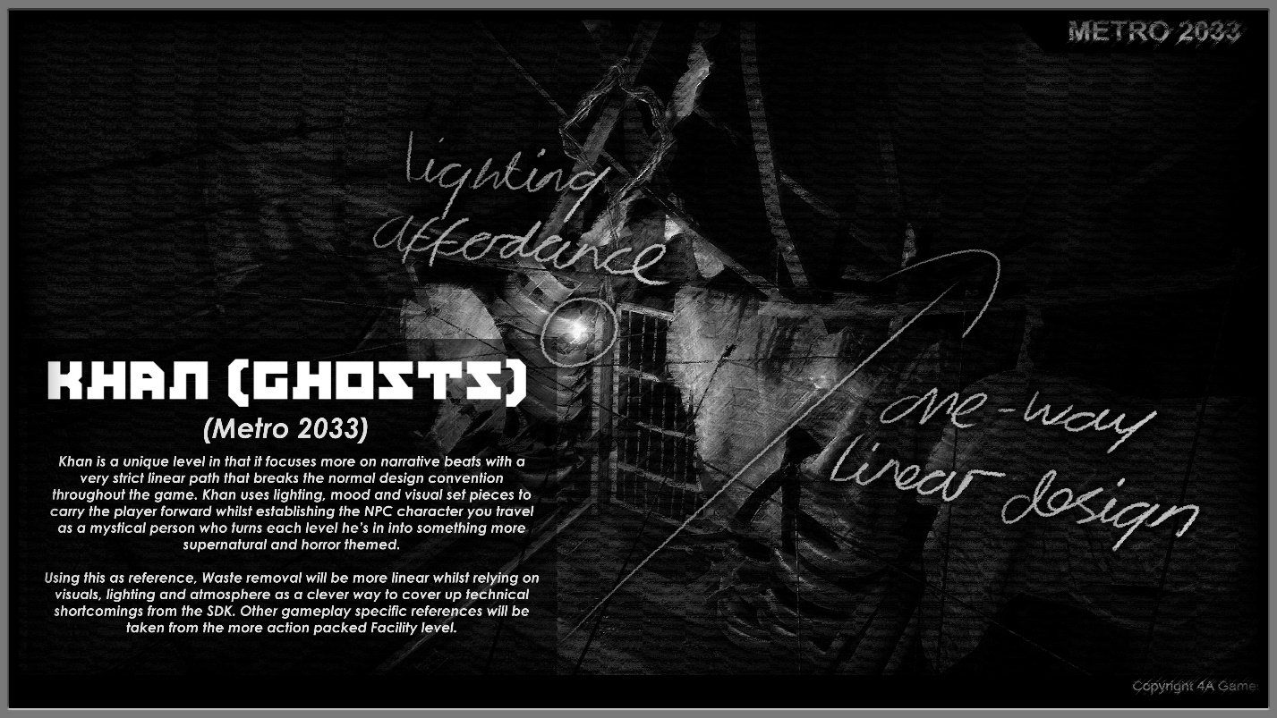
Khan was a big inspiration for the level, as it breaks away from normal action-packed design conventions whilst still maintaining place in the metro. Despite this, the introduction of a new character (Khan) takes primary focus as the level is more supernatural and horror themed compared to previous levels, which then becomes a recurring theme when said character Is present.
- These types of levels are extremely linear, focusing more on narrative beats and visual set pieces rather than engaging the player through the main gameplay loop.
- Lighting and sound are used to create a gloomier atmosphere that makes for a rememberable level.
- Offers a nice break from the gameplay when placed halfway through the game, but standalone can prove to be a bit more boring which then leads to taking reference from Facility and Yamantau.
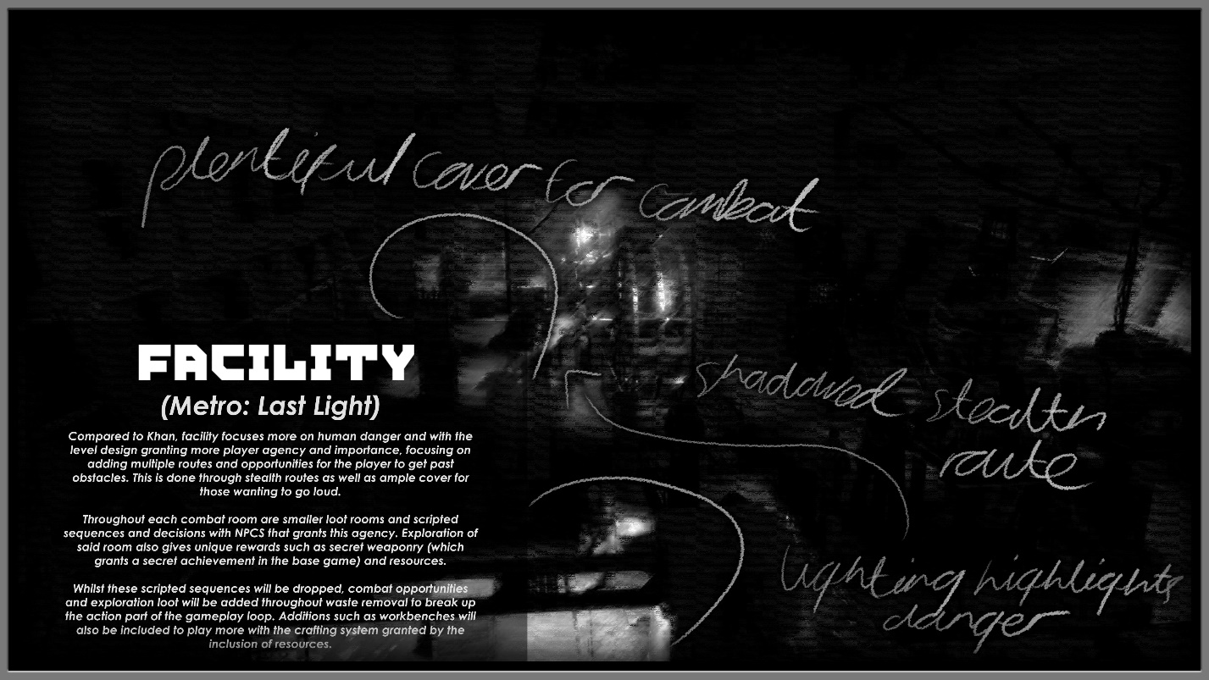
Facility from the 2nd installment juxtaposes Khan, featuring less narrative and more player-based design, with different routes to tackle combat segments from loud to stealth.
Player agency is more of a focus, littering in decisions such as sparing non-combatants that links to the morality system which determines the players ending.
Players are also rewarded with more exploration compared to Khan, with powerful sidearms throughout enemies lockers that linked to system achievements. The redux version also added on this by added a safe per mission that required a secret key hidden throughout the level.
- Enemies are shown in the light to highlight for the player whilst also making sense within the Gameworld.
- Verticality can be used for stealth through use of ladders.
- Variety in scale and environments through room (E.G from mechanical gears to a small greenhouse) which are broken by corridors with player decisions and transitional spaces.
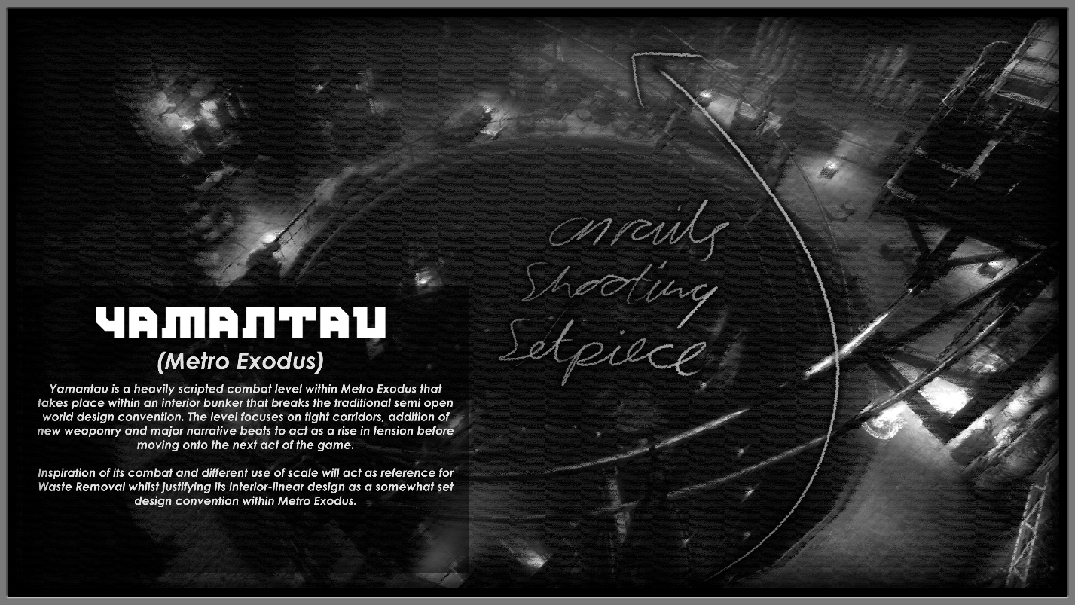
Yamantau from Metro Exodus (SDK’s installment) completely breaks the design rules set up throughout the game. Contrasting the semi open world, explorative elements and side quests, Yamantau does a 180. The level is a on rails shooter that uses the chaos of a narrative twist to feature more action-packed gameplay within an interior linear setting.
- Proper balancing of ammo and enemies are needed for combat segments.
- Consider routes for engaging enemies from different cover placements.
- Will use gameplay elements from Yamantau and facility whilst taking visual and atmospheric notes from Khan.

Key Elements
The key elements of the level are puzzles, such as finding the power switch to activate locked doors, as well as crafting with resources gathered throughout the level in boxes and behind corpses. Other key elements are big combat scenarios that can be tackled in different ways for attentive/experienced players.
One example is being able to shoot out the lights in the first combat encounter IF the player explores side passages, with references to lighting affordance discussed later on. Another situation is in next big encounter, players can crawl into a side vent passage that can be used to ambush NPC’s instead of fighting head on. Both of these optional key elements are discussed in more detail later on.

Expected Player Experience
Players are expected to pick up their equipment at the beginning of the level, but this weapon will repeat if missed to ensure players won’t play without a primary weapon. The player progress through each room, looting from boxes and bodies, whilst following the light affordance that takes around the level and introduces small mechanics such as doors only being locked on one side.
The player then solves puzzles, fighting enemies and progressing further into the bunker. After the halfway point. Players are forced to use gas masks to avoid suffocation by poisonous mushrooms which helps add to the tension.
Players will crawl and jump through these areas to the next big holdout of bandits before arriving at a makeshift safehouse, harboring a mutated inhabitant. Once the player is safely inside the safe house, the level is over.

Map Overview

Consolidated Map Overlay
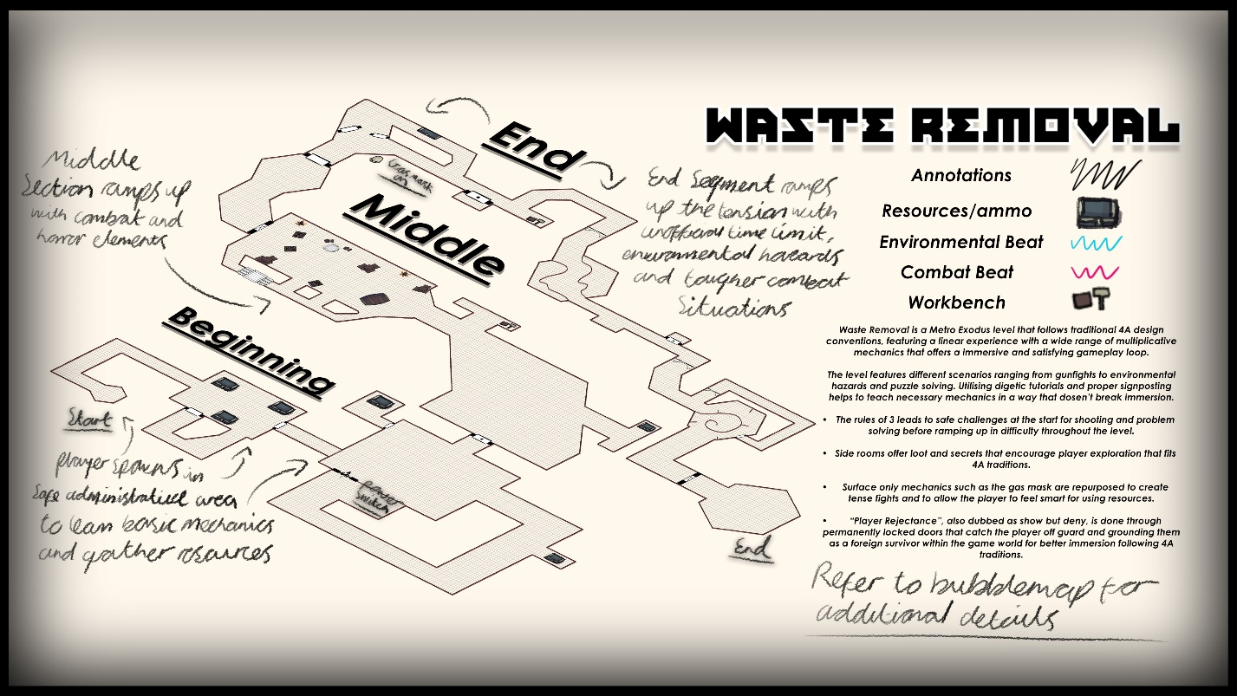
Expanding on the key elements and expected player experience, the map also features a more windy and non-linear directional progression, taking reference from the semi-open world design from the latest installment. Despite this, the main references are from previous installments combined with these new multiplicative mechanics for better overall immersion. Sense of scale is also experimented on again, ranging from small corridors and abandoned tunnels to tall, wide-open rooms that are still operational with proper lighting. Using this scale helps to ground the bunker and avoid boring level layout repetition.
Rules of three have also been used to introduce primary mechanics such as movement, jumping and shooting. Because of the wide range of multiplicative mechanics, these are NOT included in rules of third. My justification for this is that this level is more suited to be midway through the game and does NOT act as a tutorial for all mechanics in the game as this would be impractical.
Following 4A traditions multiple side rooms have been constructed that offers simple resources such as crafting materials or ammo to complement the gameplay loop whilst providing breaks from either shooting or puzzle solving.
The idea of using gas mask comes in the form of adding tension to the level, as the player is now on a strict time limit which is covered more in PACING.
A term coined throughout the level creation is “Player Rejectance” which could also be described as an eviler form of “show, don’t tell”. This is done by introducing permanently locked doors that catch the player off guard and helping to ground them as a foreign survivor within the game world for better immersion. Since most levels resolves around the level accommodating the player, a decision was made to experiment going against this to take power away from the player, making them feel/act as a vulnerable survivor.

Mechanics Resonance Table
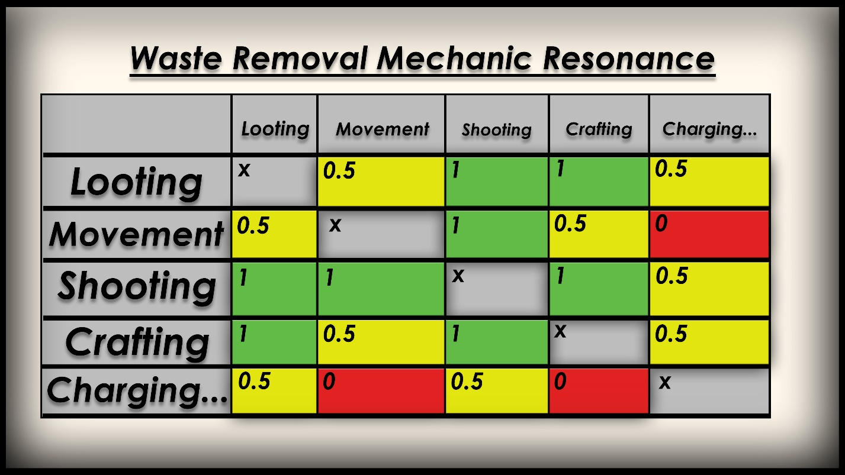
Using a mechanic resonance table, we can see that in contrast to my previous Fortnite level, Metro Exodus relies far more on having mechanics communicate with one another to formulate a fun loop for the player, such as crafting playing into resources for shooting and looting accompanying crafting resources and new items for combat.
Some mechanics however go with my earlier idea of “player rejectance”, such as charging that makes the player have to stop and recharge their electrical devices which makes them defenseless. However, this is also used to power open doors. Waste removal aims to make use of all these mechanics to tie it closer to 4A designs and standards.

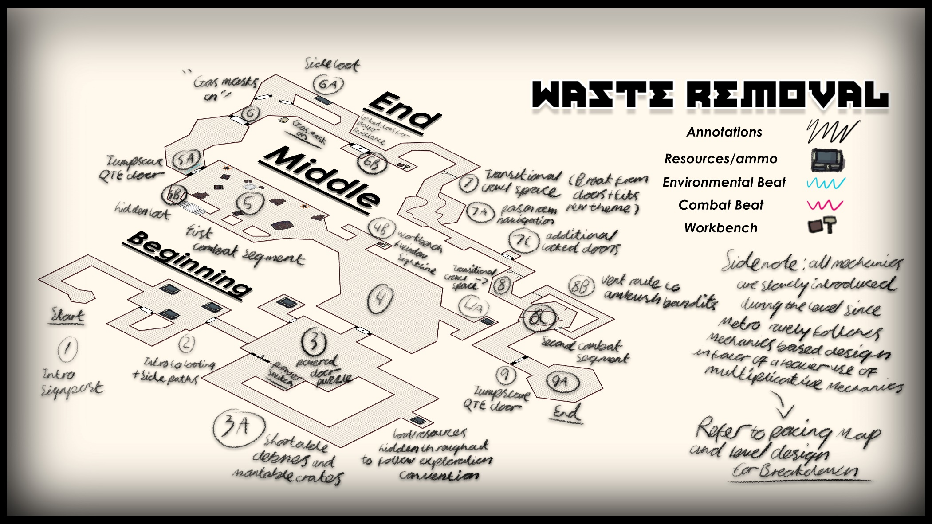
Bubblemap (see PACING and LEVEL DESIGN for more info)

Pacing
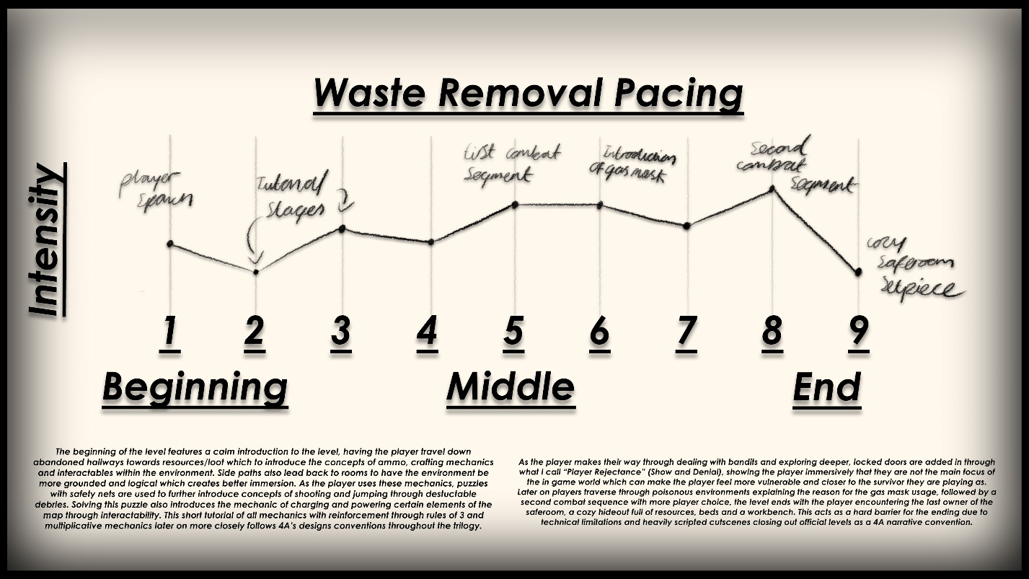
The beginning of the level is a calm introduction that is safer for the player, offering no enemies or threats and just having loot and side routes for the player to explore. As the player first arrives in the puzzle room, the tension increases as they have to destroy destructible debris to hit the power switch and solve the puzzle.
This leads into the first major combat segment which acts as a bigger challenge followed by a jumpscare QTE and the introduction gas masks which imposes a time limit. Though the player is tense, the level calms down, offering transitional spaces and precise traversal before introducing the last big fight of the level.
At this point most players will have a low number of filters, combined with the mask being damaged by gunfire pushing the pacing to its limit. This results in a nice cooloff as the player fights their way through to the saferoom, which is safe from the fumes and offers loot, workbenches and an interactable bed to rest in.
Using this wavy band of tension, combined with side looting as a fun distraction and other minor set pieces such as door interactions and workbenches helps to carry the pacing more solidly and establish a better sense of tension compared to past projects.

Player Pickups
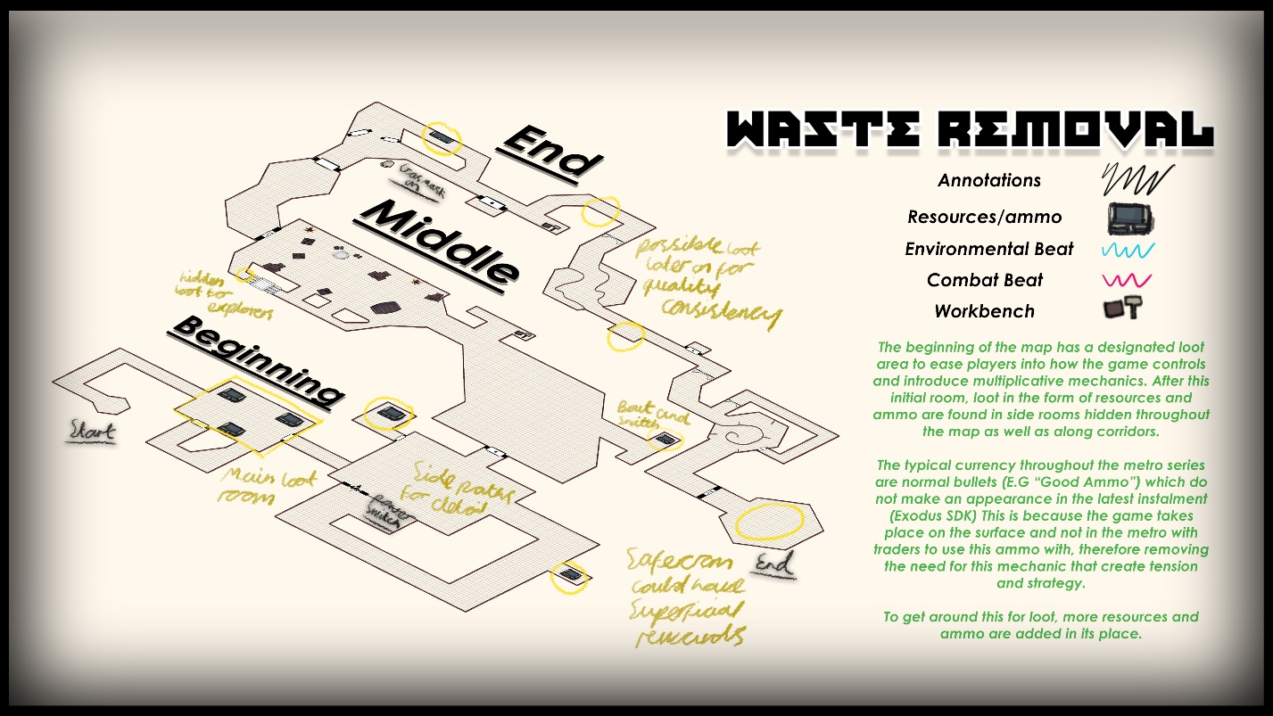
In the beginning of the level, loot is used to help ease the player in, once the player understands loot is about in the level, this is then scattered throughout the side rooms to encourage exploration. One design convention that was created is that loot is absent from main combat areas as loot is structured to give a nice sense of preparedness before a fight through ammo, with loot after giving resources as a reward which is a design standard seen throughout various games in the horror genre. This however can be ridiculed as these are drops are in abundance in these games, which will be shut down by having boxes away from the critical path and then tweaking fights to work without a large amount of resources to not punish players who miss this.

Critical path
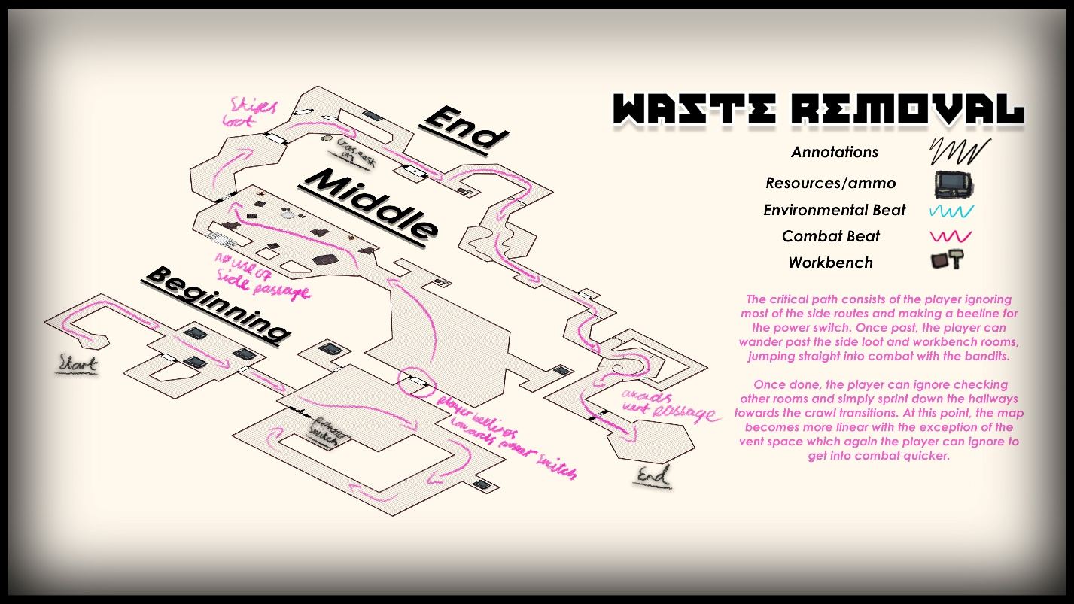
Players critical path will still have them follow the windy corridors of the bunker and through the major elements of the level such as combat segments and set pieces. However, most loot can be avoided as side rooms are on the optional path. Other side routes/advantages such as using the pillars in the first fight and the vent room on the second can also be avoided, with cover being placed in the center of the room to favor more brute force approaches.

Optional path
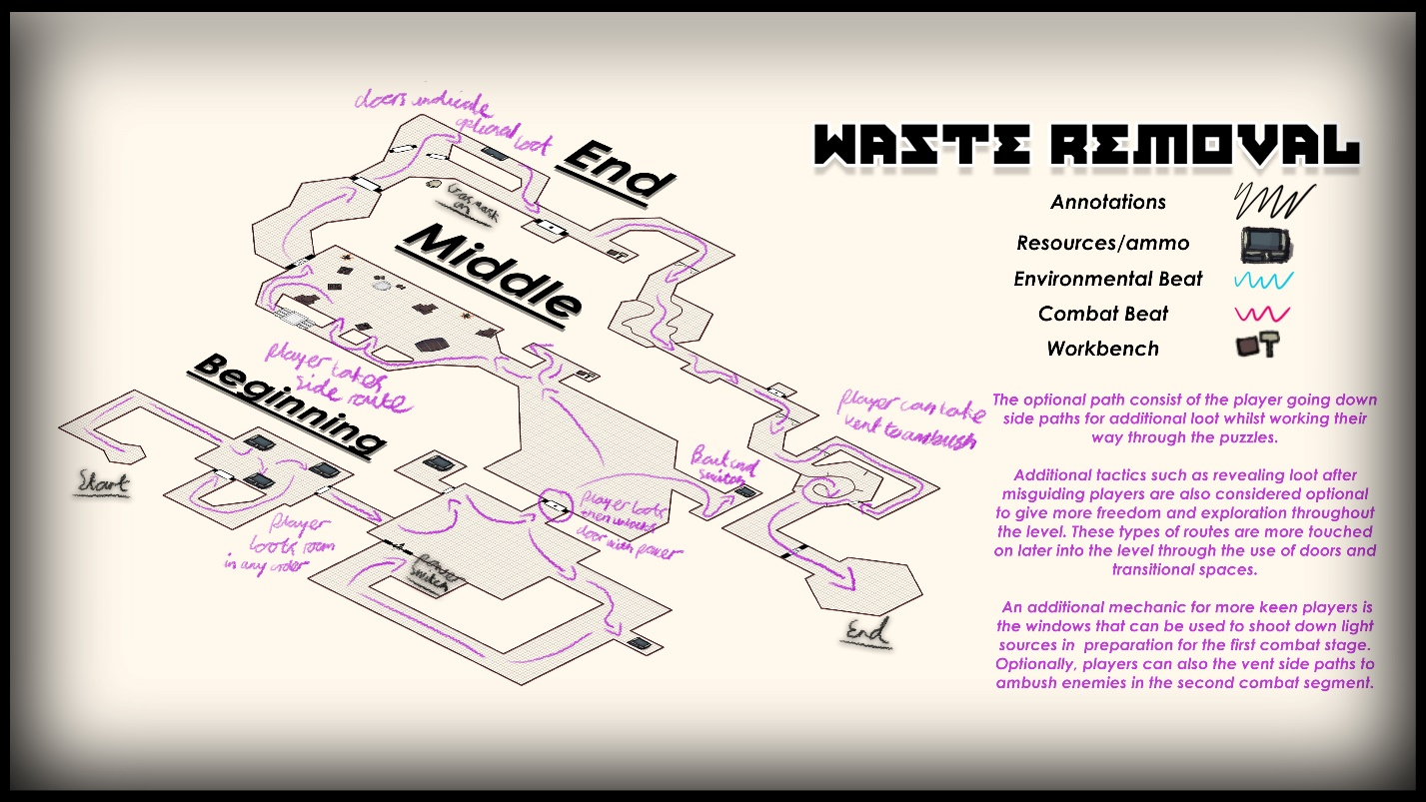
The optional path features more looting and exploration of side rooms with inclusion of subtly showing how lighting highlights doors. Alongside this is “bait and switch” with players being led to the corpses with promises of loot only to find none, with the player turning around and seeing the loot on the other side of the room. Side paths also include making more use of combat engagements, with side cover, sightlines and crawl spaces being used to ambush enemies to reward player engagement.

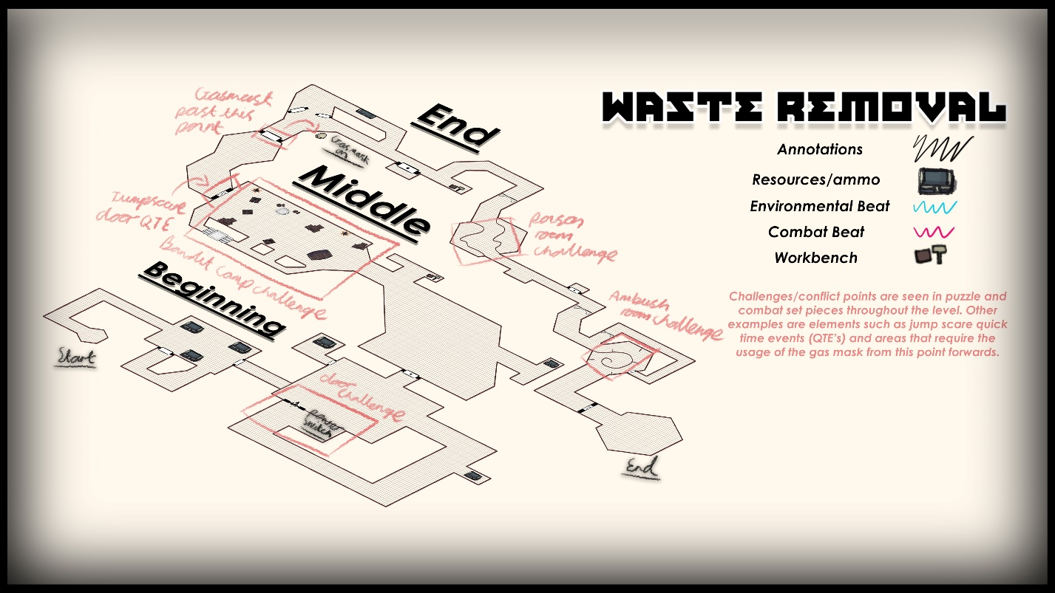
Challenges
Large rooms accompany most challenges such as having a large open room followed by smaller corridors for the first puzzle, followed by larger rooms for combat areas. Rooms being larger are typically on one axis and then contrasted on another, such as small and wide or tall and narrow. Another conflict point are the inclusions of monster after QTE’s as well as environmental threats such as gas masks and poison areas.
Challenges are varied in visuals and playstyles throughout the level following 4A traditions, with the rooms often being made around the challenge such as the first camp encounter being in a large cozy room with side routes and cover to ease the player in, later followed by the ambush being narrow and tight to choke the player.

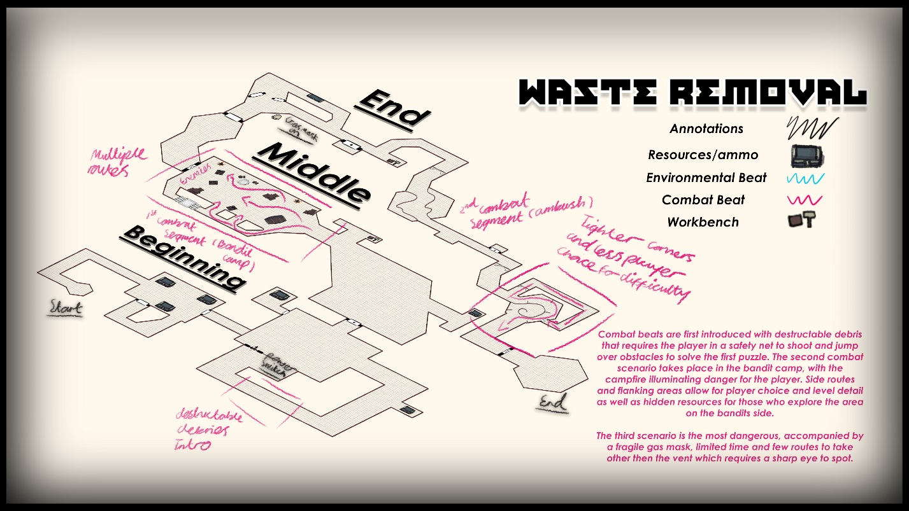
Conflict points (Combat)
Combat rooms often have different ways to tackle challenge. The first room, which is a small bandit camp, offers a slight line that can be used to disable the lighting around the room which players can use to ambush. The way this room is conveyed is discussed later in VISUAL AND AUDIO AFFORDANCE. The entrance to the room is angled towards side pillars that cut safely into the middle of the room and give players another opportunity to ambush and take cover. Reasoning for barrier placements and cover opportunities are covered later in BALANCE.
Earlier in the level, destructible debris is also used as a conflict point to teach players about how to shoot obstacles in a safe environment. However, this might mess with AI pathfinding and cause enemies to be in an alert state for the remainder of the level (explained in 4A’s AMAZING SDK…)
The 2nd combat segment is the ambush segment, consisting of tight hallways with limited visibility with enemies catching the player off guard alongside gas masks being used to add to the difficulty. The optional way to tackle this challenge is by using the vent crawl space before the encounter (VISUAL AND AUDIO AFFORDANCE.) to flank the enemy before emerging from a physics door that the player can simply walk into to push open, avoiding unfair restrictions through animations. After dealing with the bandits through this route and using cover, a side room is also seen that shows the bandits hideout for some environmental storytelling. This then has a straightforward route towards the safe room which then acts as a reward for beating the level.

Rewards
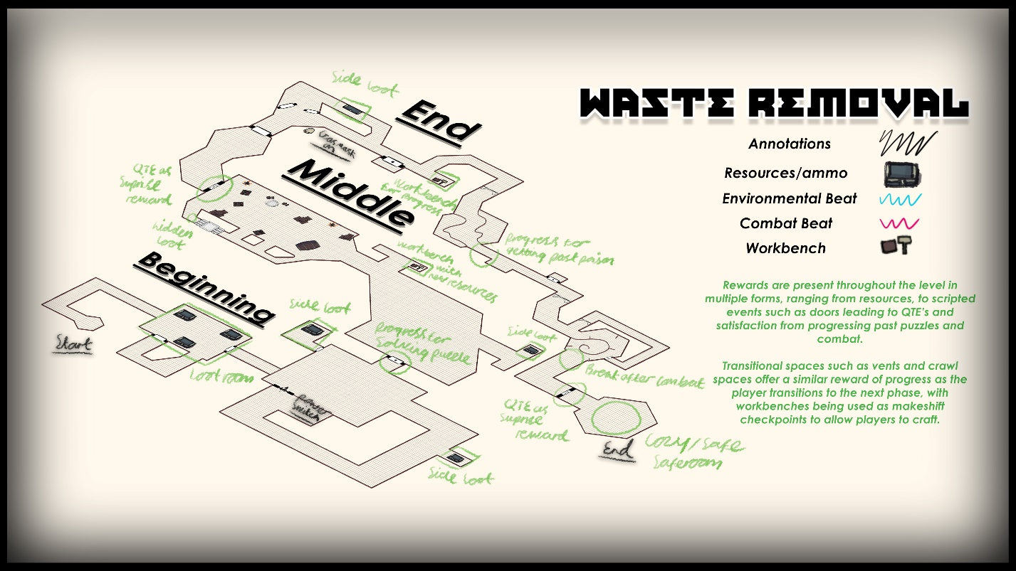
Most rewards are given for playing the main gameplay loop, capturing points and gaining control of valuable areas to help influence team wins. Valuable pickups such as large pickup spots in the sewers and around the dome hallways can also act as rewards for players who traverse the map, at the same time rewarding killers who just play the gamemode.

Aesthetics (Look and Feel)

Setting
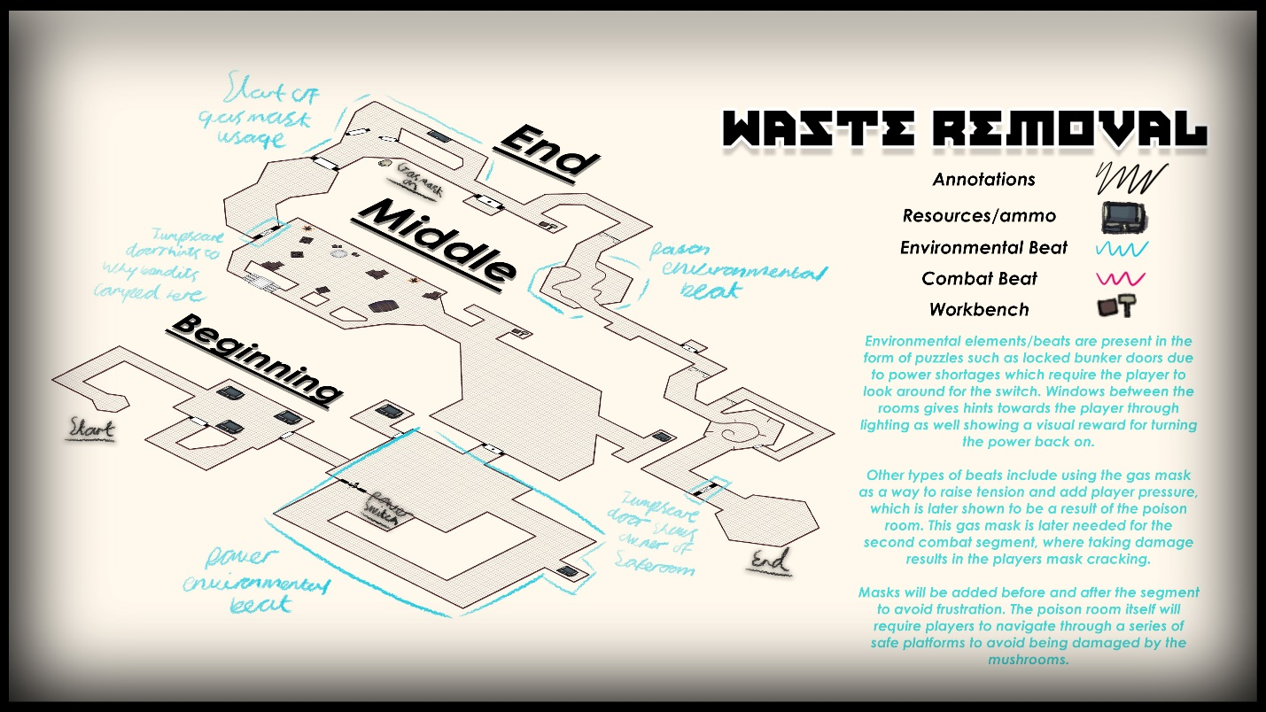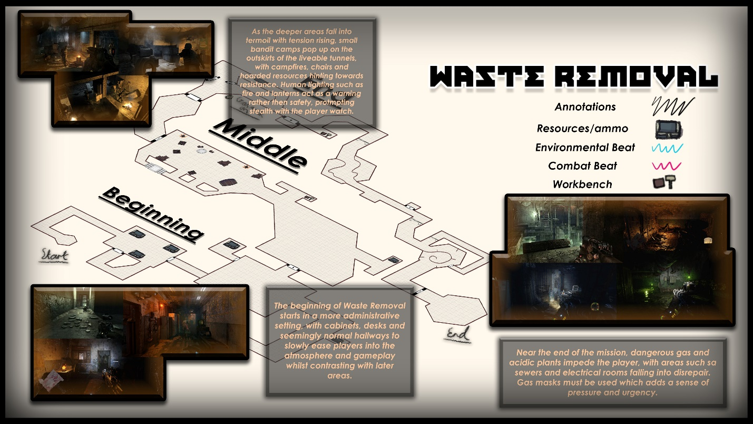

The level is set within an abandoned bunker instead of on the surface, with dying electricity and the remains of the military stationed here before the bandits took over and set up shop. The main theme of the level is industrial, with military styled corridors and larger more open rooms followed by tight transitional corridors. Because of the disrepair of the place, roofs have collapsed leading to debris and crawl spaces, with nature reclaiming its deadly place later on throughout the level.
Opening stages are administrative with clean desks and cabinets with electrical gear followed by decrepit hallways and deadly fumes/fauna after the first bandit camp. This is to help setup environmental storytelling of why the bandits camped there in the first place, as well as justify the use of the gas mask mechanic.
The map itself will use the default skybox that is loaded on a new level, but the time of day will be set to dusk to rely more on lighting for better visuals and affordances whilst avoiding particles systems from other sky boxes.

Visual and Audio Affordance

Visual affordance has been at the forefront of signposting as the SDK lacks functionality of have sounds play in specific area upon triggers. A mixture of lights have been used to signal for players, including broken blinking lights that point in the direction of objectives and having green lights above useable doors, with blinking needing interaction somewhere else for the door to work, and no lit sign indicating the door is inaccessible. Other variations include swinging turned off lights above broken doors to also catch the player’s eye.
Poisonous mushrooms harbor a bright green colour to signpost for the player as well as campfires showing hostile activity. Lights are also used to indicate beginning weaponry.

Player weaponry is clearly highlighted with lighting affordance.
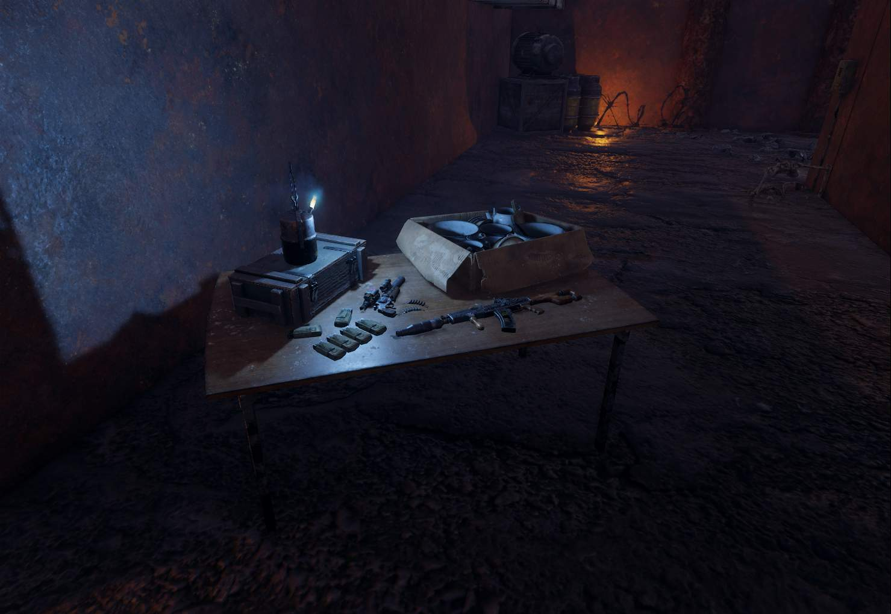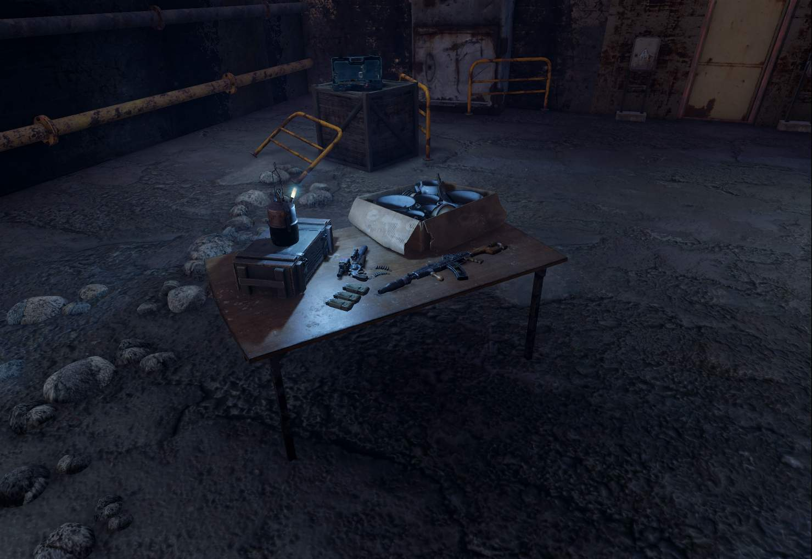

Lighting above doors to indicate availability.
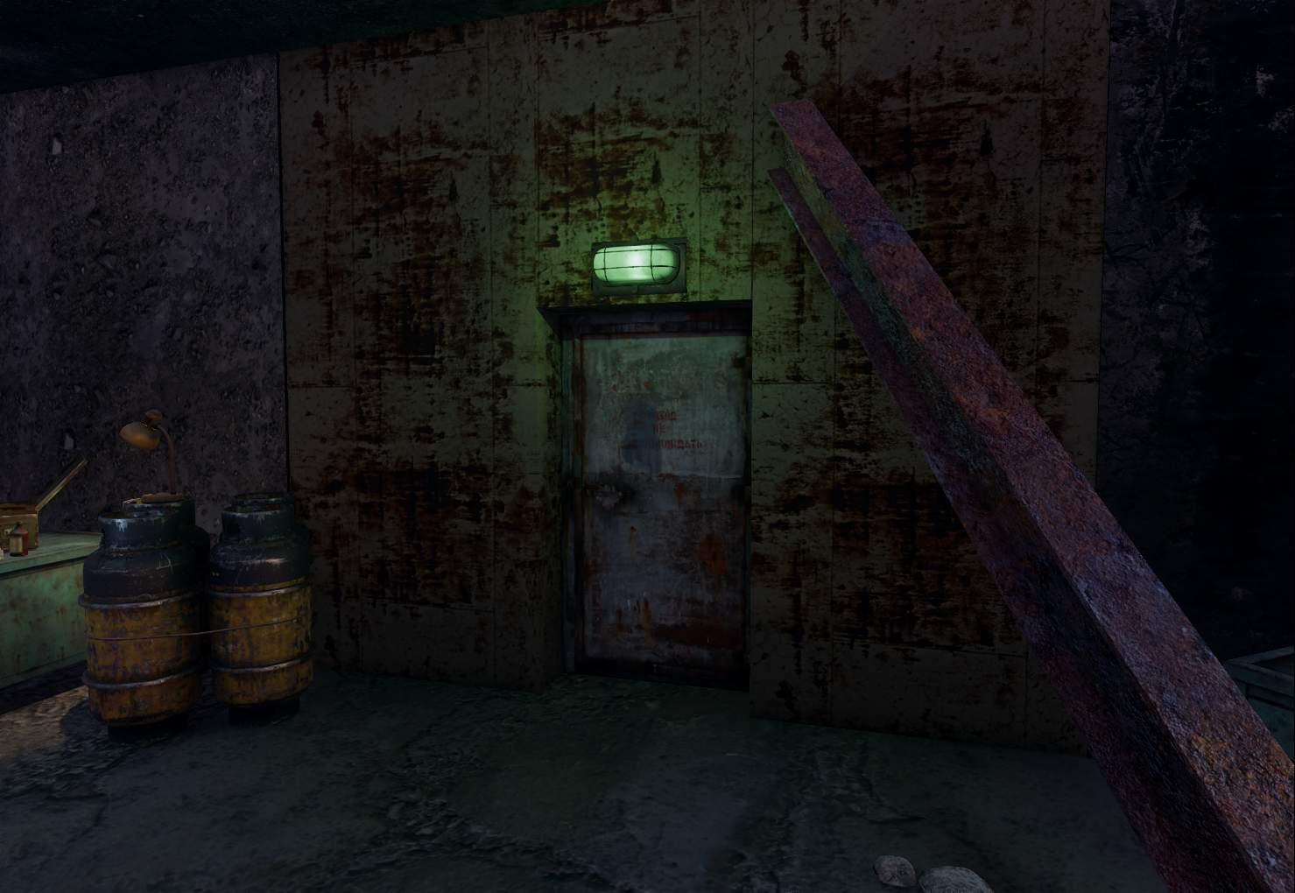

Lighting in various forms to indicate player path.
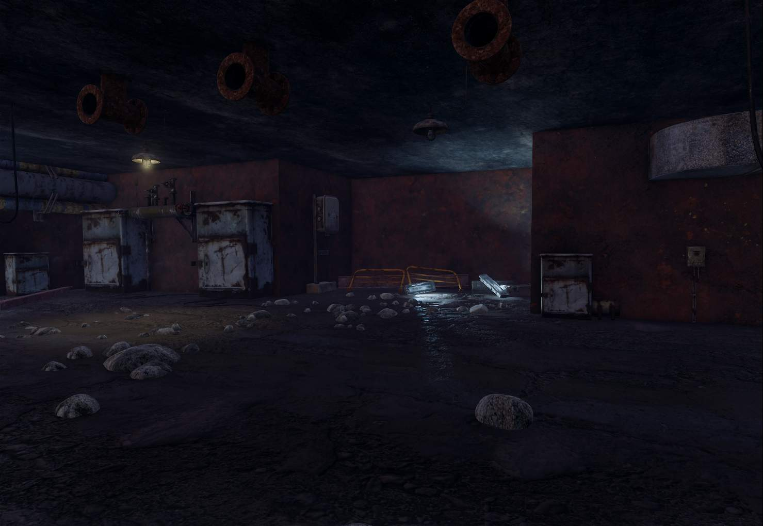
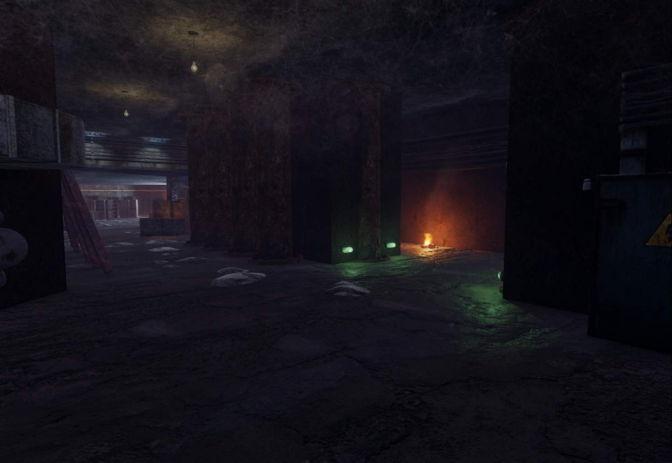

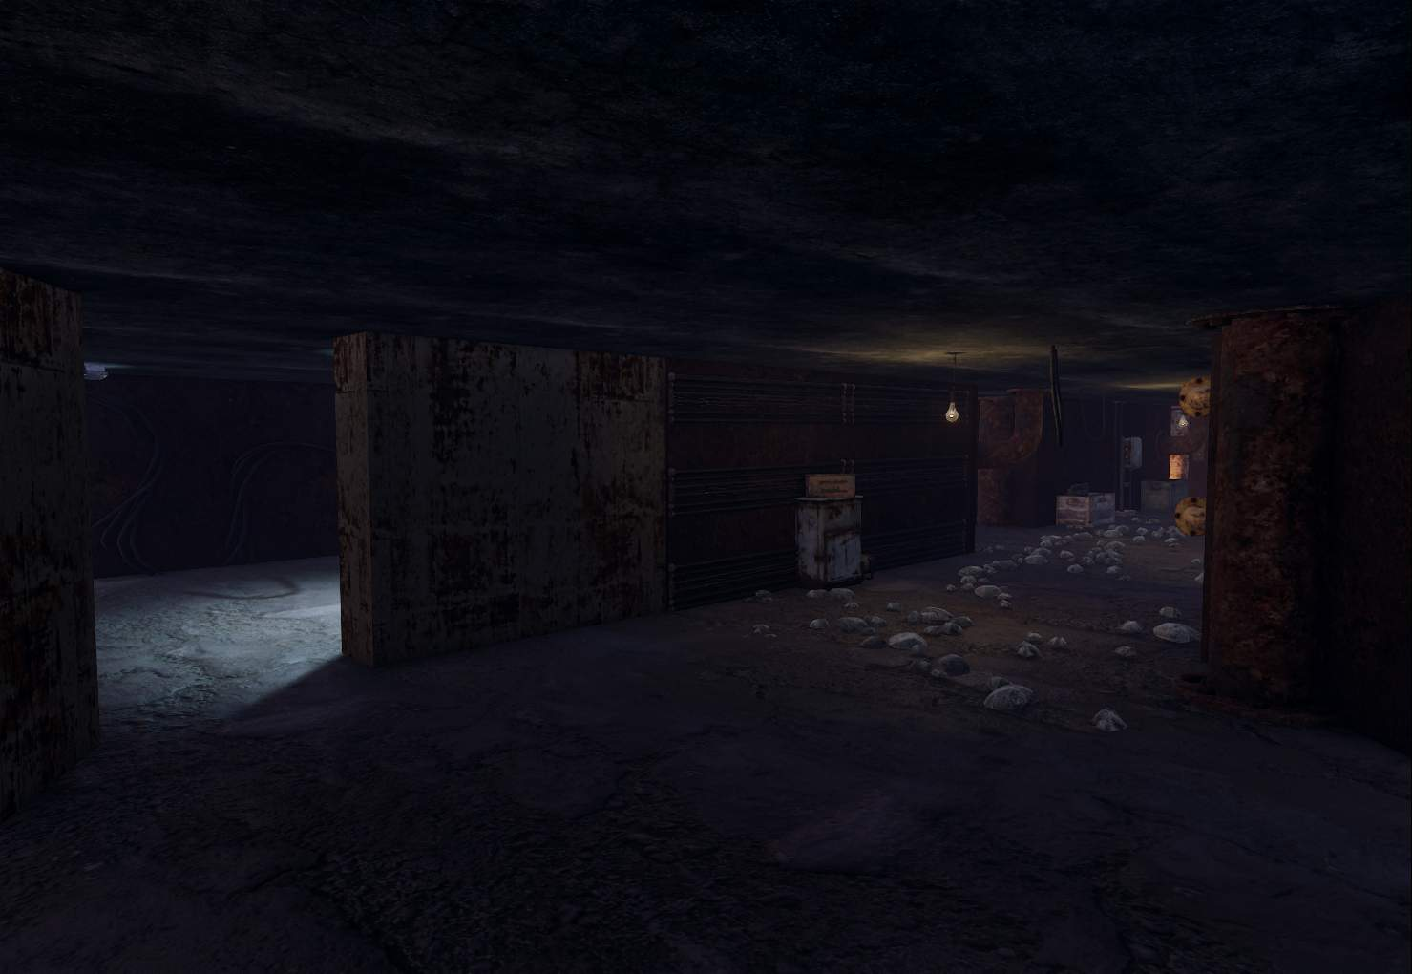

Different use of colour to indicate different objectives/routes.
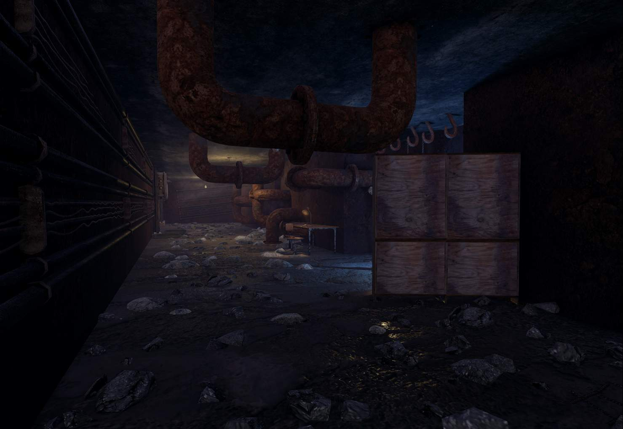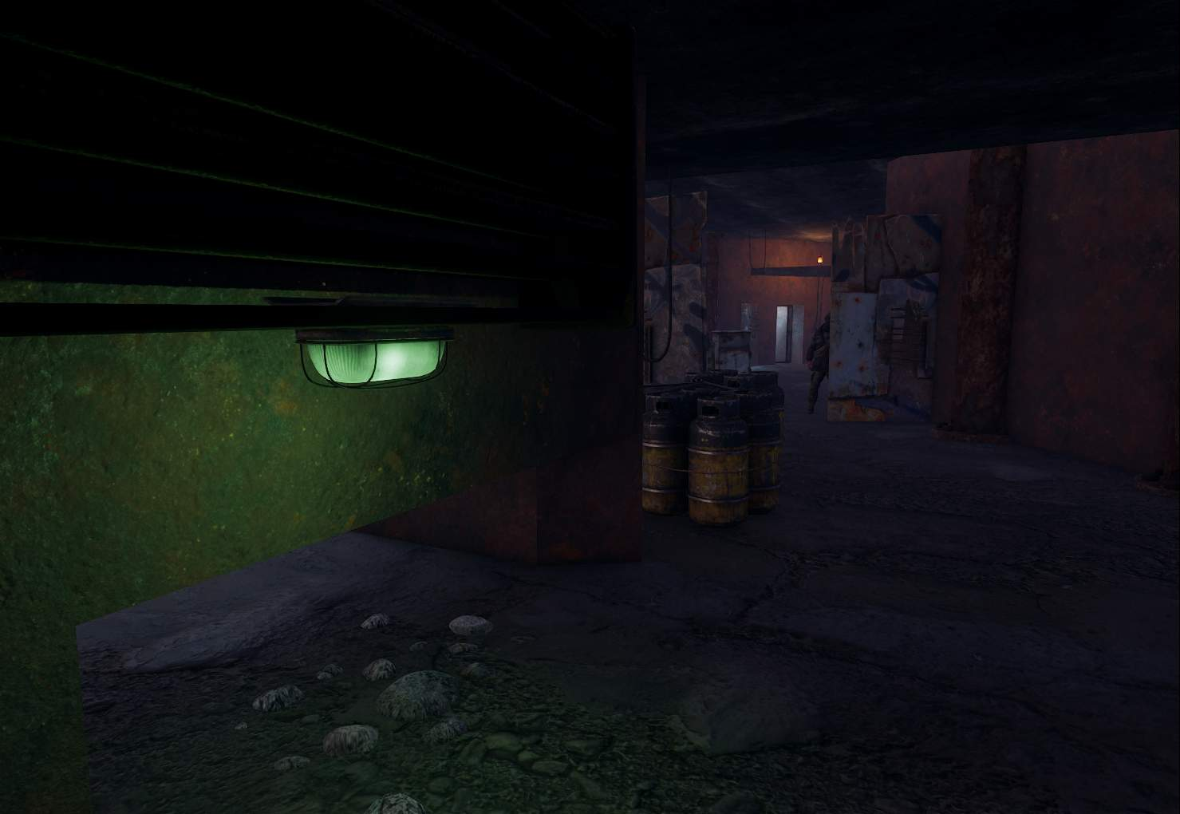

Lighting also used to highlight resources.
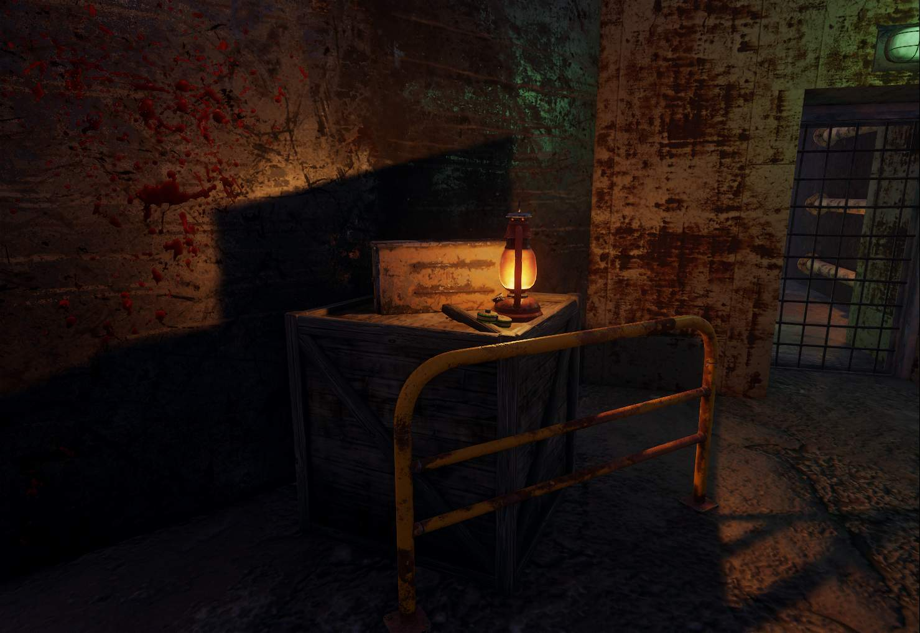

Visual Development (Progression Screenshots)
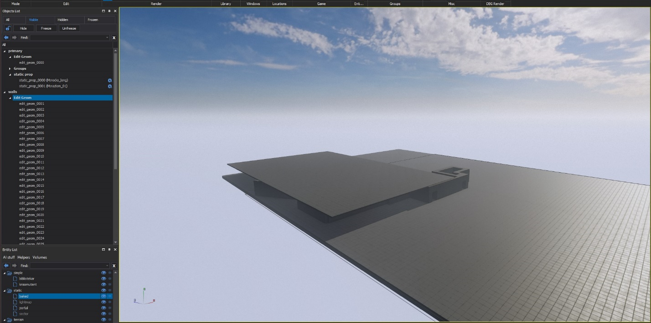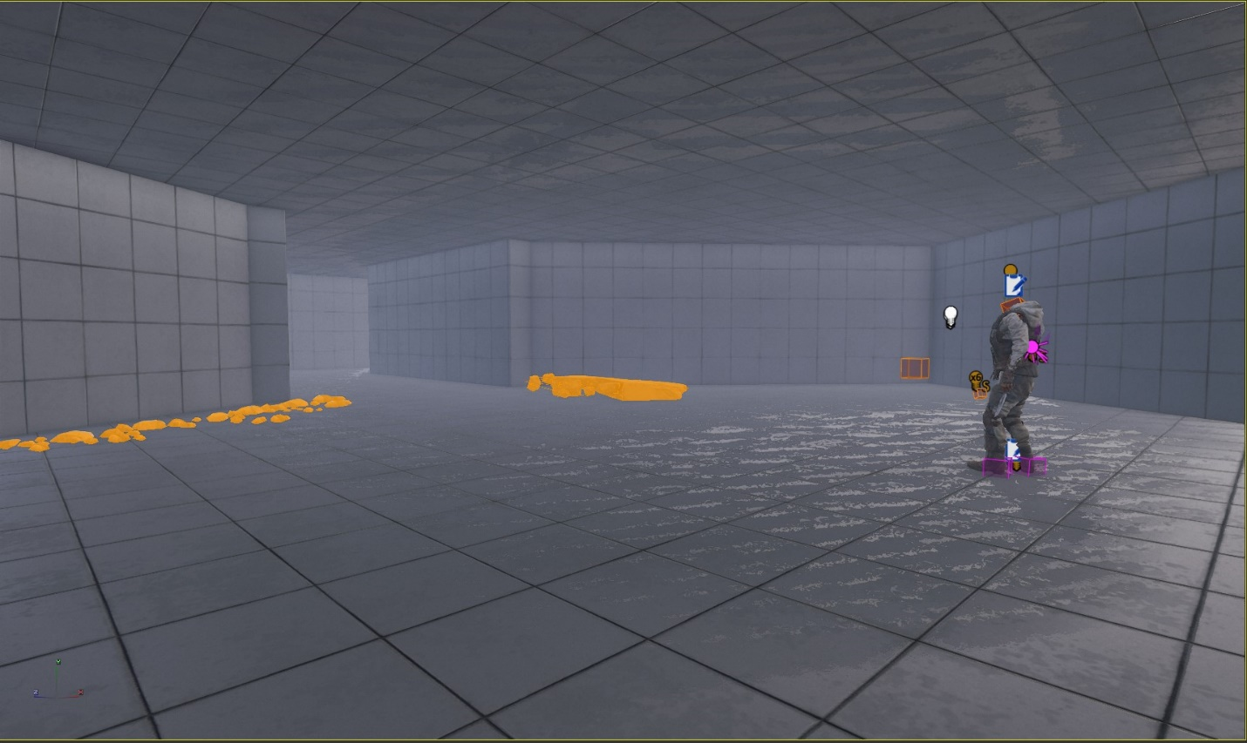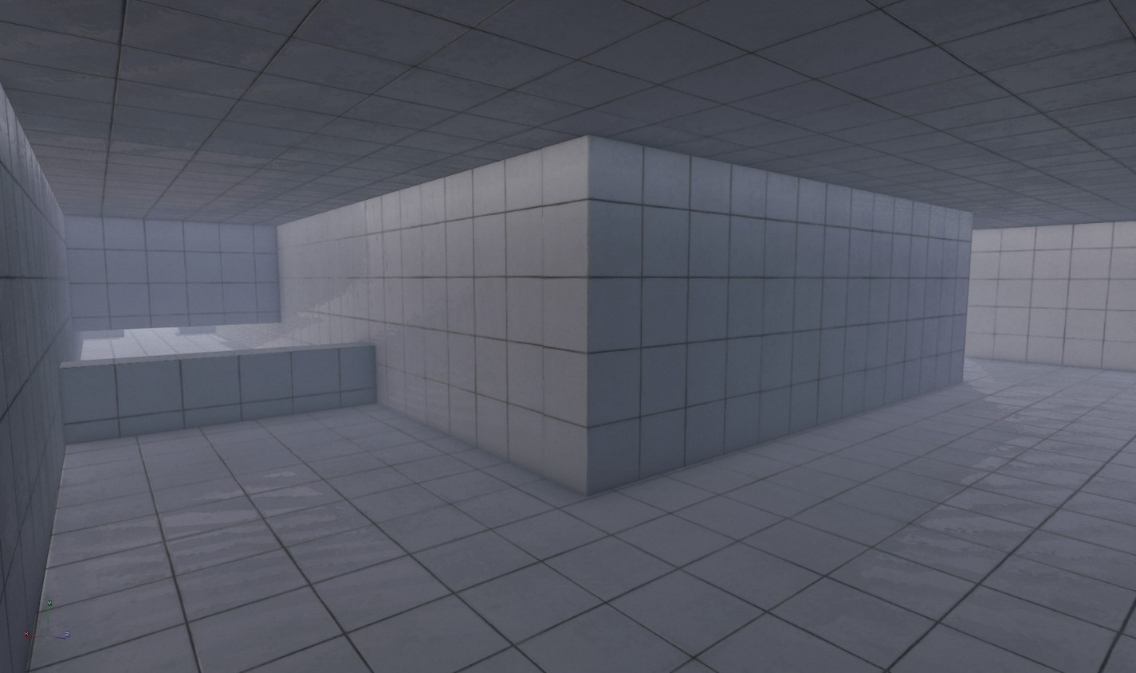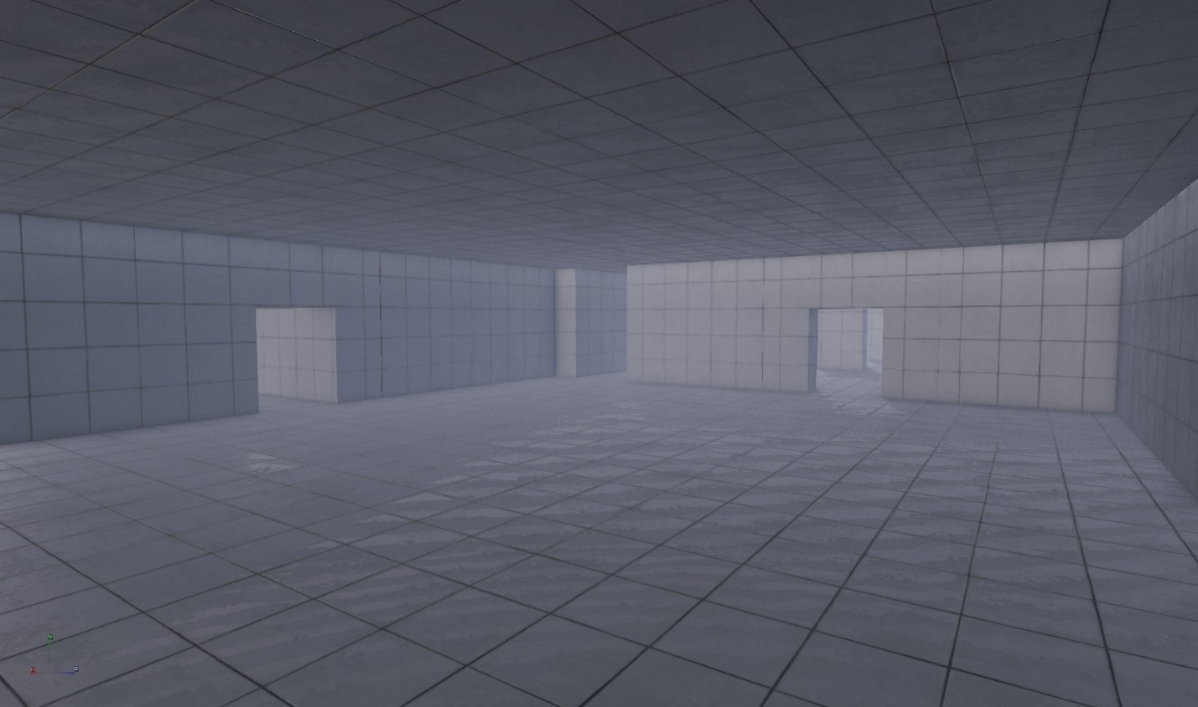

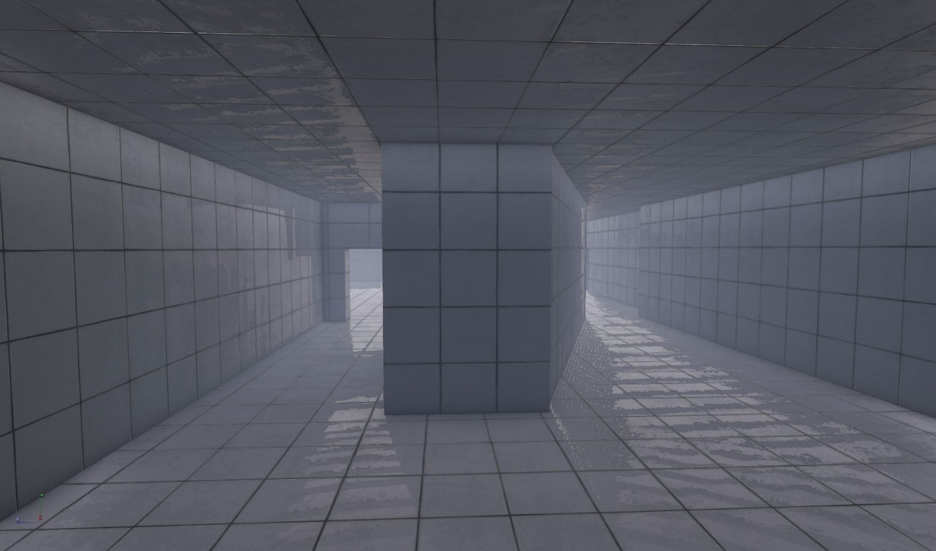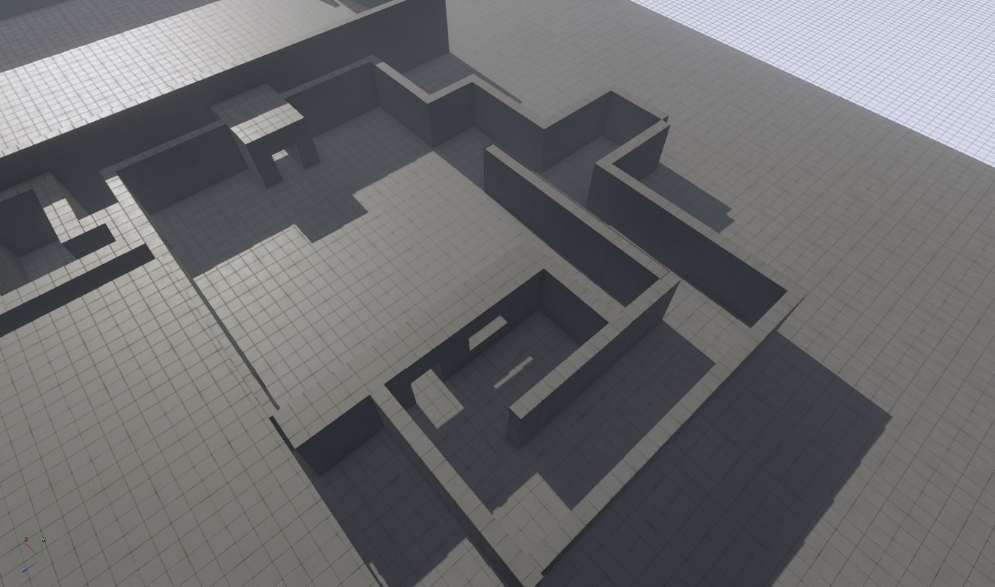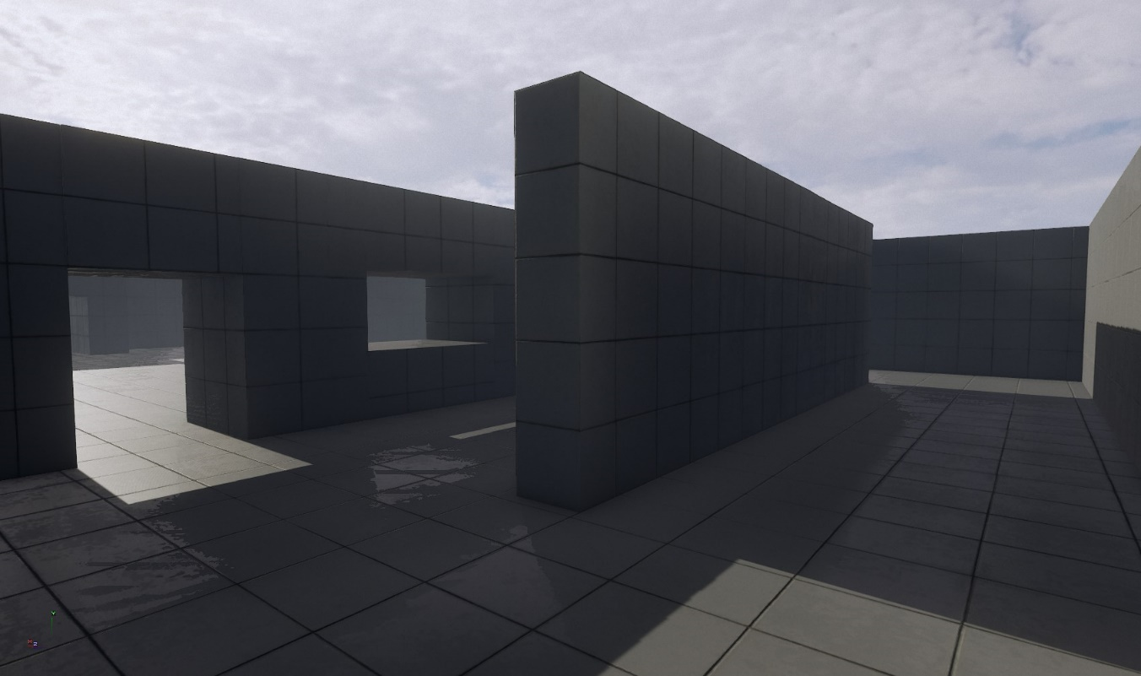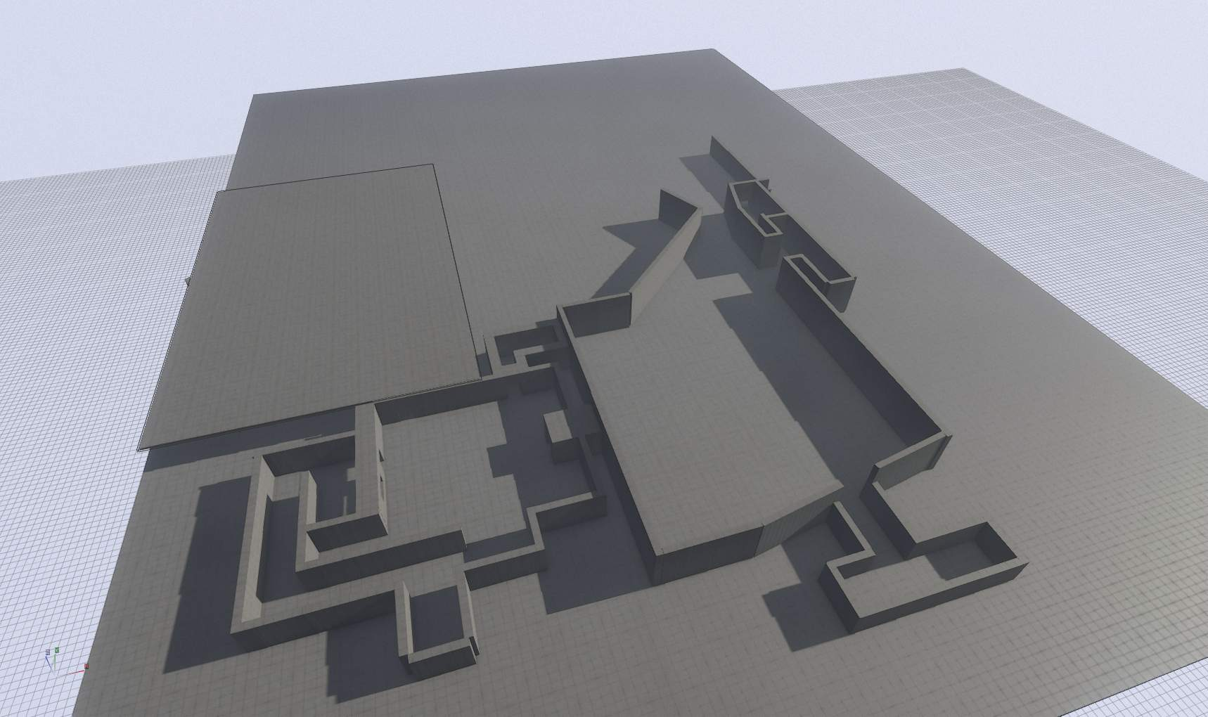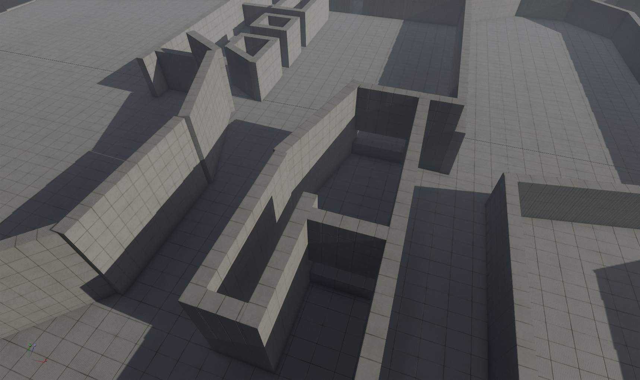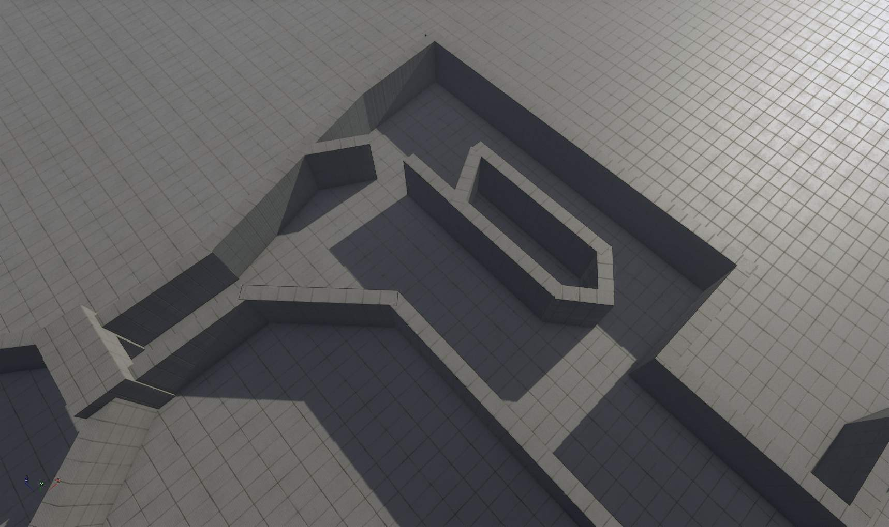

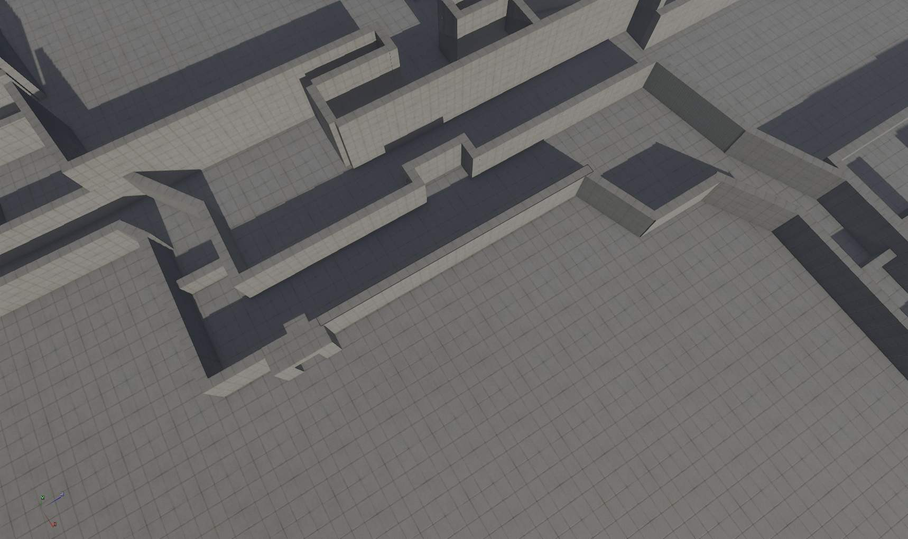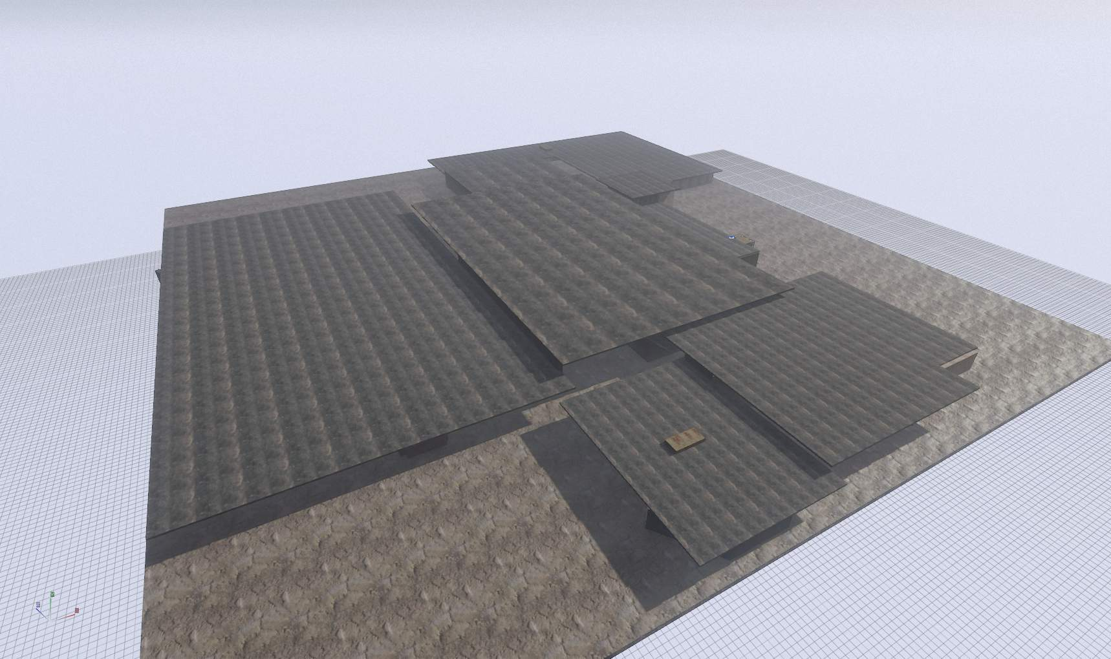

Starting the blockout was fairly quick as a new level was created using the documentation, alongside creating a new mod, then adding in the basics such as a character setup before duplicating the ground geometry and using that for the grey walls. This was sped up using the efficient scale tools which is talked about more in 4A’S REDEEMABLE QUALITIES.
During this stage, the player character was used to scale per room and make appropriate changes which helped prevent my level from being unfairly and unrealistically big. Despite this slightly changing the final level design in terms of distance between rooms and room scale itself, this worked out better and helped to create a more immersive atmosphere that fits in line with a traditional 4A game.

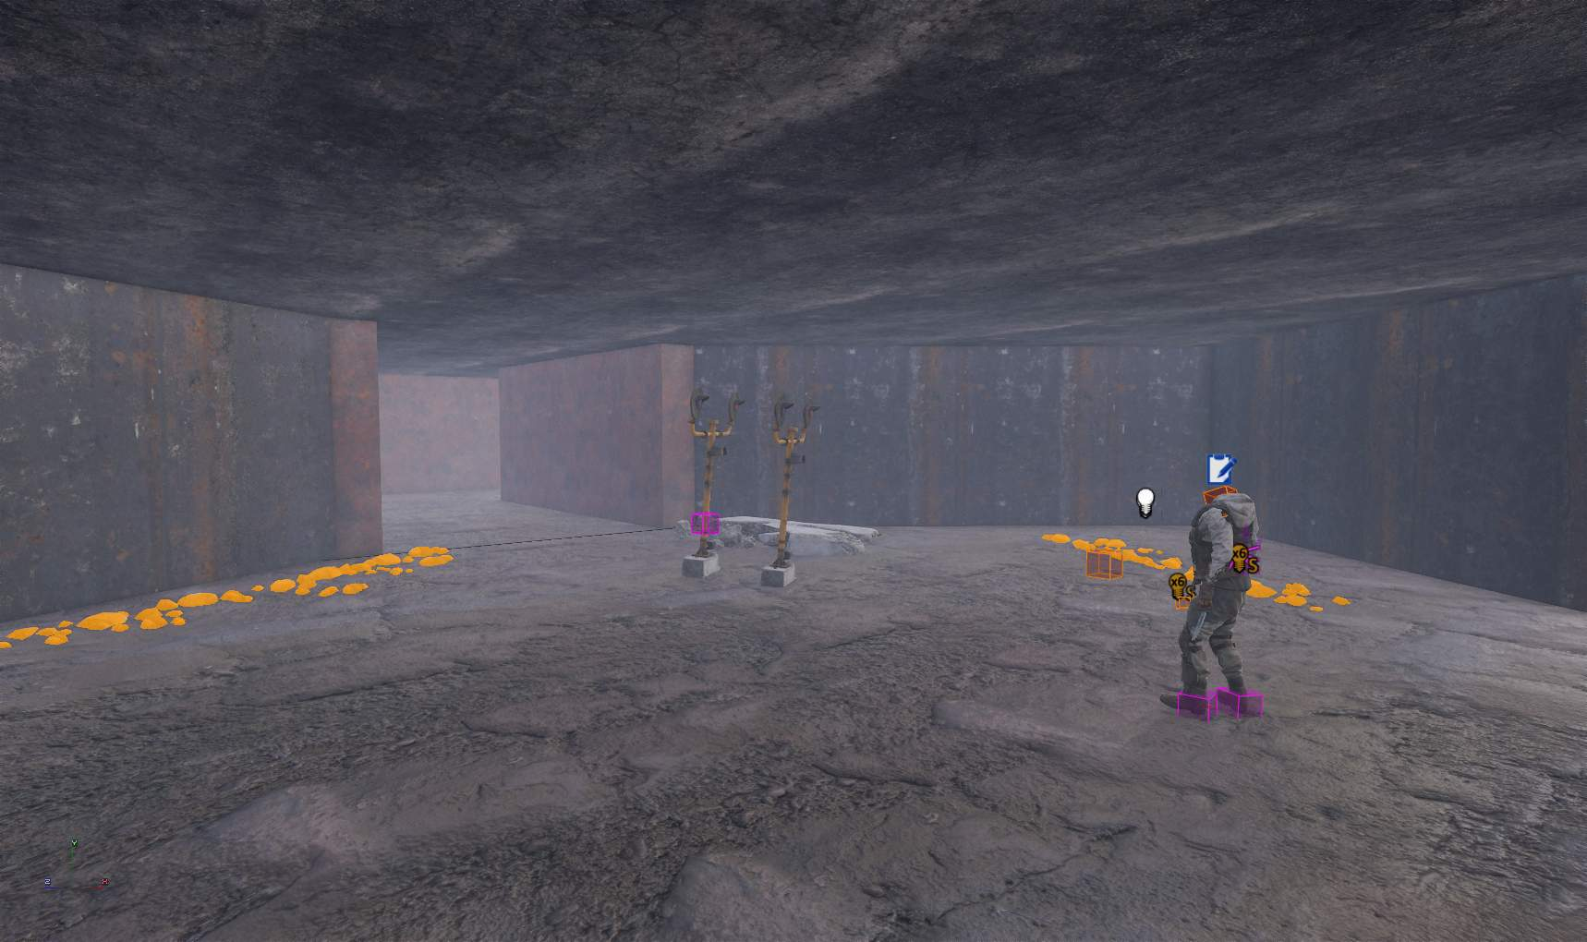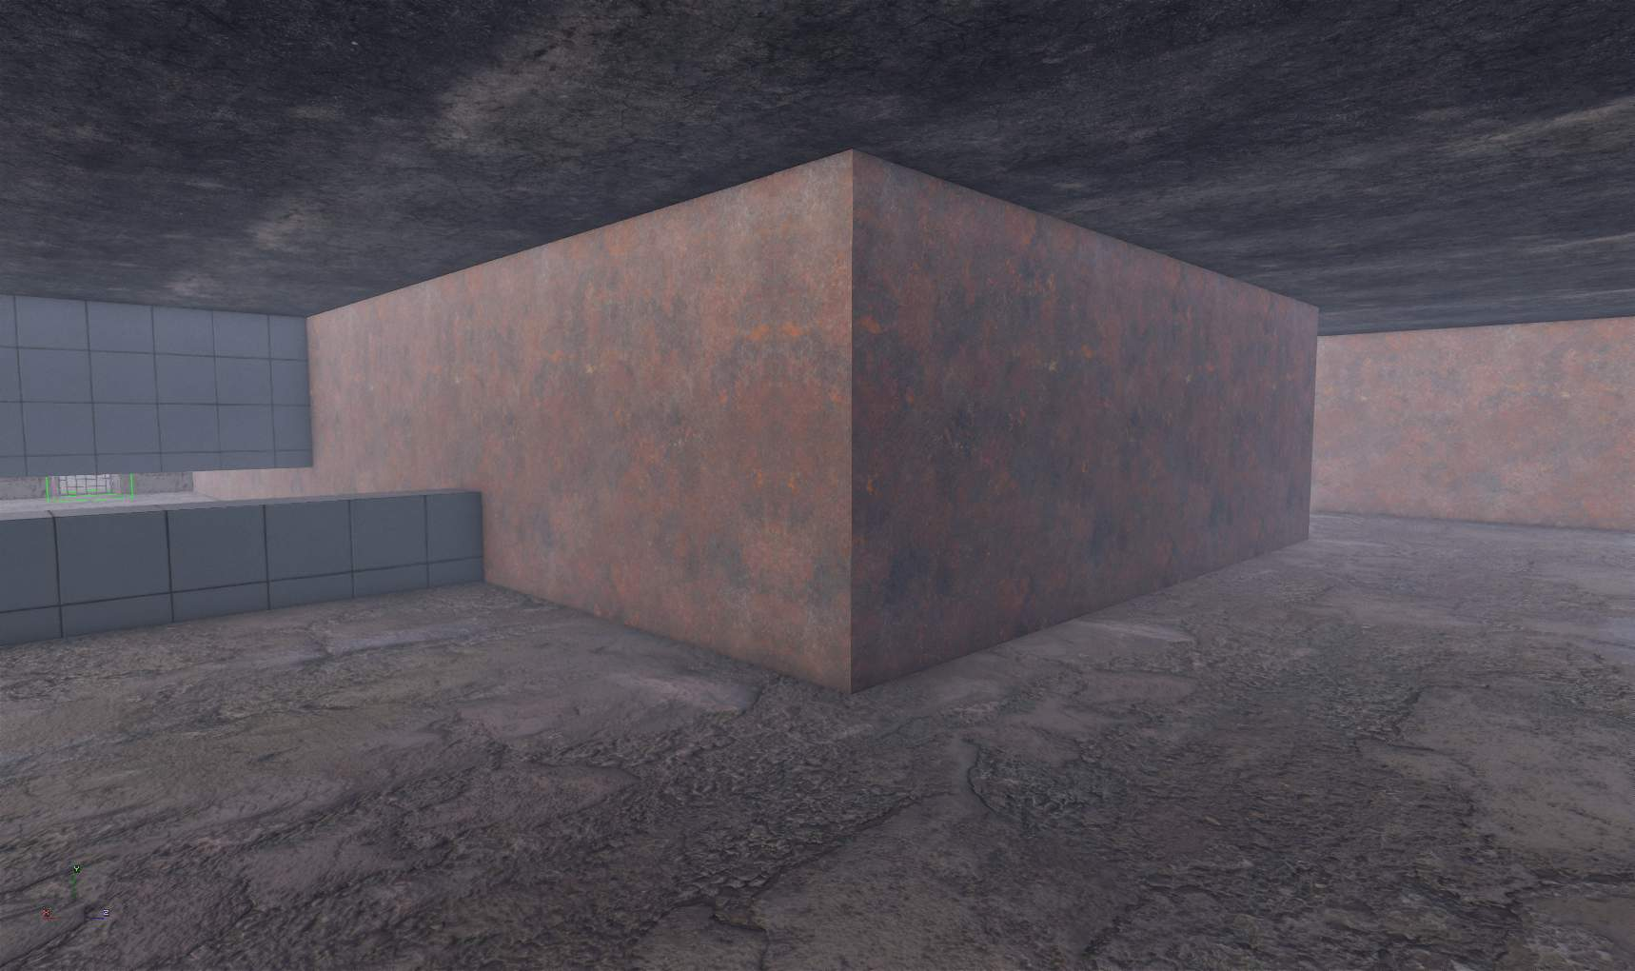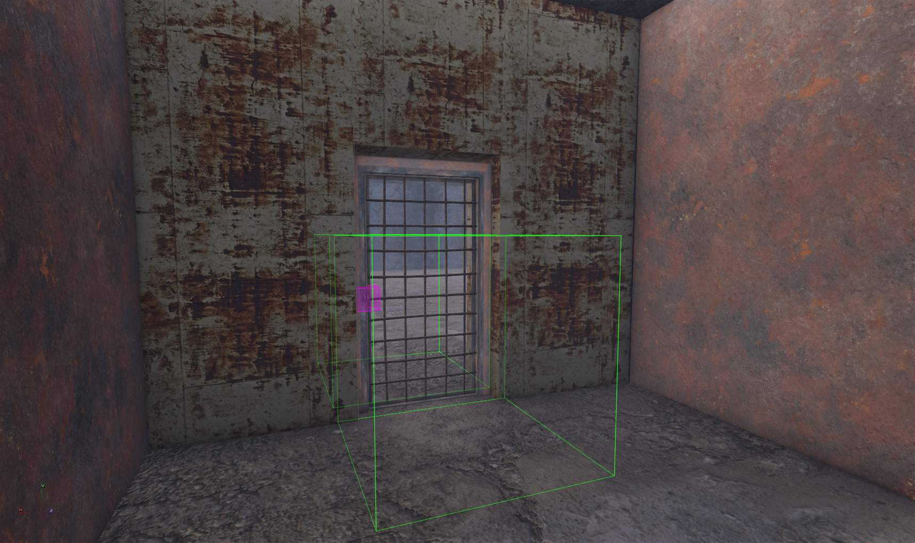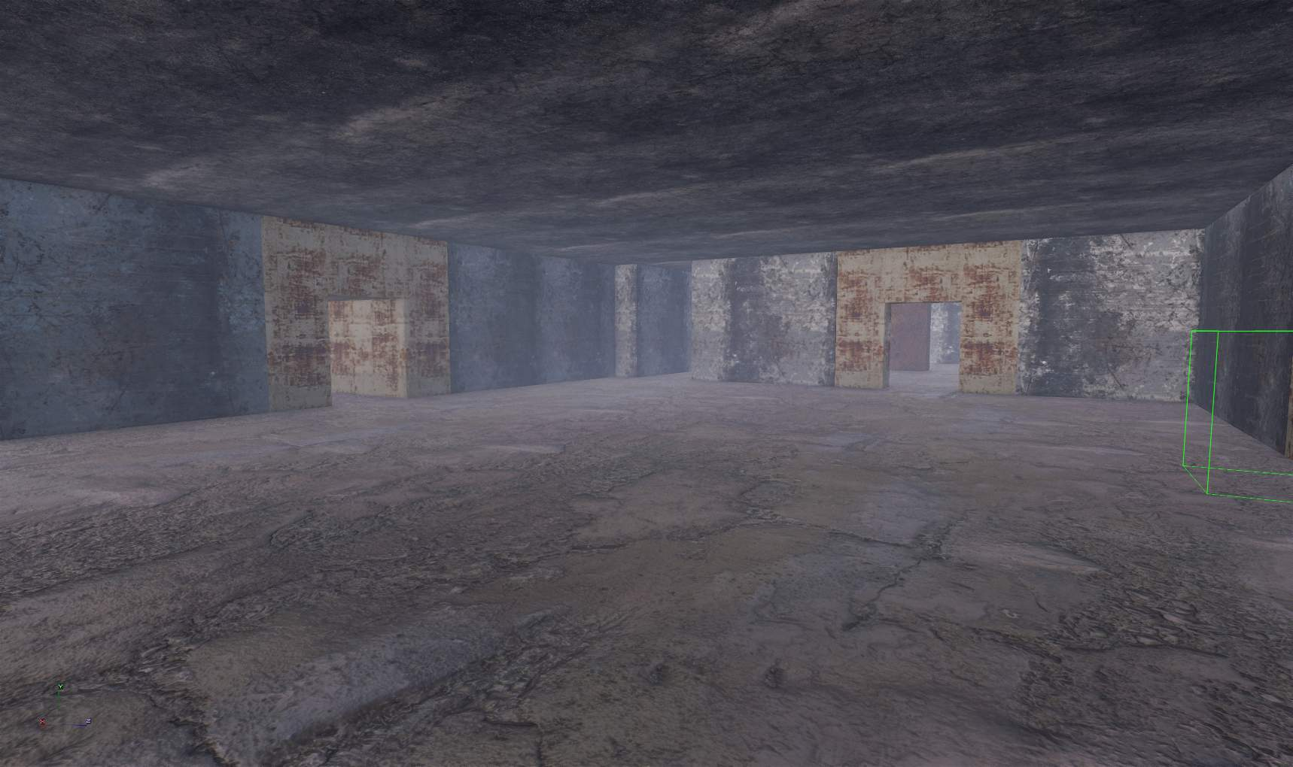

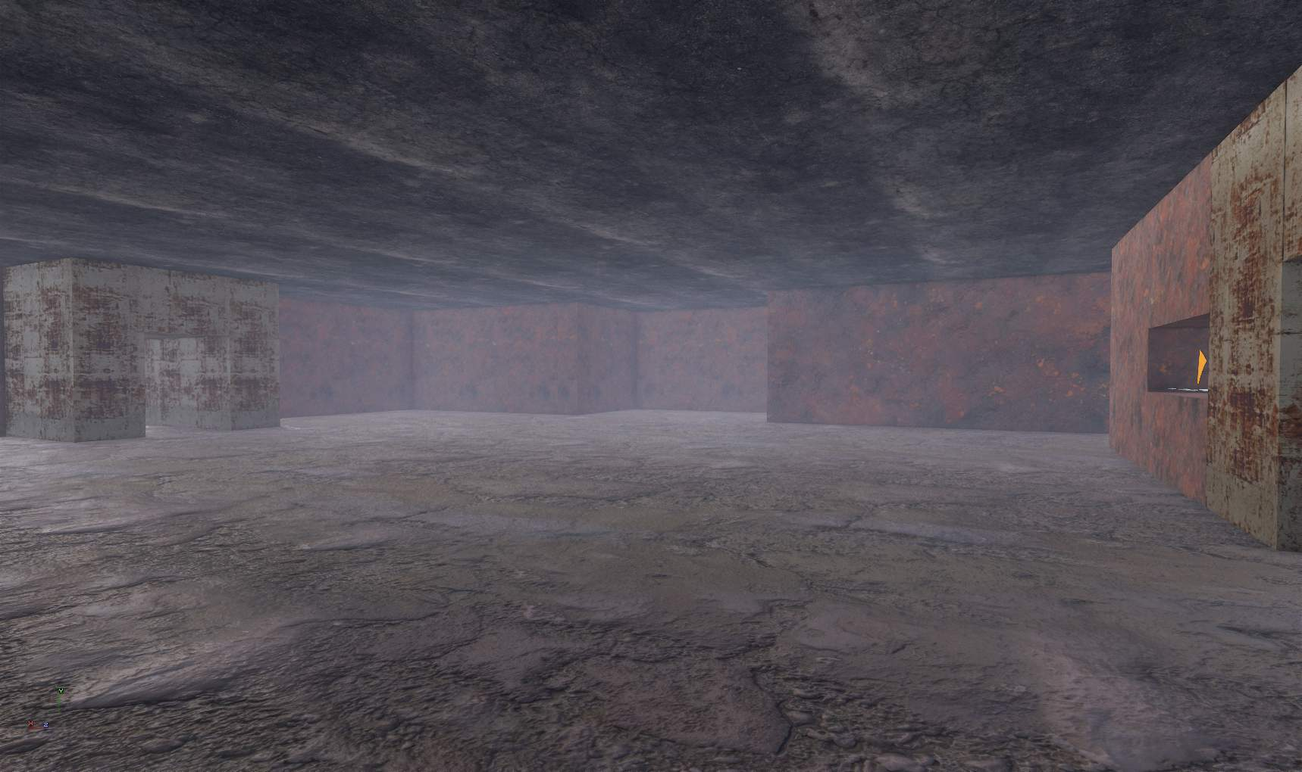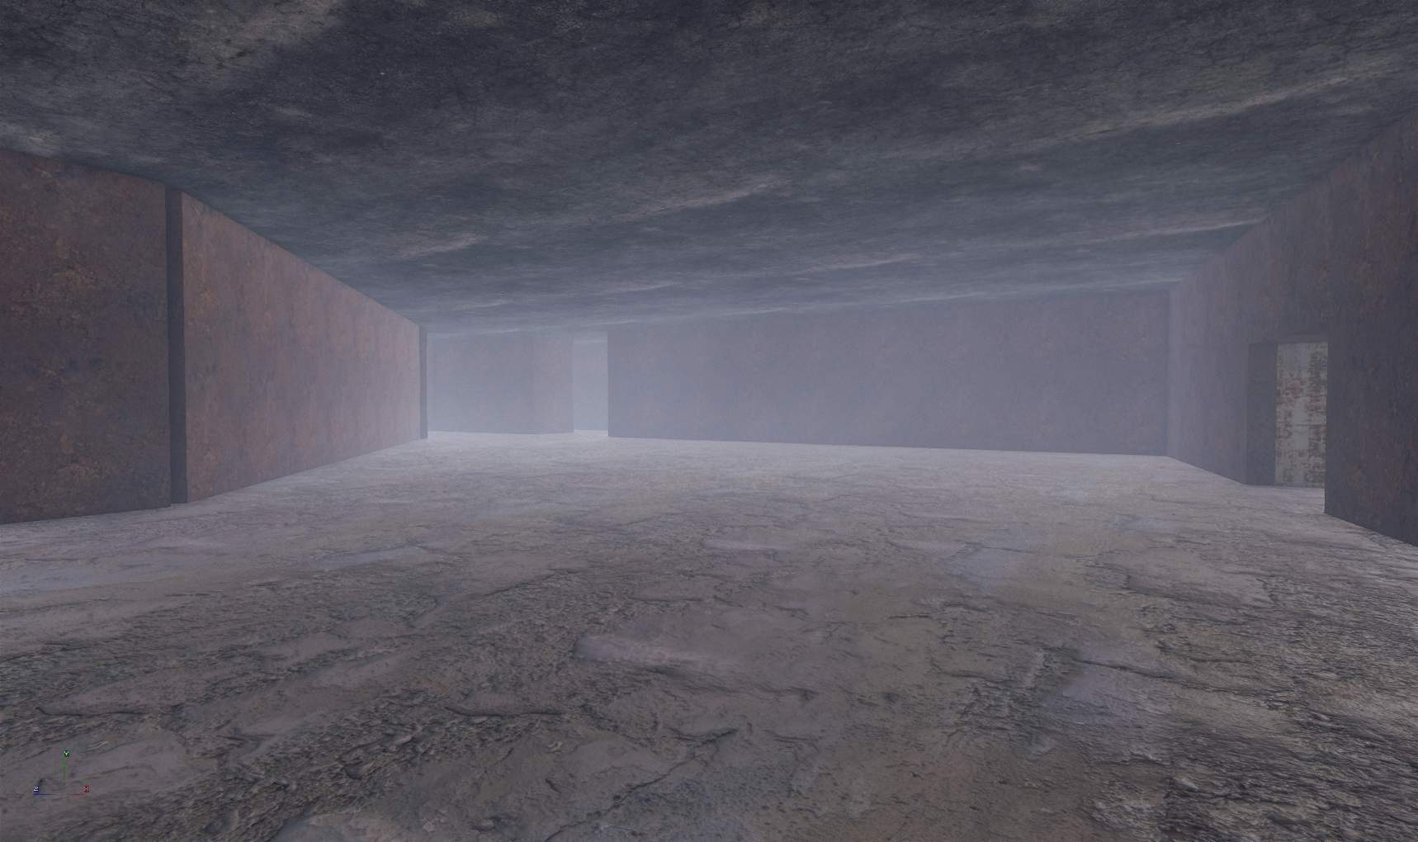s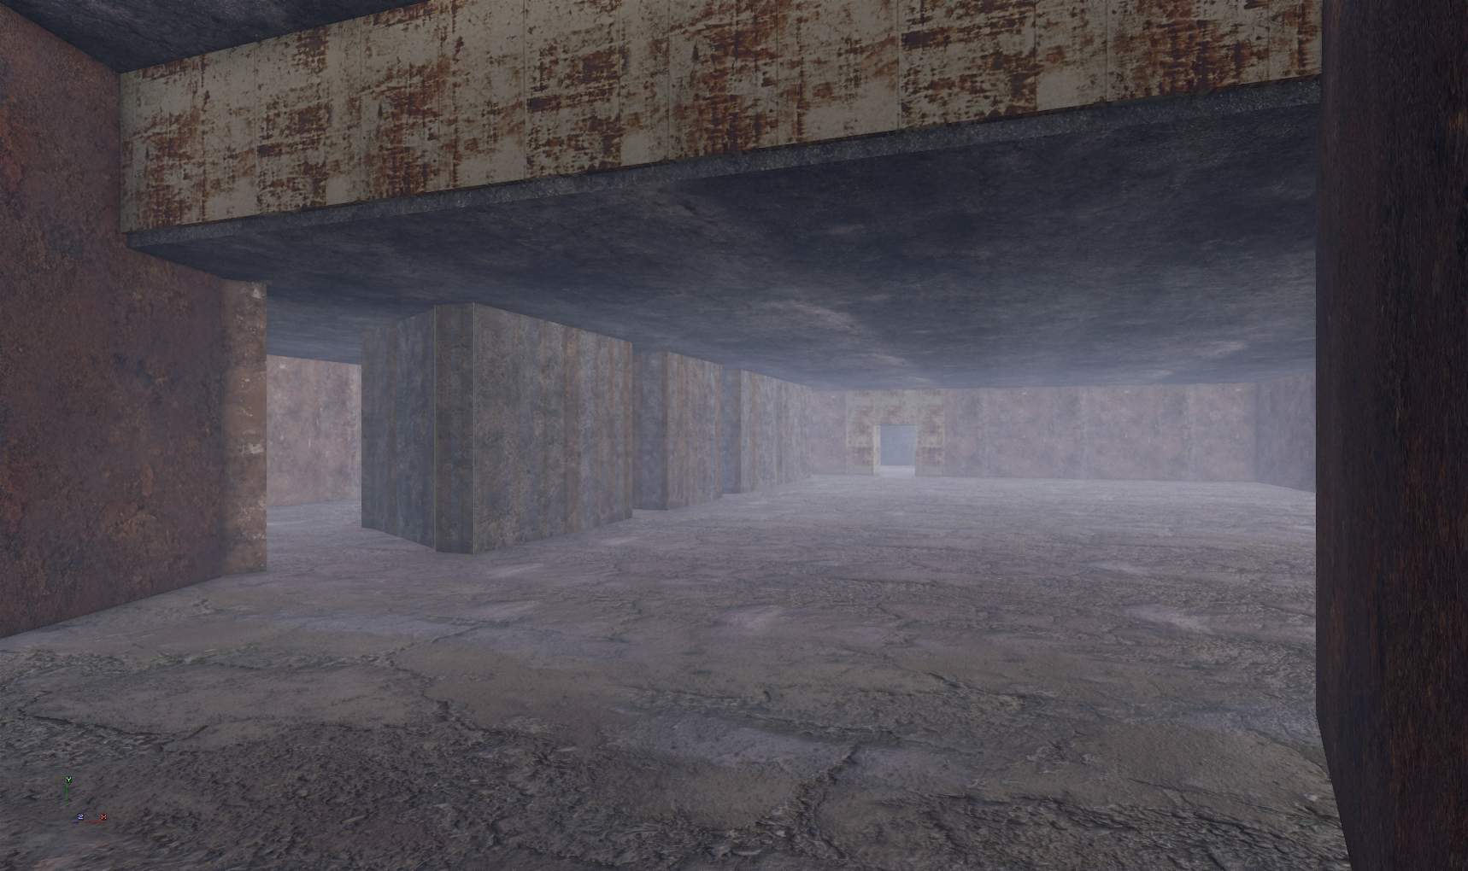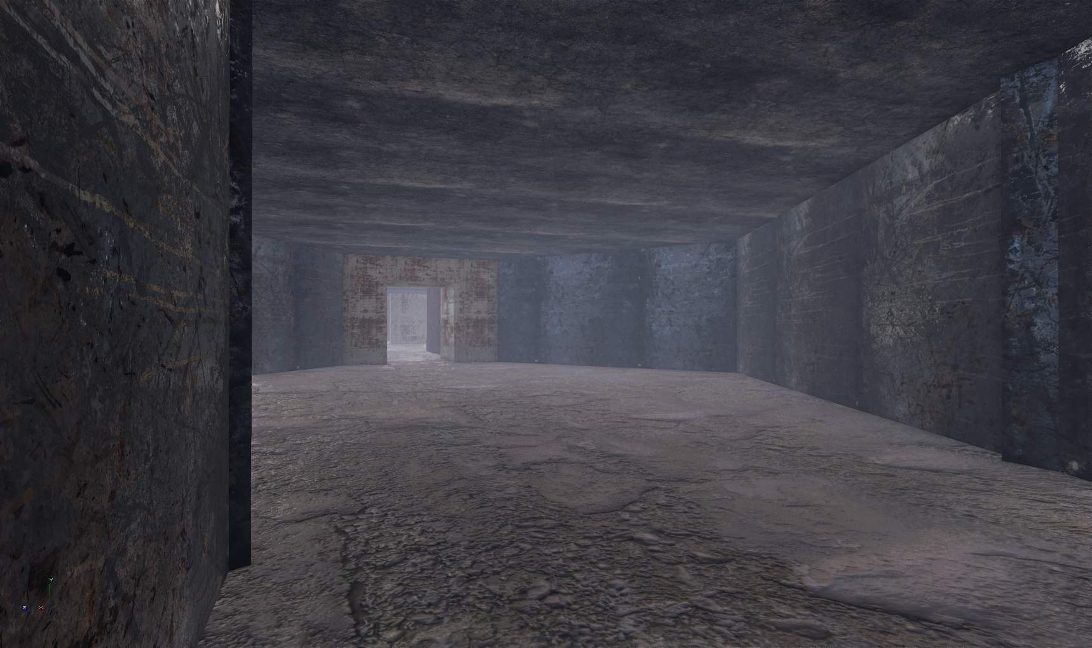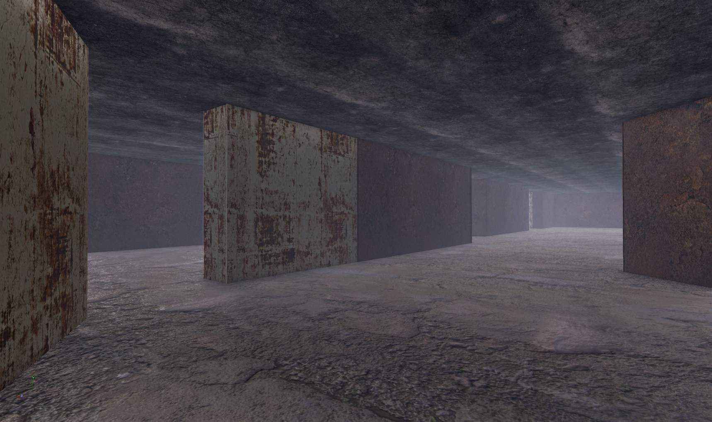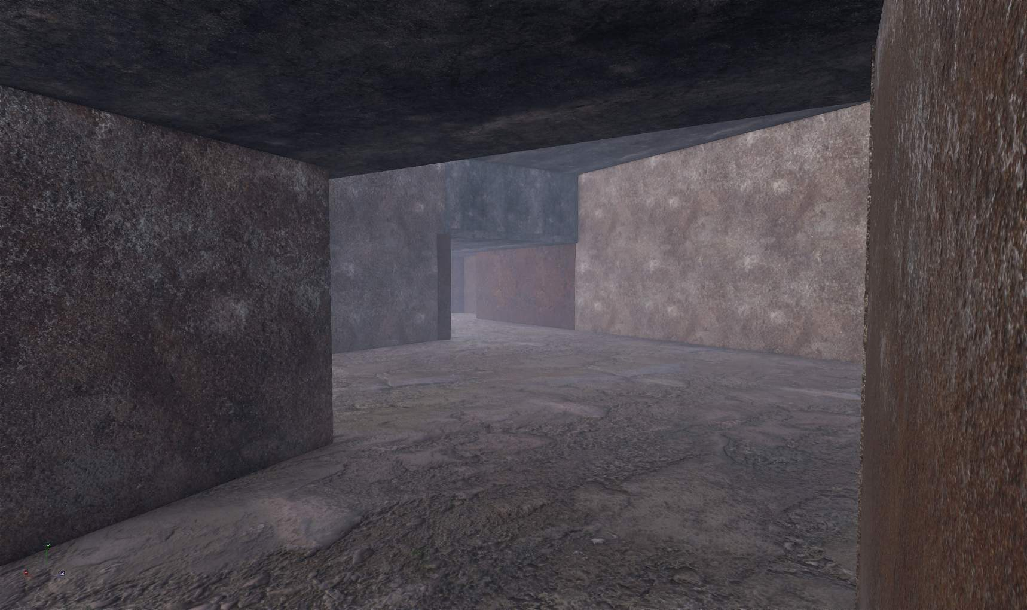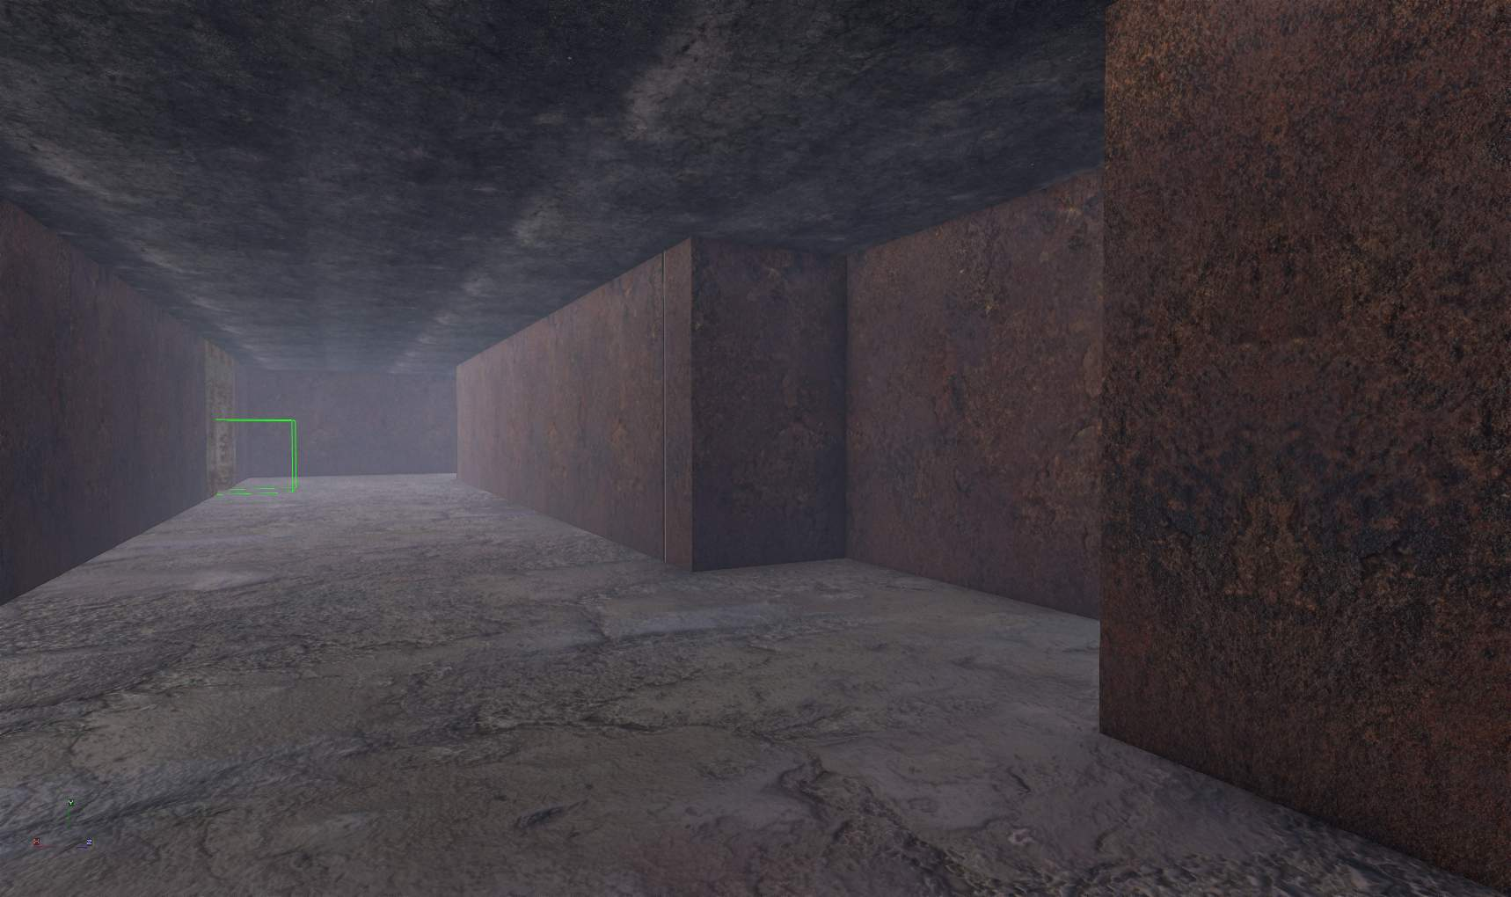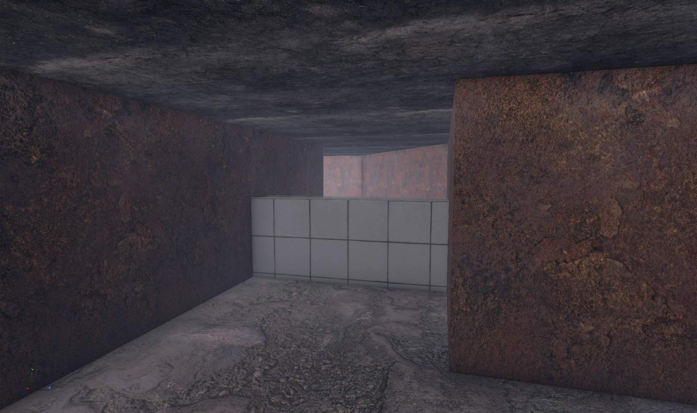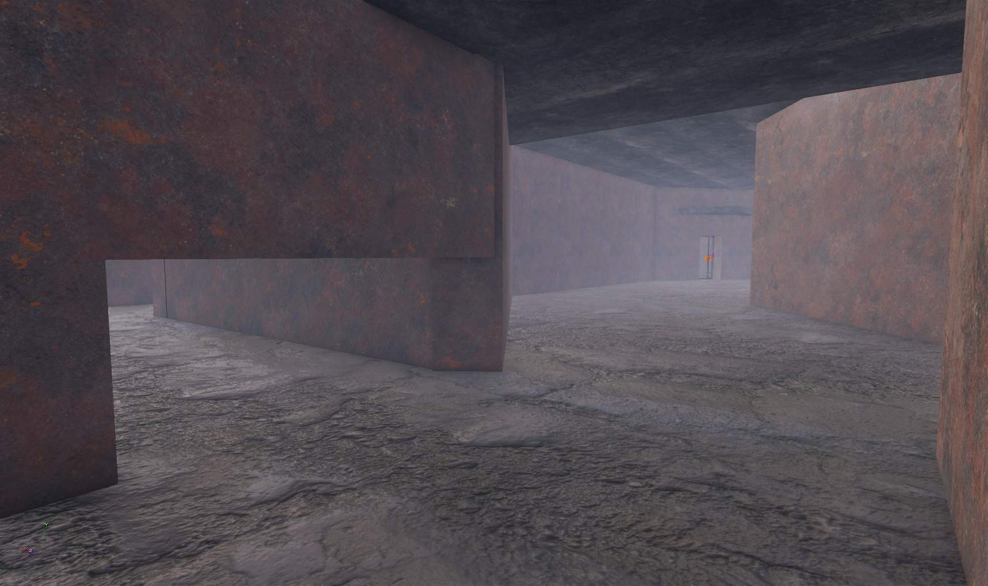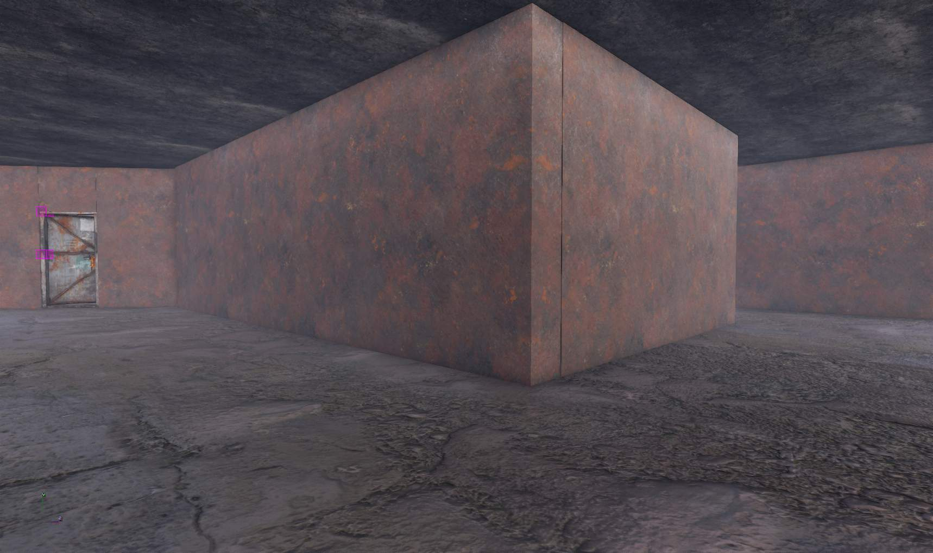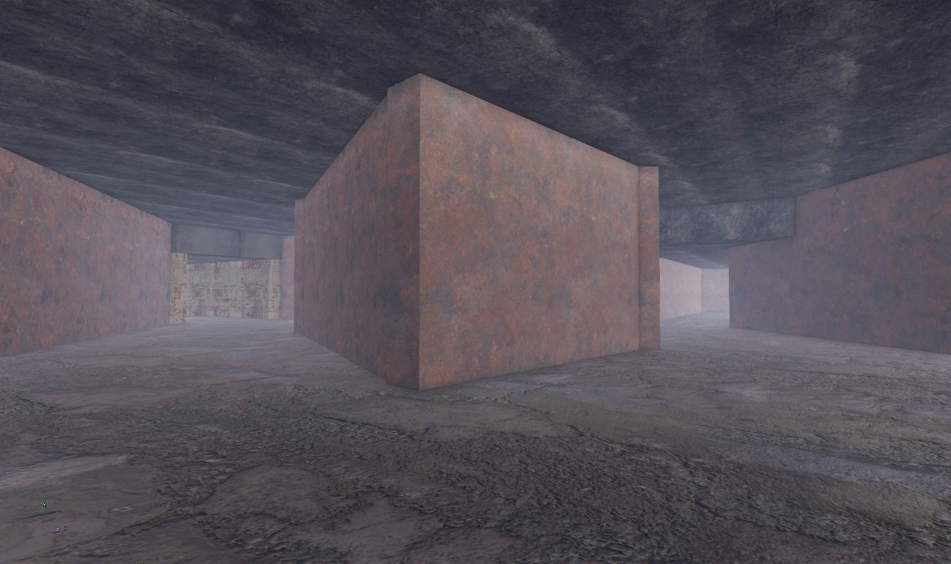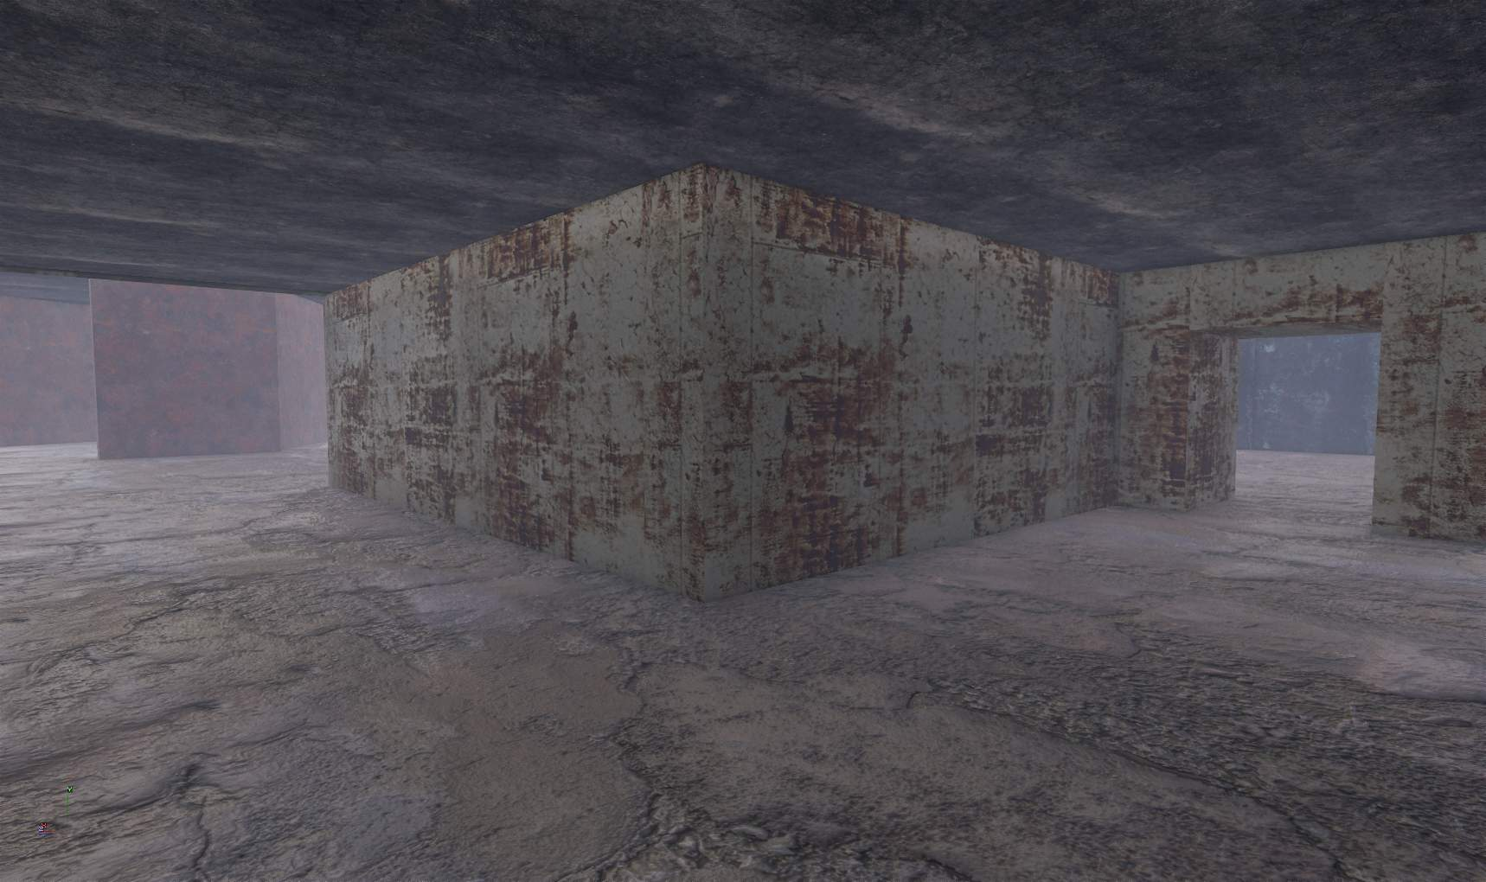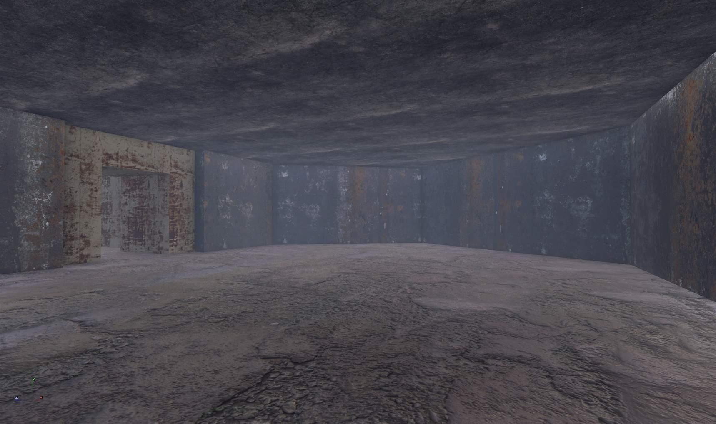

At this point in the project, it was quickly discovered that the SDK was inherently broken. Base game content was not accessible within the SDK ranging from meshes to textures and prefabs with scripting. To get around this issue at first, textures with different materials were used to add some visuals and variety to the level. This issue would later on be fixed but this was counted as a material pass whilst fixes to the SDK was underway.

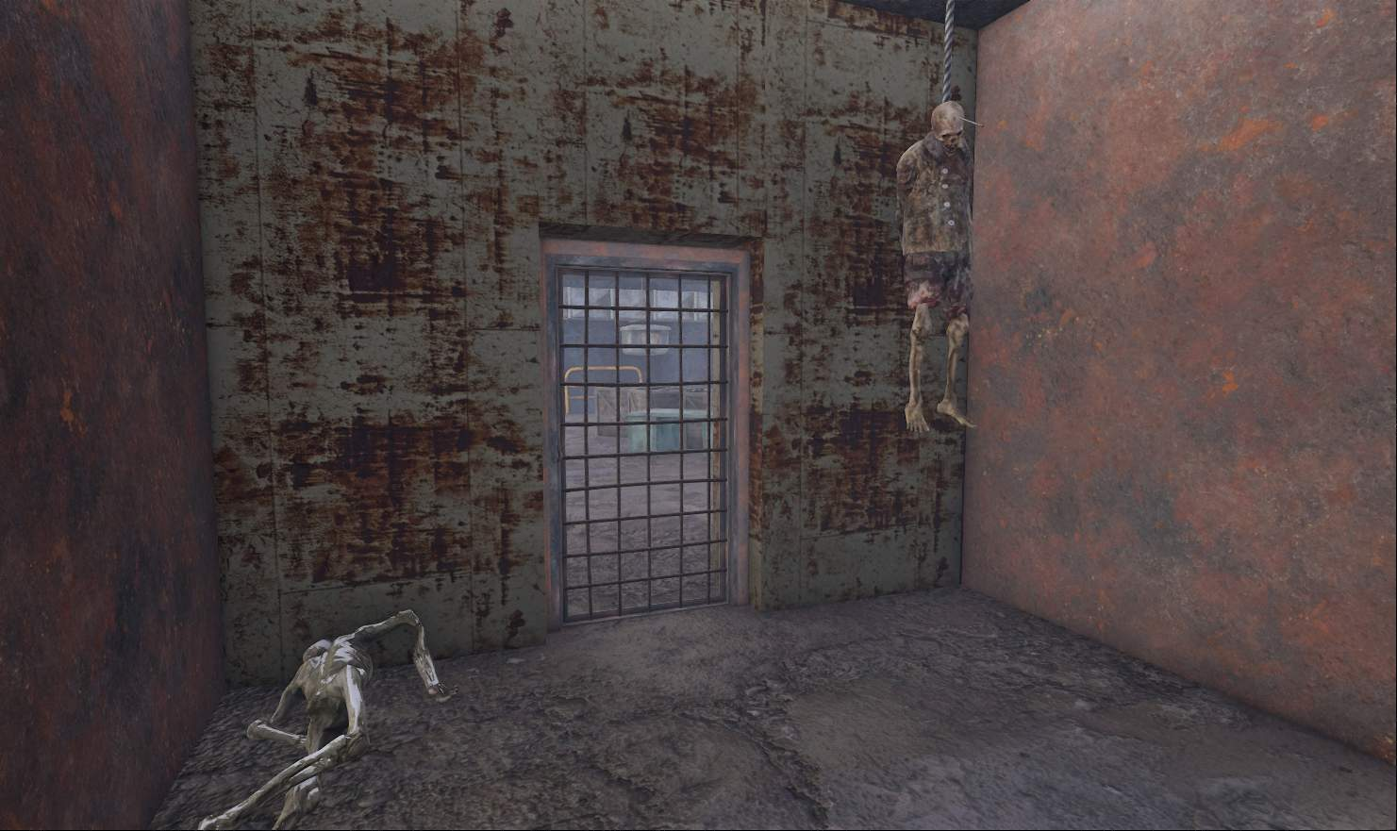
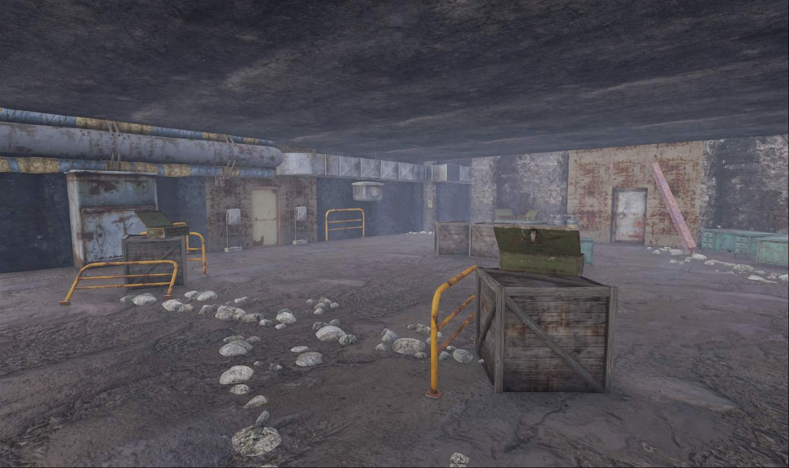

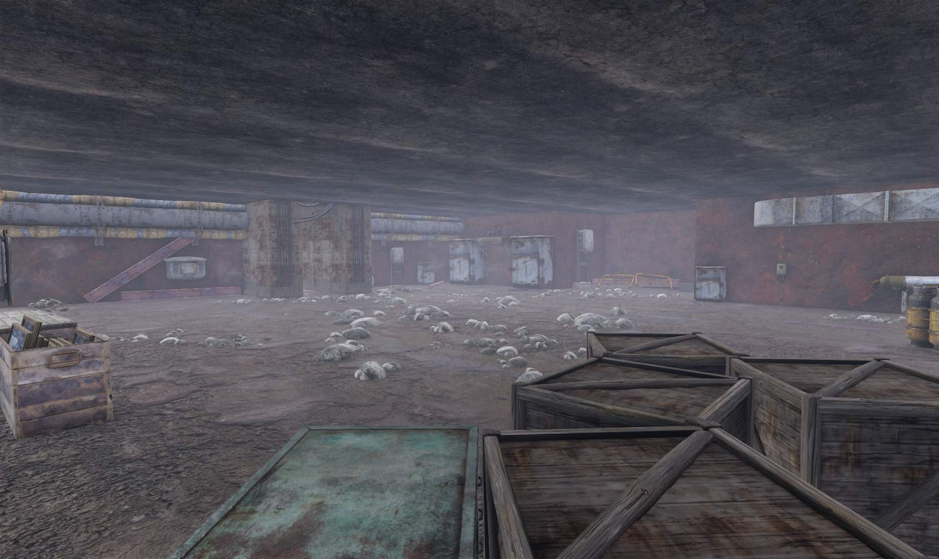
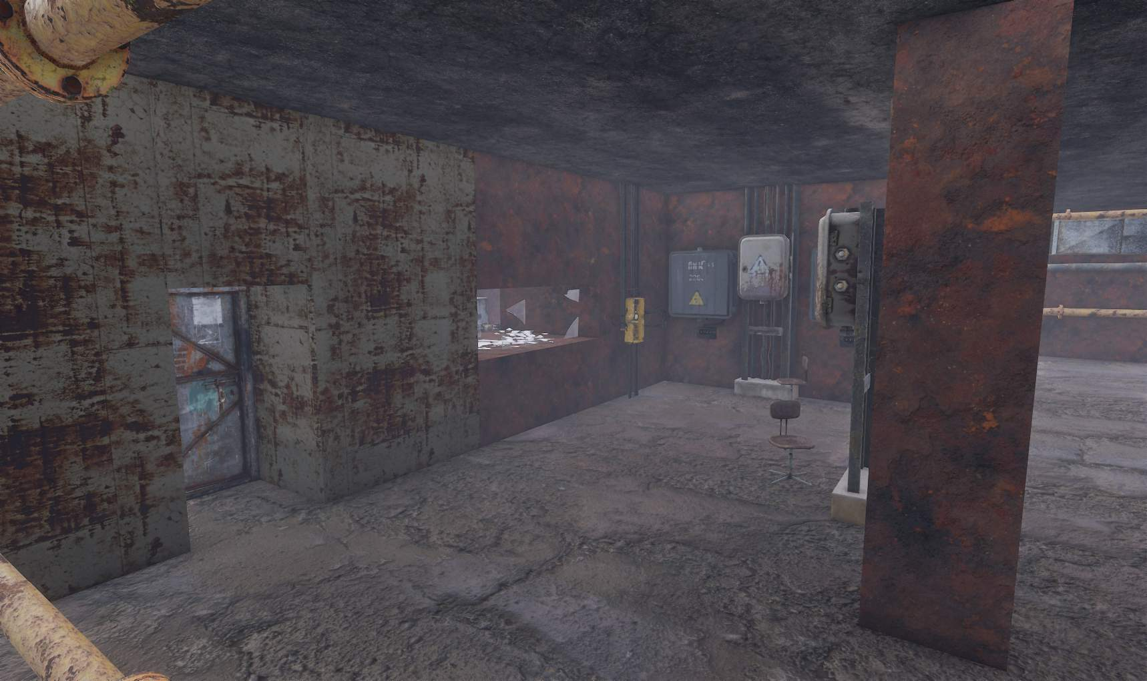

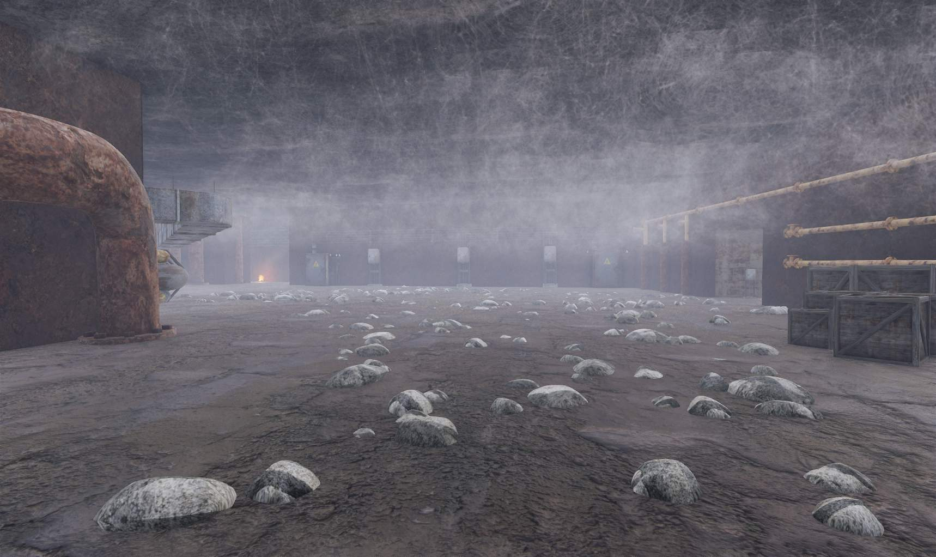
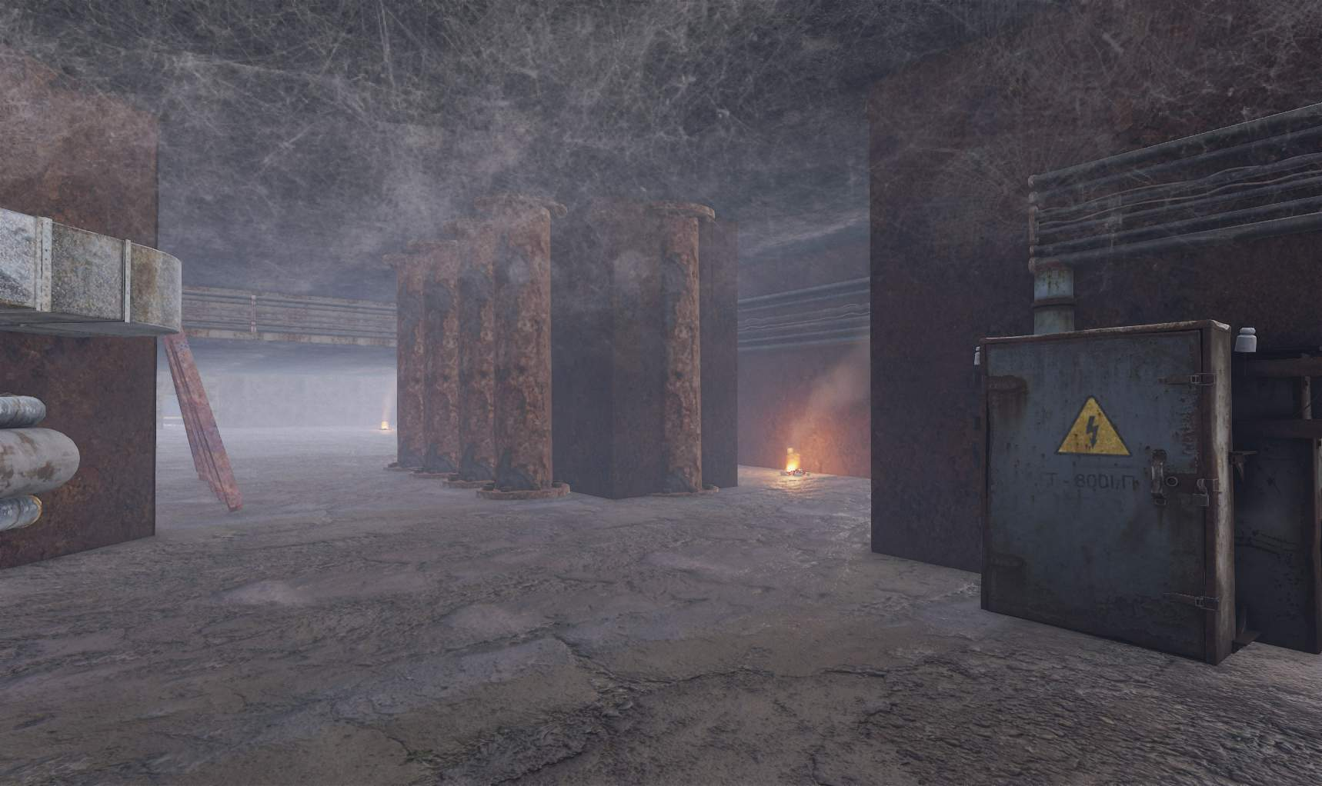

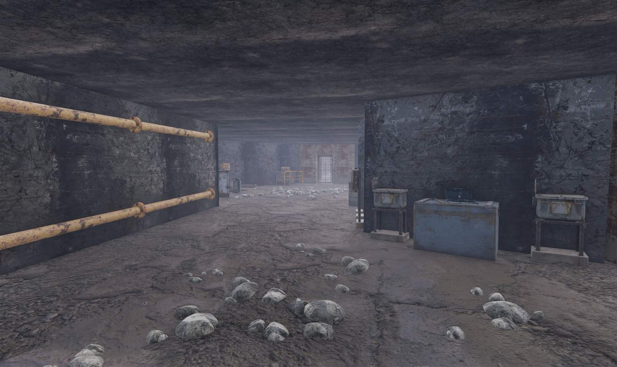
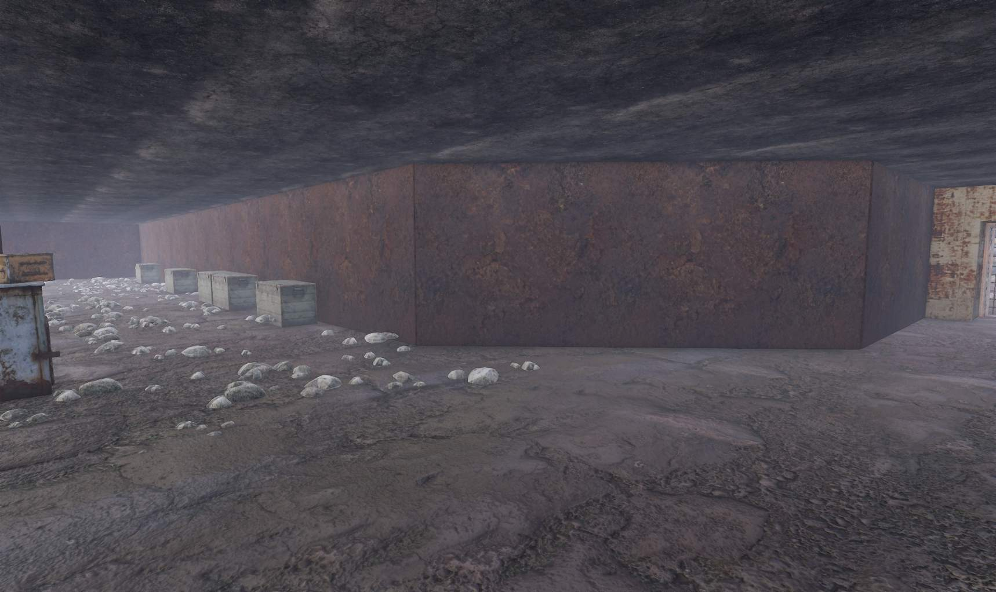

After spending some time looking for fixes to the content issue, one member in the community showed that at the time the only way to fix this was by using 3rd party software to export the FBX and TGA texture files which would then need to be imported into the SDK.
Because this method only worked for single models at a time, one attempted fix was to simply port the entire base game CONTENT folder into my mod folder which worked as it unlocked the majority of the games meshes, scripts, textures and sounds.
At this stage, meshing was underway, using a combination of regular meshes, some meshes with missing CForm (SDK’s wording for collision) for better optimization such as ground pebbles, and lastly cards such as cobwebs in corners and on the ceilings.

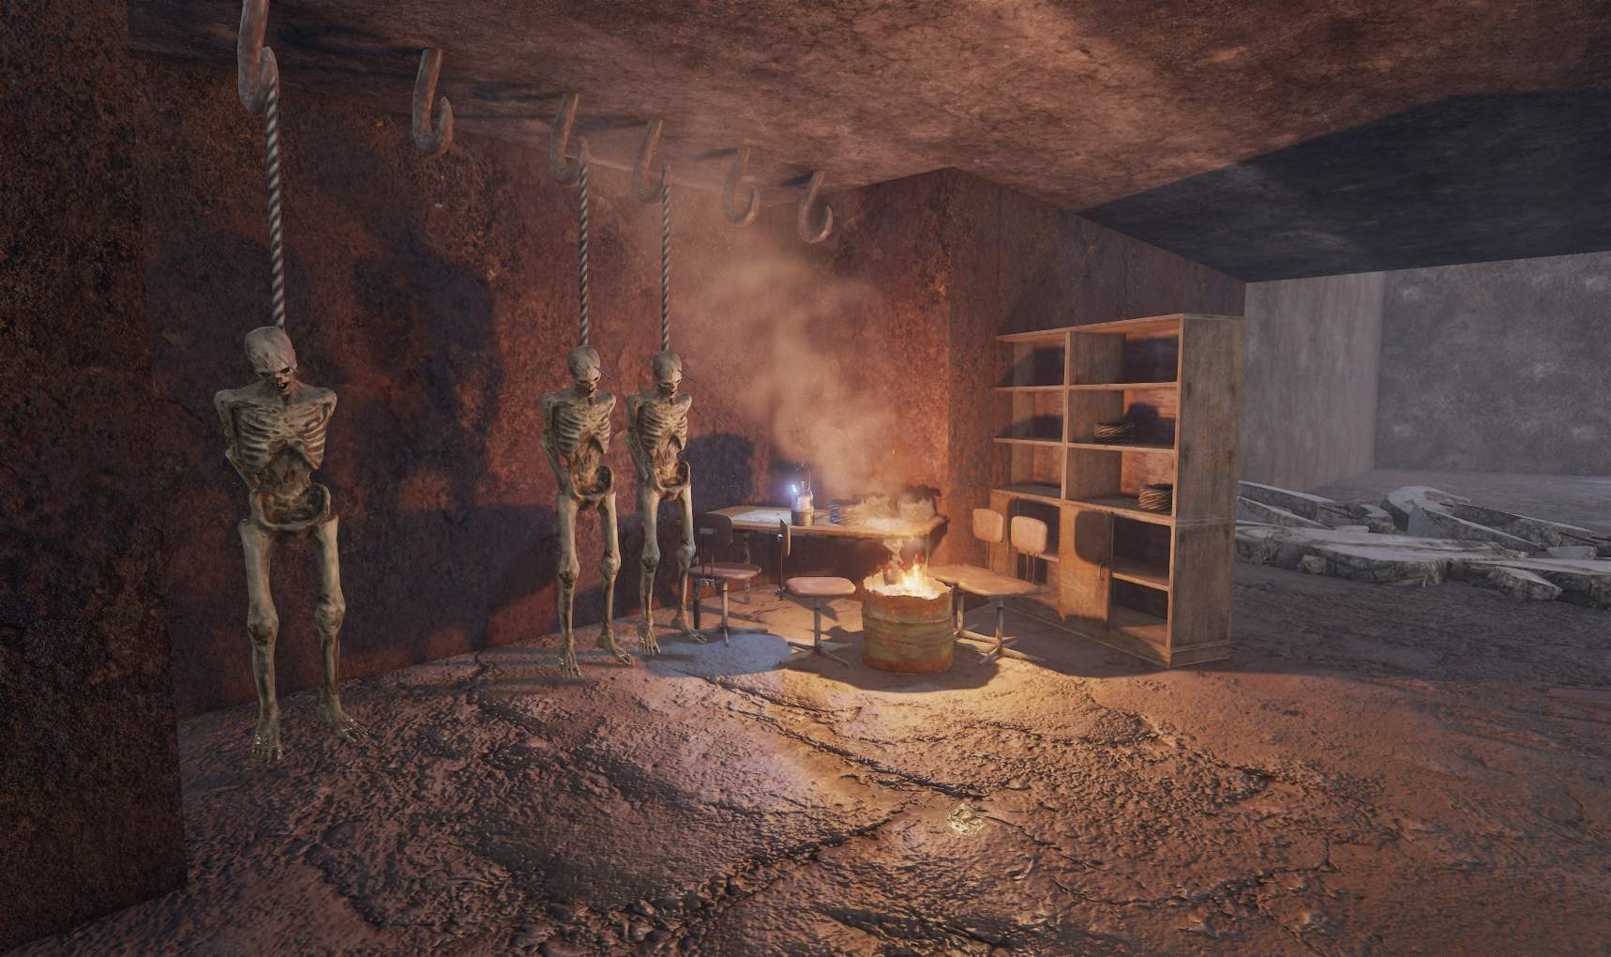
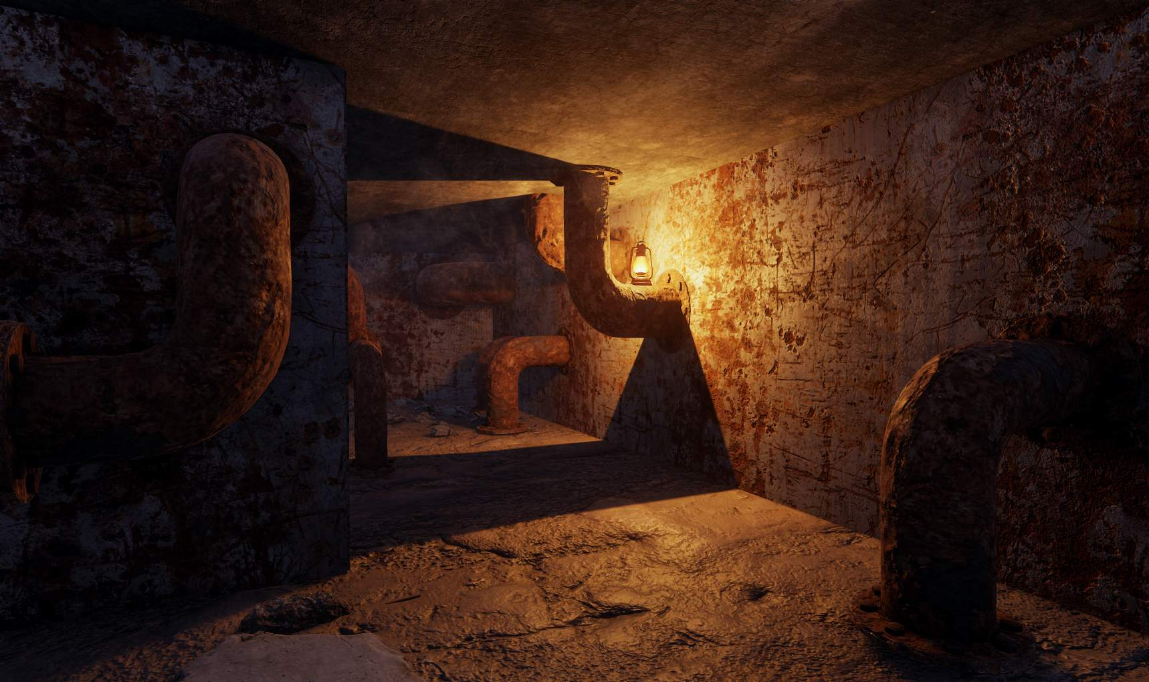

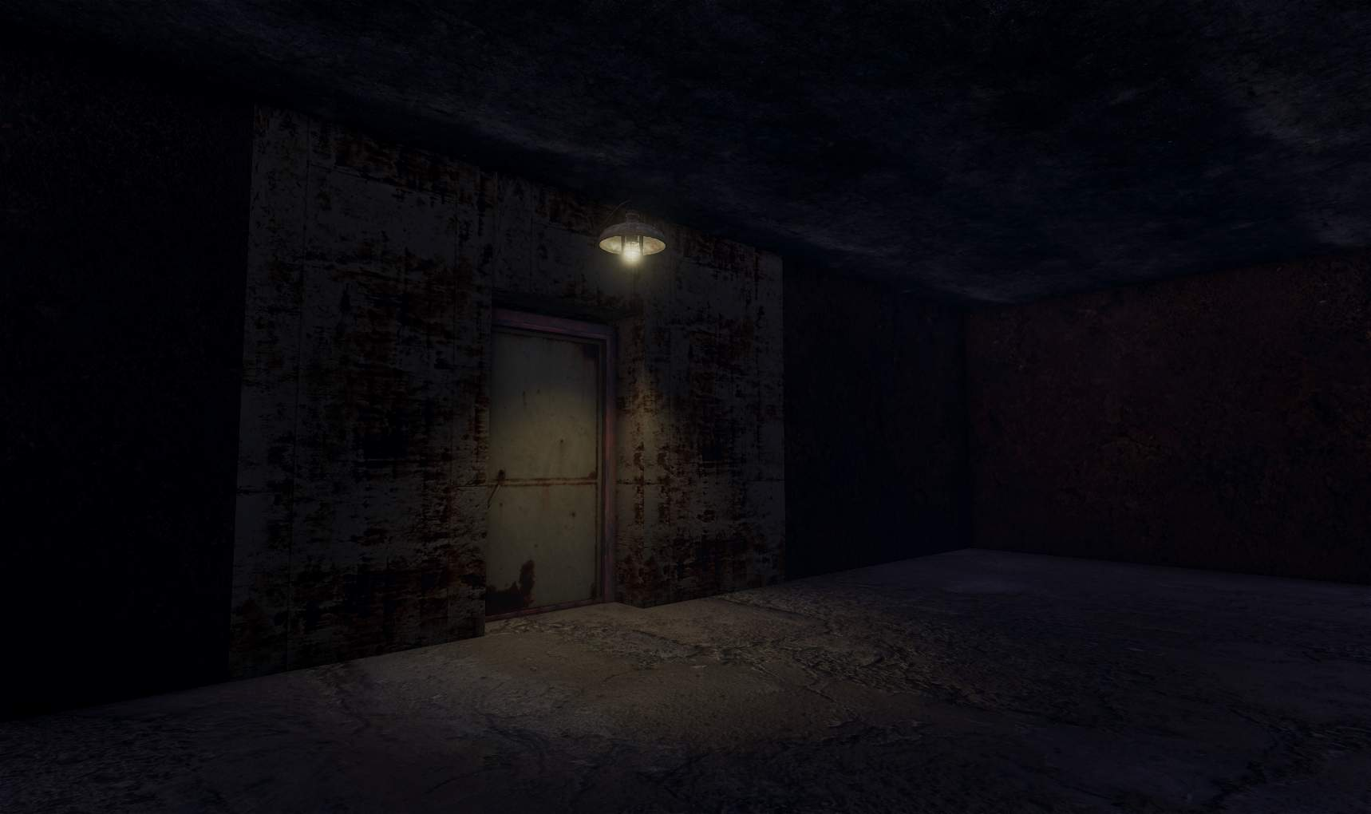

Whilst in the midst of meshing, lighting prefabs were added to test how lighting was compiled within the SDK. These lights had controls for its state, brightness, range and more unique settings such as blinking, interaction from the player and movement from fake wind.
Because of the accurate preview and how it helped to establish the tone of the level, these were setup shortly after meshing was done to give a nice visual indicator of progress.

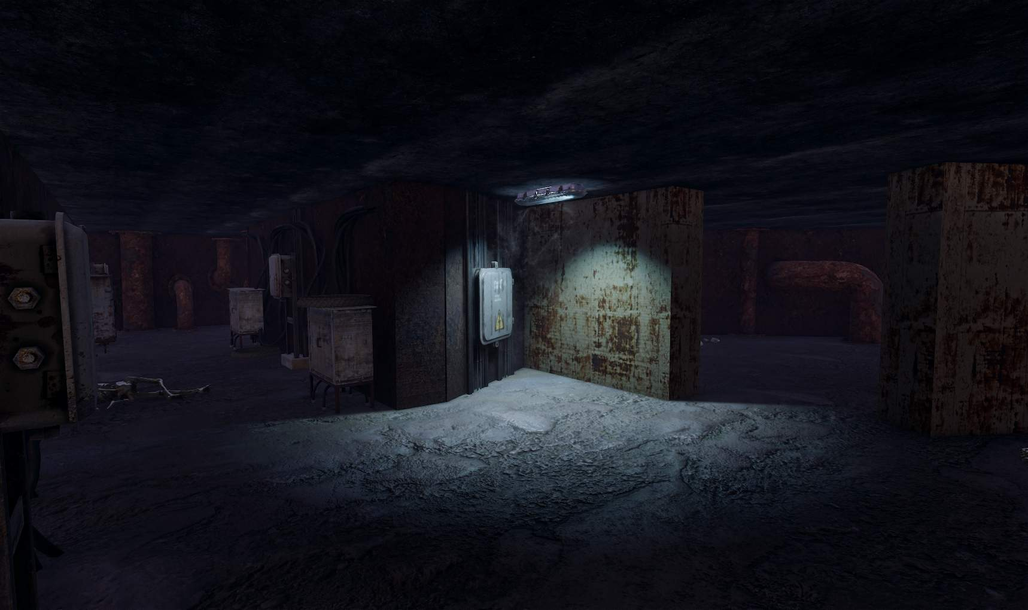
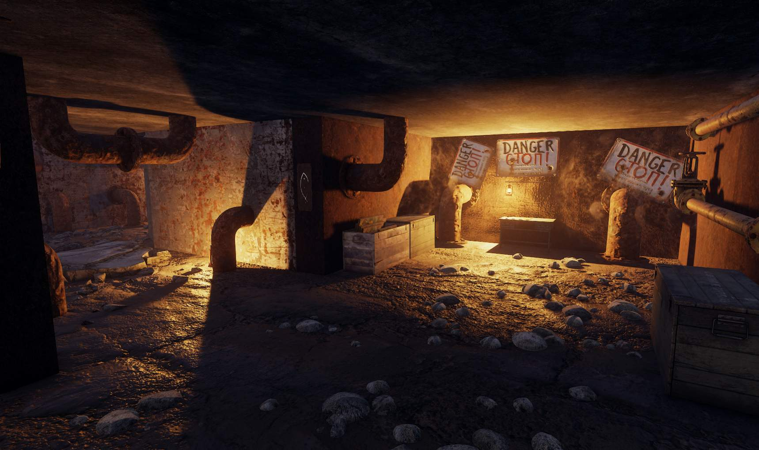

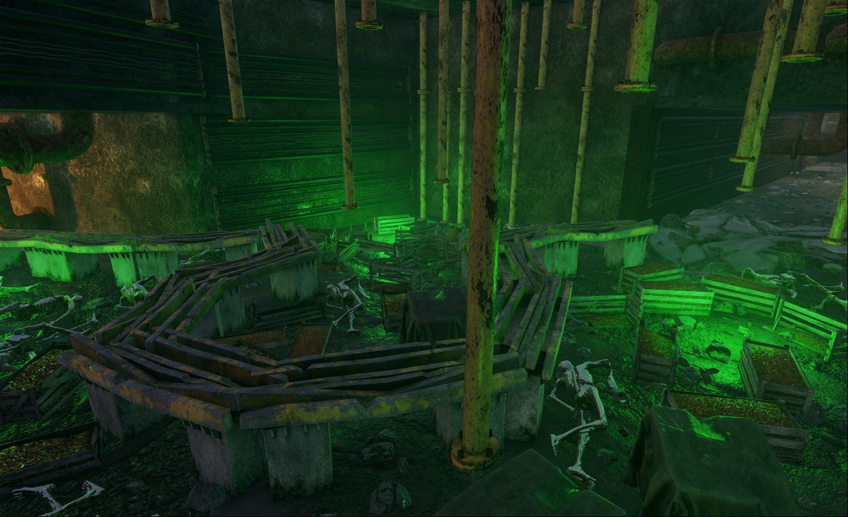
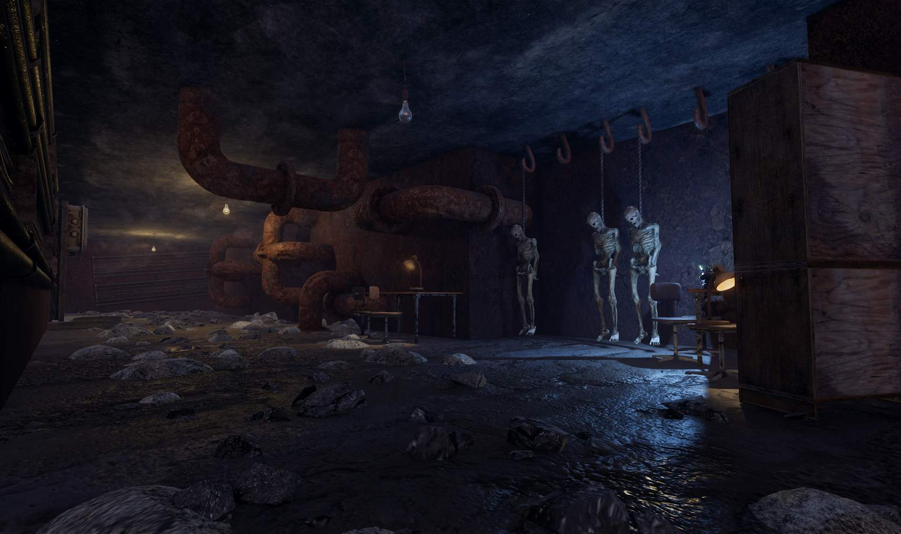

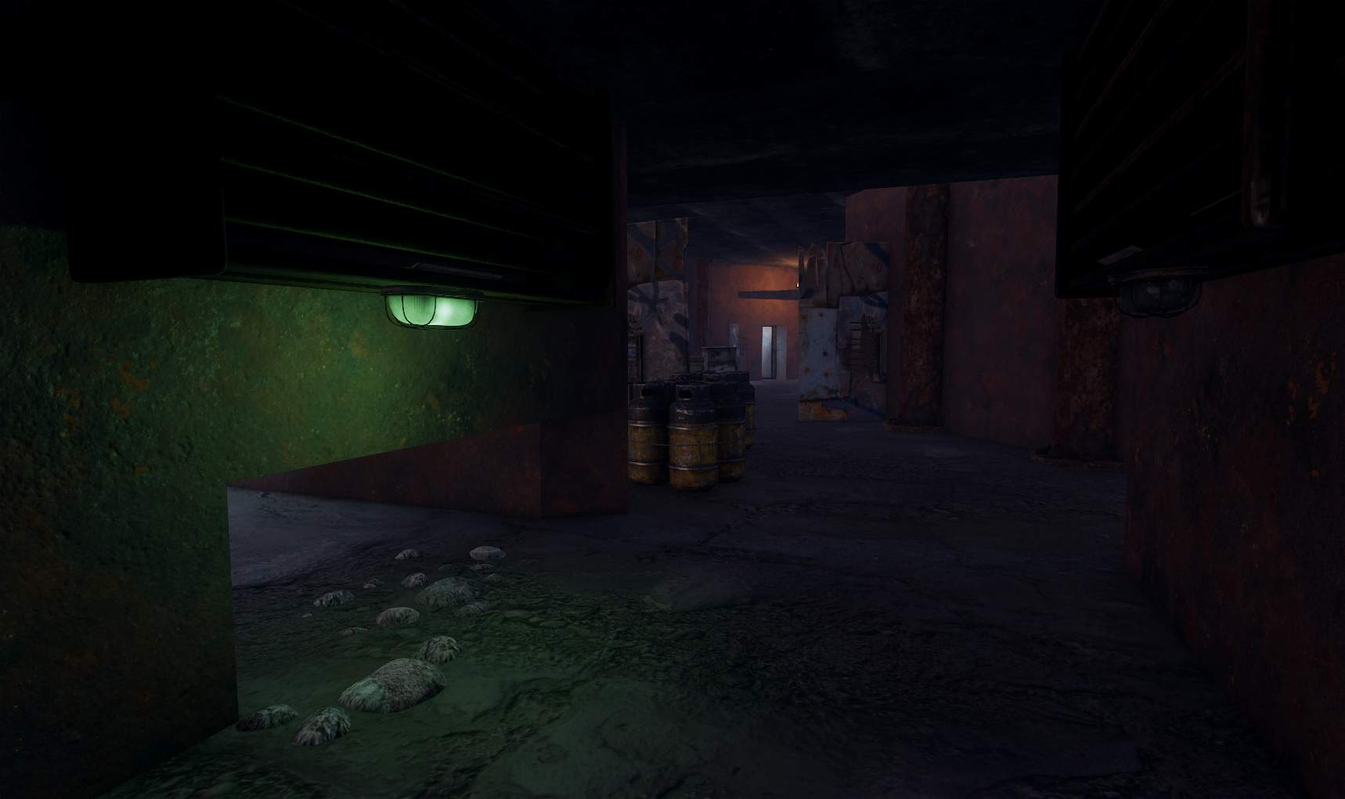
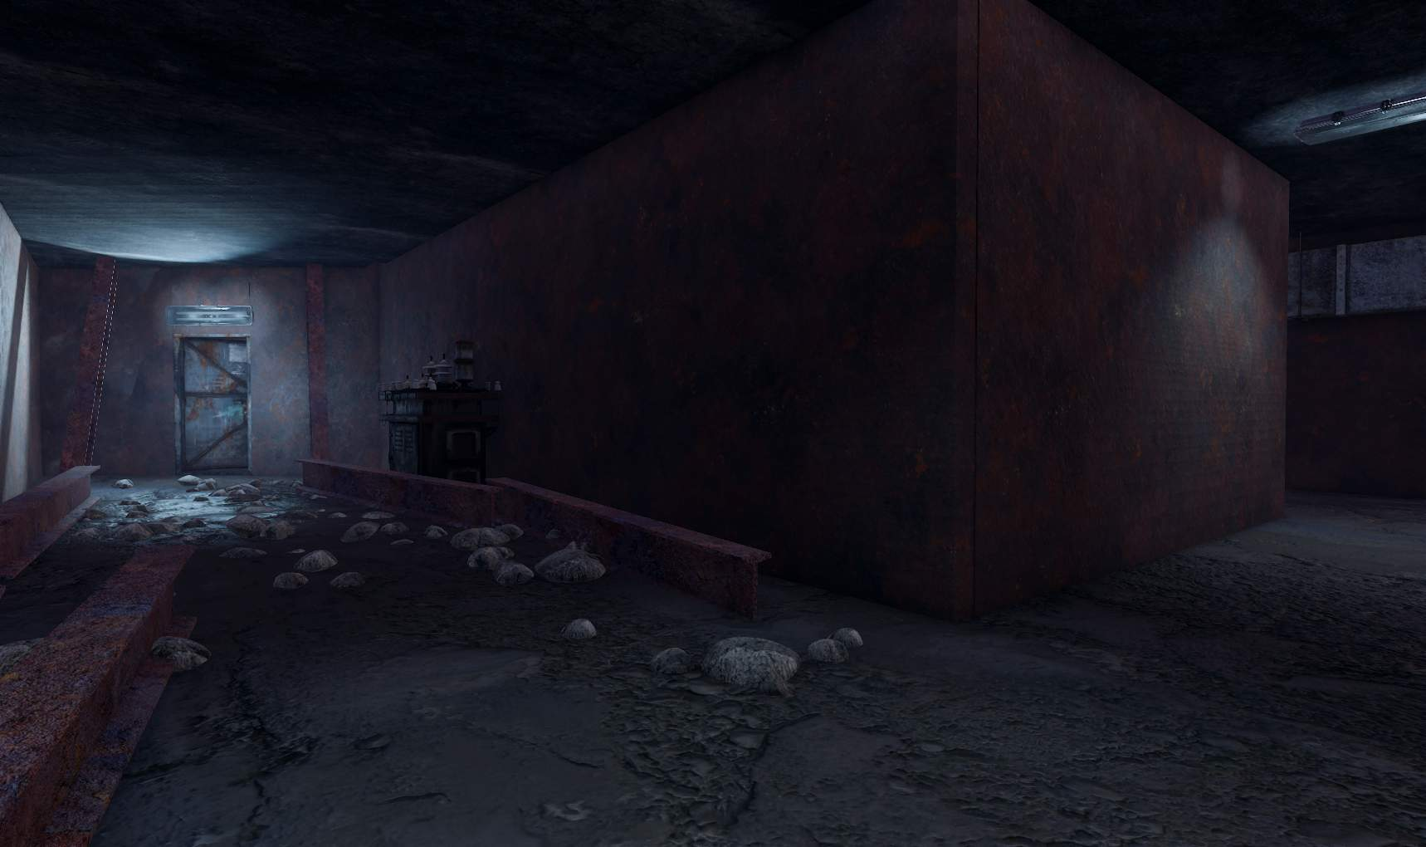

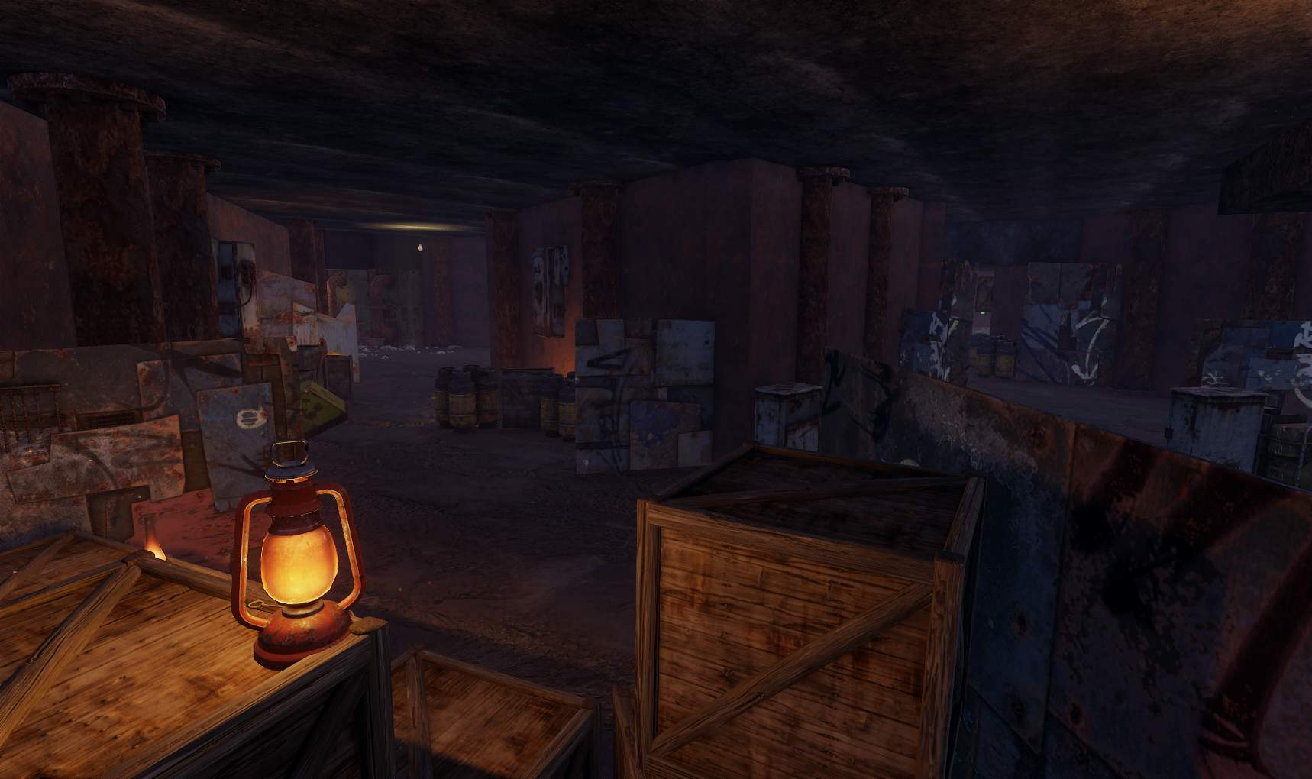
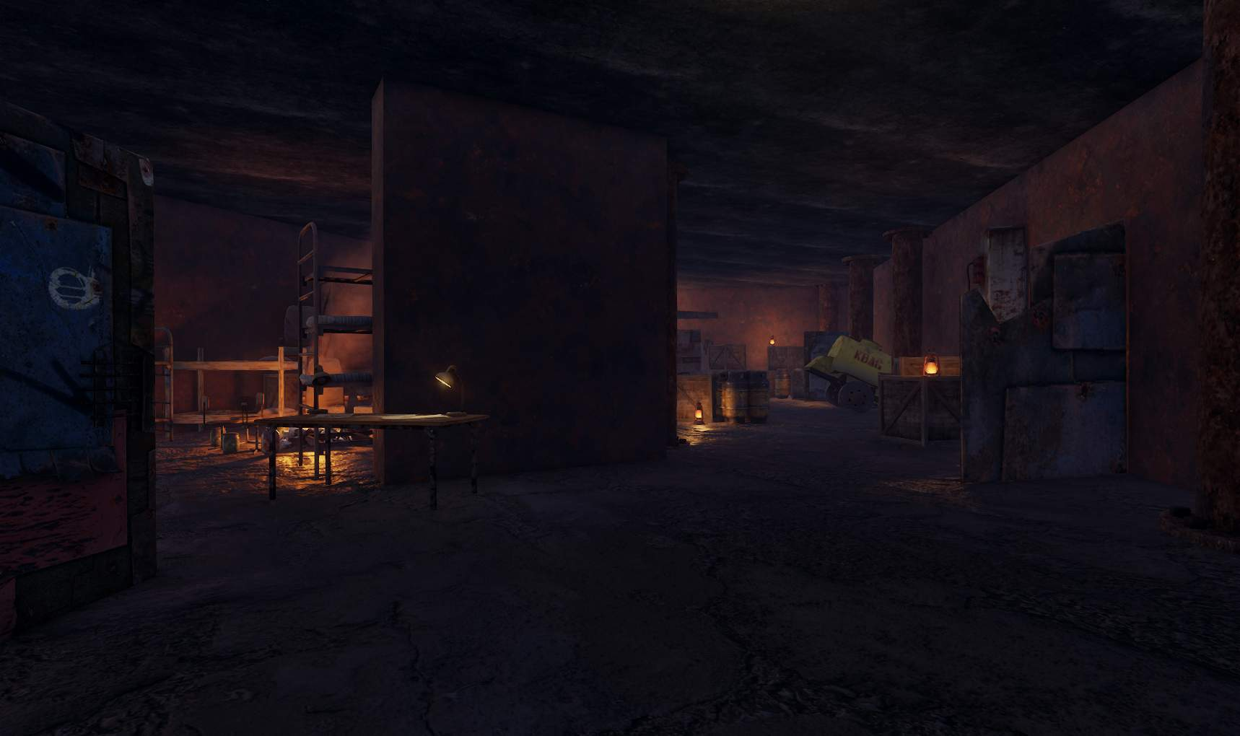
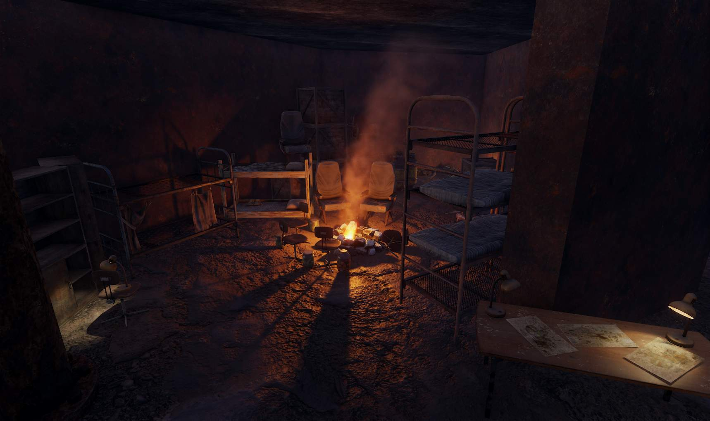
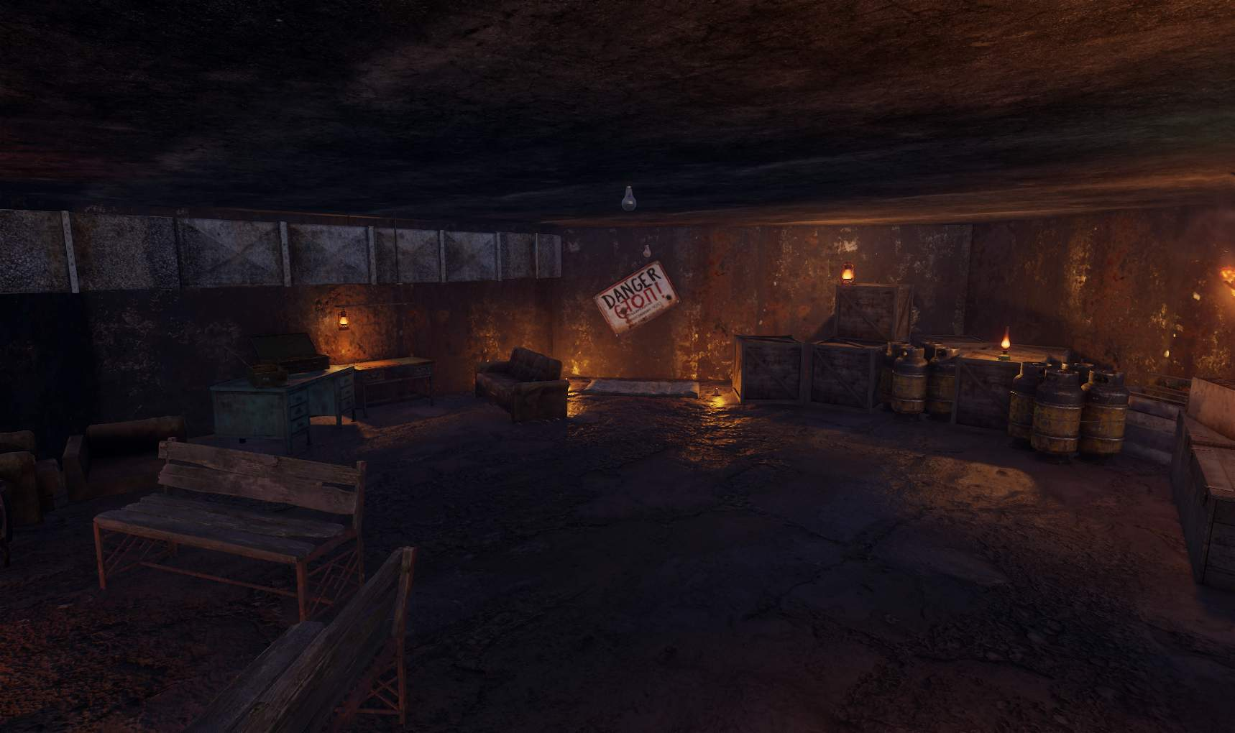

After lighting was introduced, the remainder of the meshes were added including additional elements such as danger signs, bodies and hanging military personal with lighting showing the rope that was used to kill them for additional environmental storytelling.
Some changes that followed after this were tweaks to the safe room (Last image) as it turns out some lighting prefabs had errors due to models not having correct tags which prompted fixable errors from the SDK. This is classed as fixable because there are separate issues such as the game not finding a certain player light and trees not having correct materials despite no trees or vegetation models being in the level.
These meshes were efficient when scaled instead of using multiple references, as fps remained the same throughout the level creation.

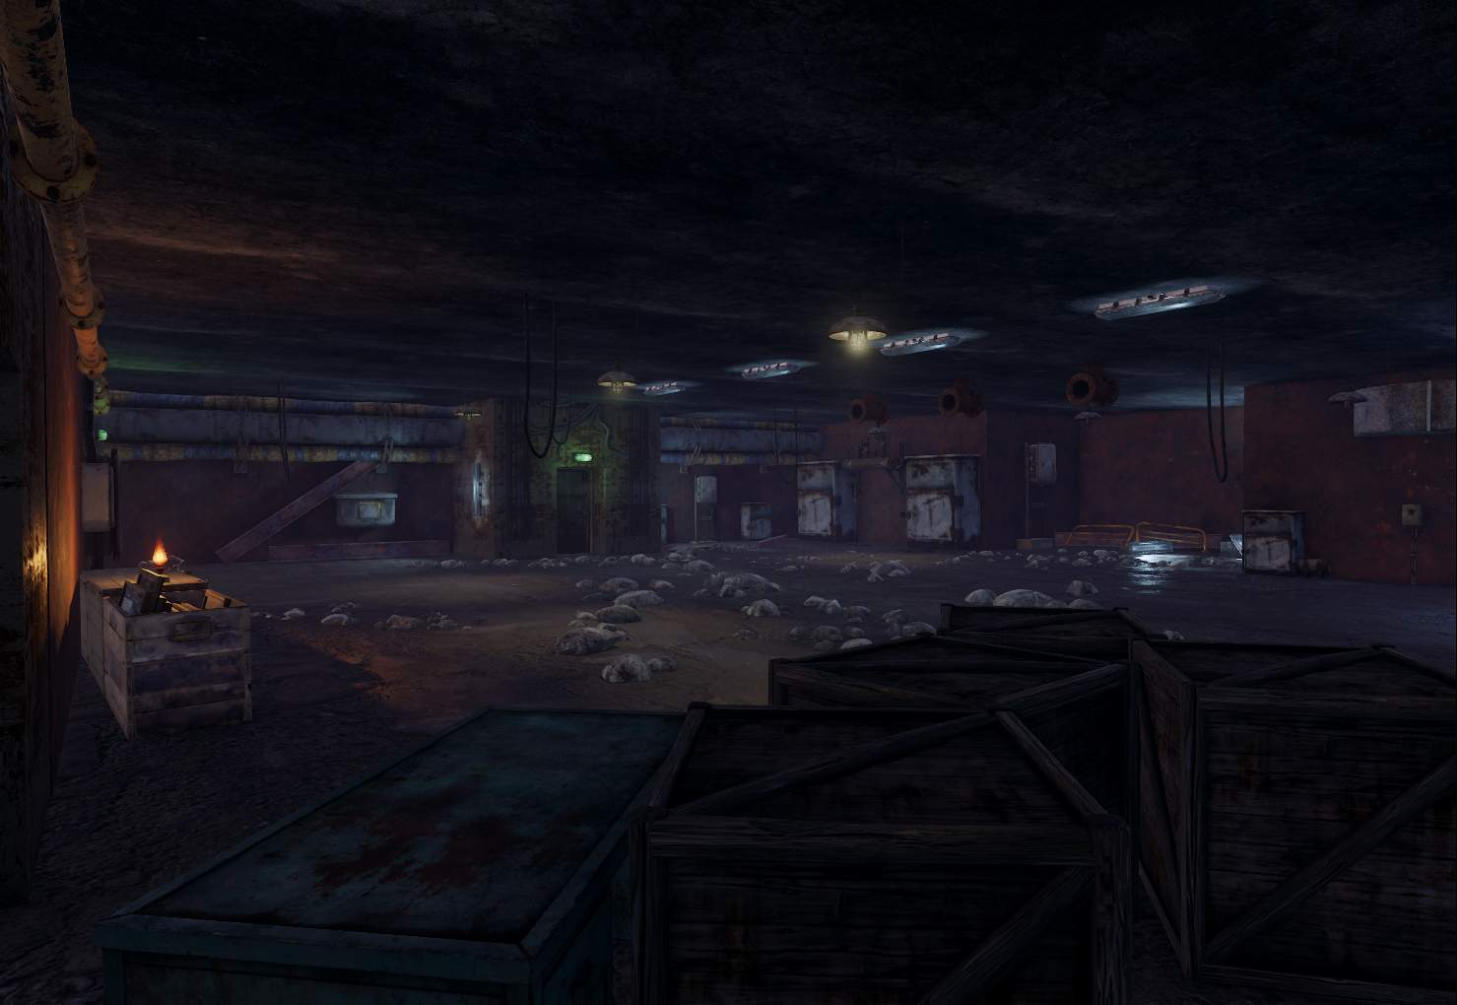
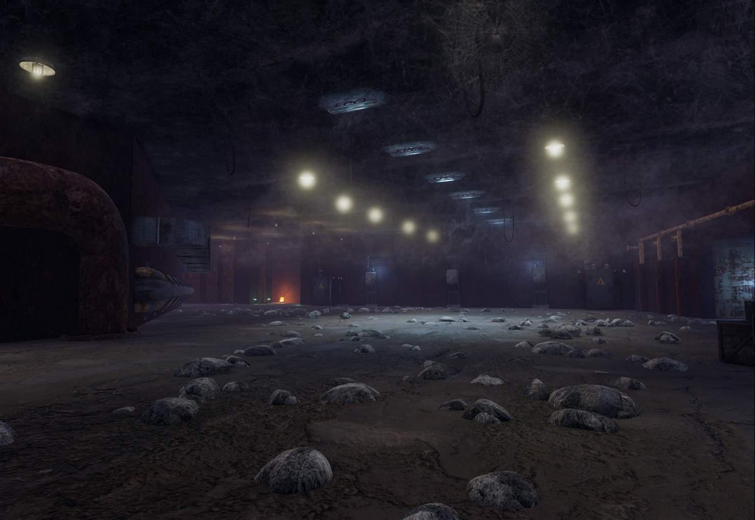

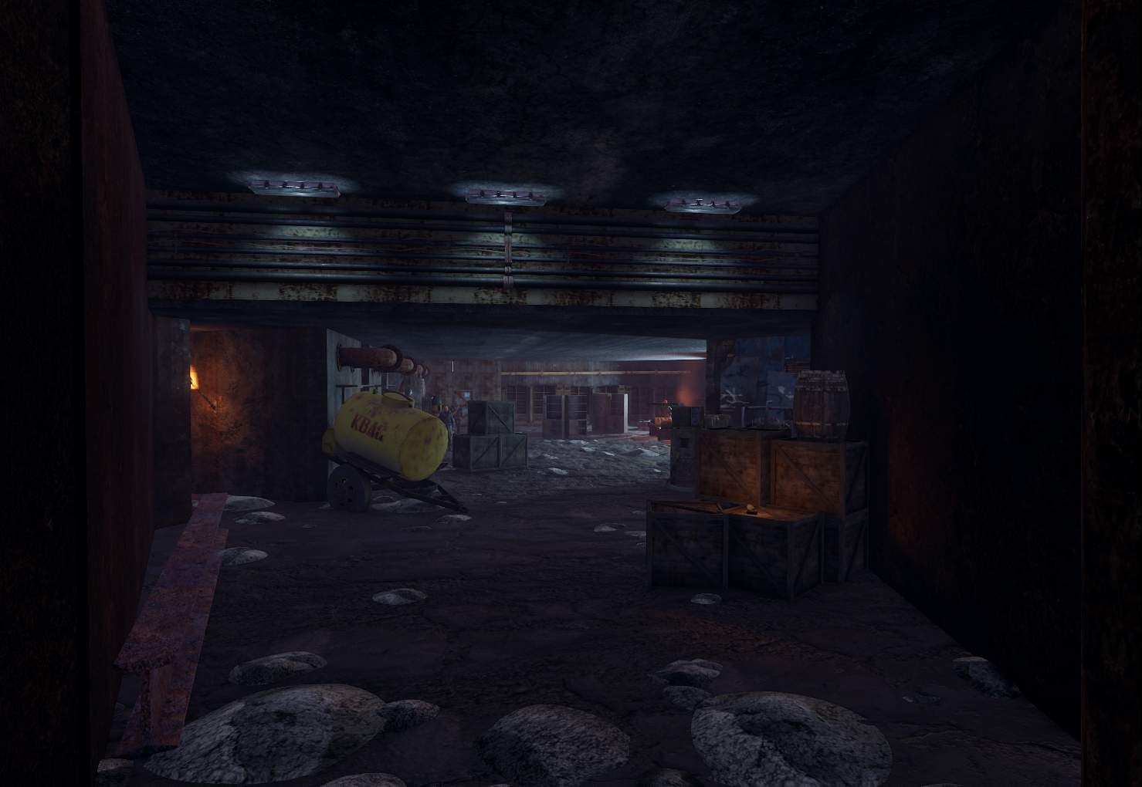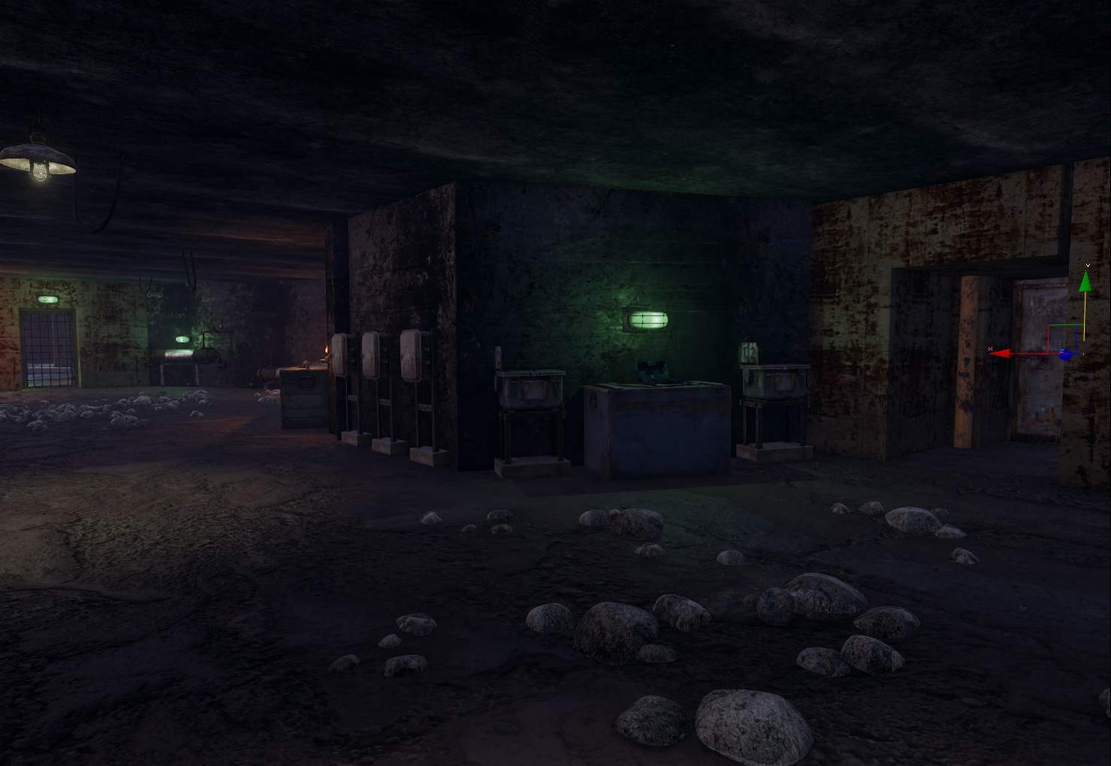
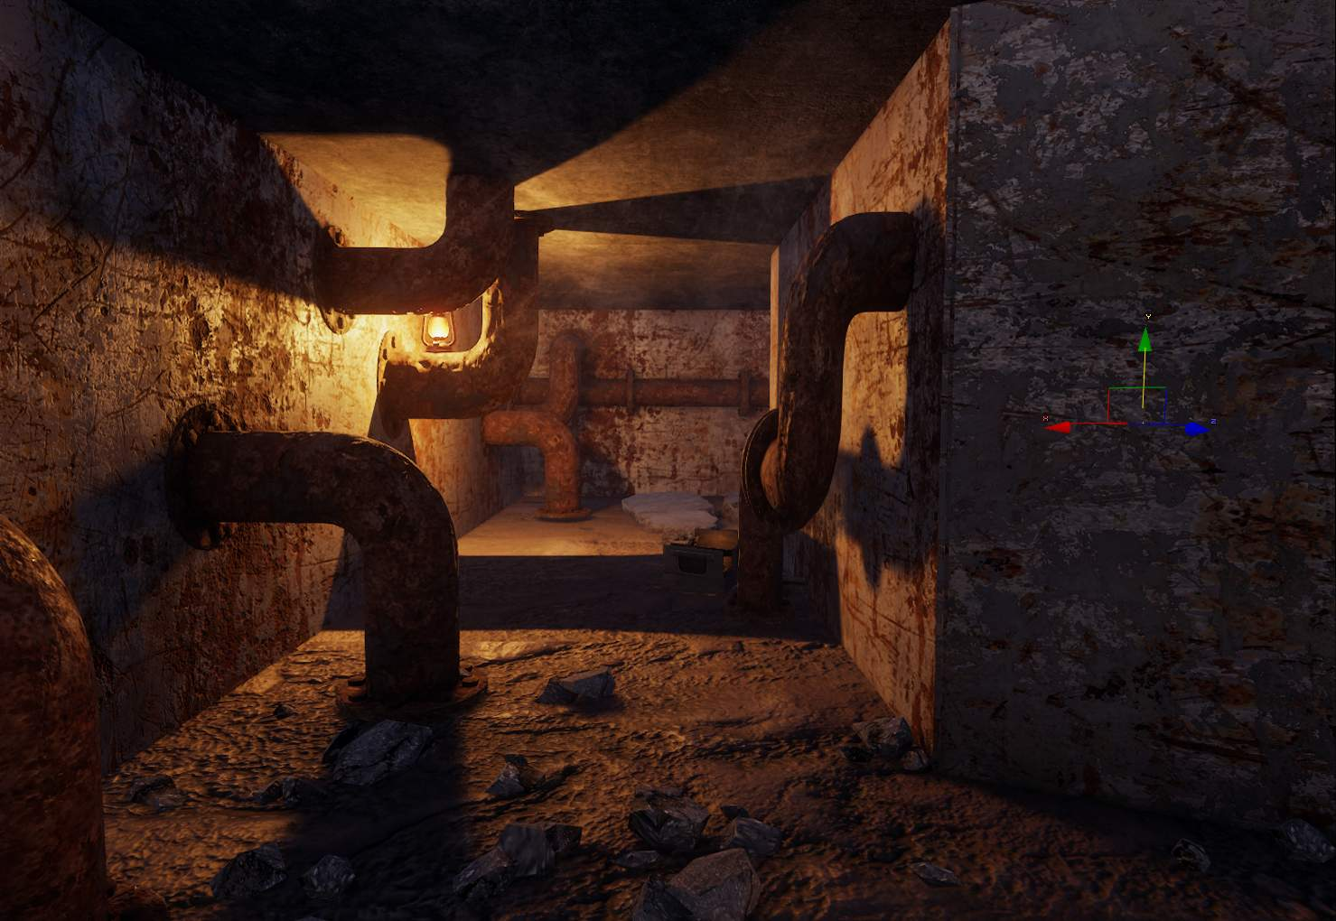
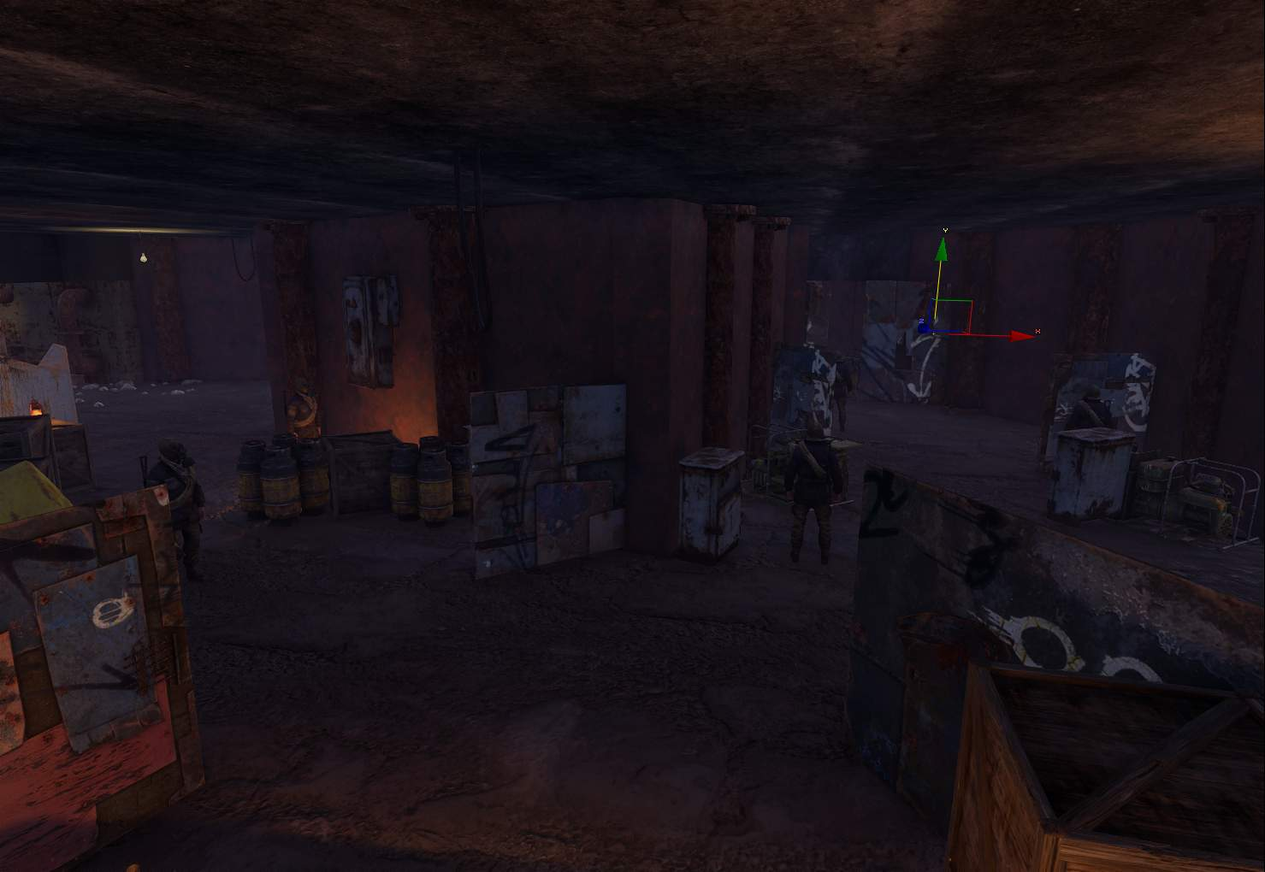
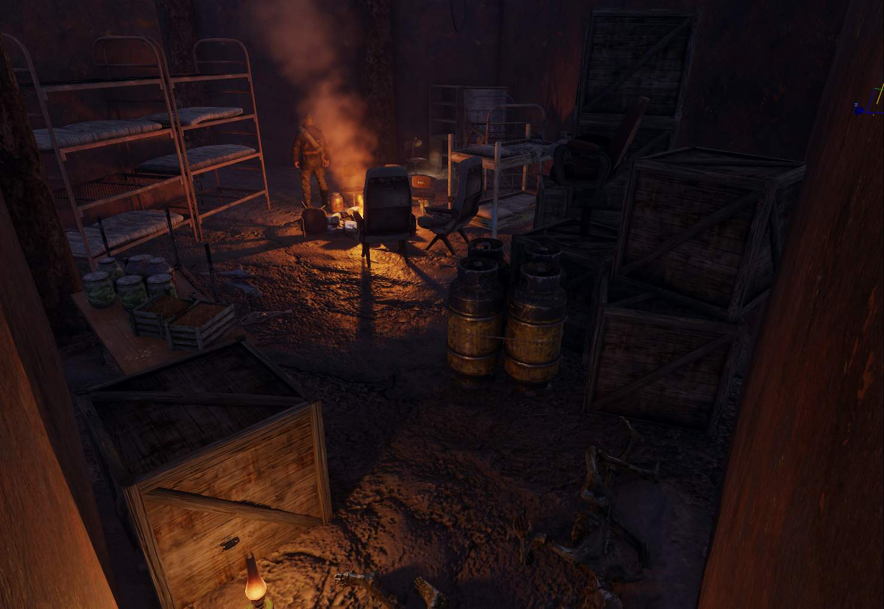
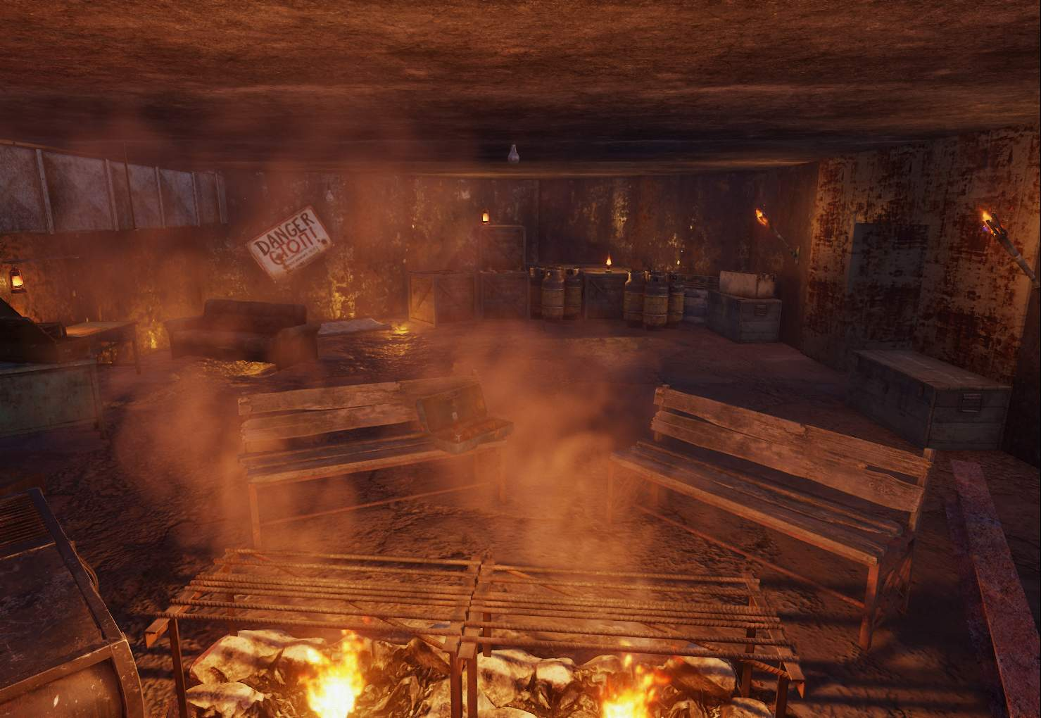

After meshing and lighting were fully done, progress was made on the devices and scripting of the level itself. Custom visuals scripting was done by using preexisting scripts and adding them into their own VS such as the level end in the safe room.
Other examples of this were using restrictors that acted as the makeshift poison room, alongside gas zones. The SDK’s logic is that restrictors act as triggers which then communicate with VS which led to some issues as restrictors had set triggers which did not support custom code, but this suited my level nonetheless.

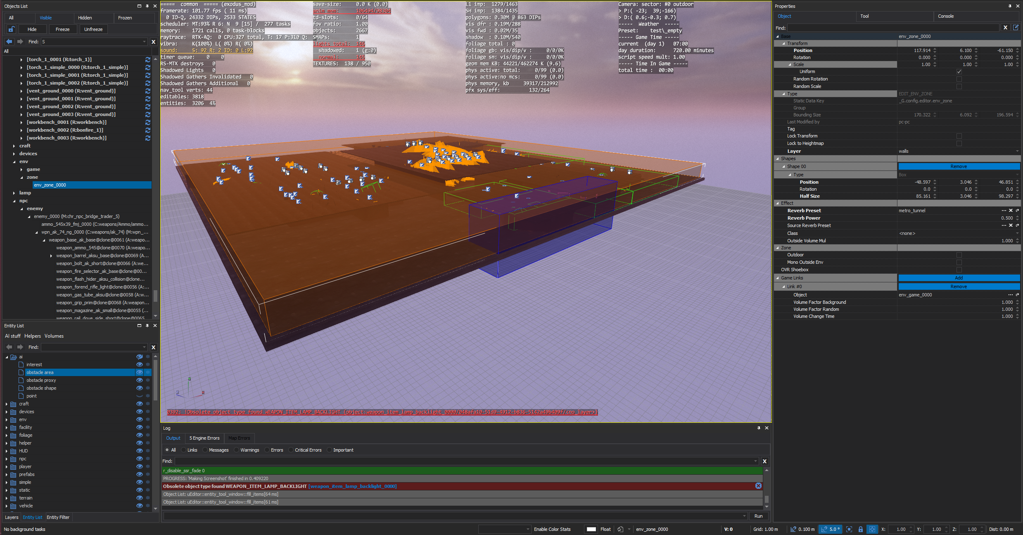
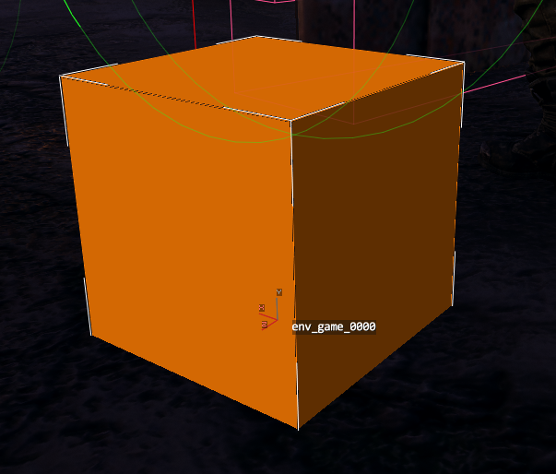
Other devices such as sound were added by placing an env_zone around the level which communicated with the env_game, giving it a reverb preset of an interior tunnel which then worked with custom sounds that were played randomly from env_game to build up the atmosphere and improve immersion in a similar way to previous metro games.
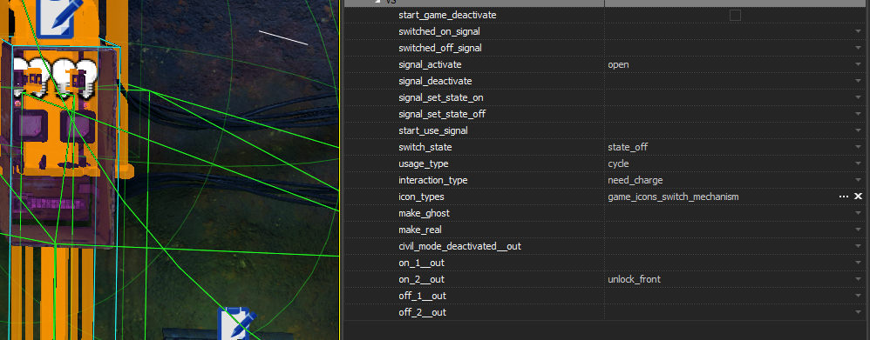
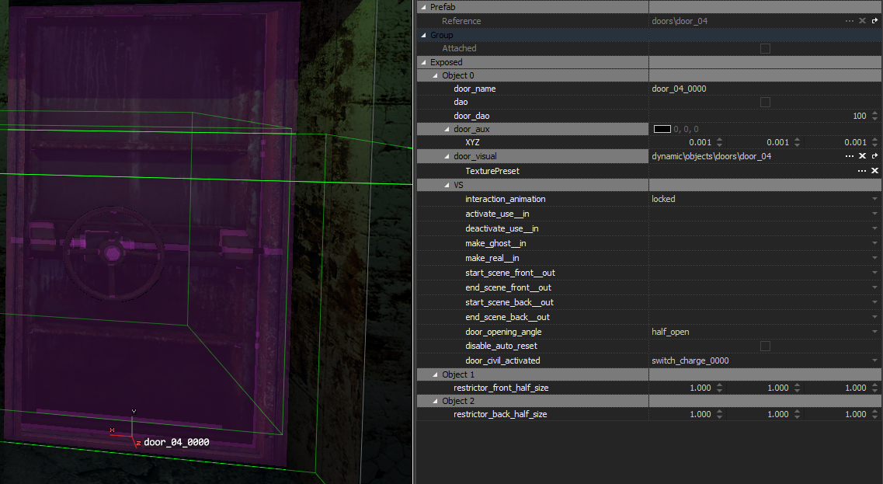
Switches for powered doors were also added after going through the list of triggers and using unlock and power options. This meant that players couldn’t skip the door and are required to hit the switch to learn more about shooting and jumping.
Monster jump scares were added after interactable doors tying into the environmental storytelling whilst adding additional tension into the level. These monsters would also chase the player after the QTE ended for better player interactability.
Due to limitations within the SDK, AI nav meshes need to be added by hand into the level. This was done by swapping to the navigation mode and manually spawning in tri meshes without having these intersect. On top of this, obstacle areas and points were added to tell AI where cover Is as well as patrol points for the enemies to roam around with. However this had issues of its own documented in 4A’S AMAZING SDK.

4A’s amazing SDK…

- Navmeshing – manual navigation maps needed to be added by hand on top of adding in cover and patrol points, which even then do not work properly as AI walks through meshes regardless of obstacles which can leady to janky gameplay.
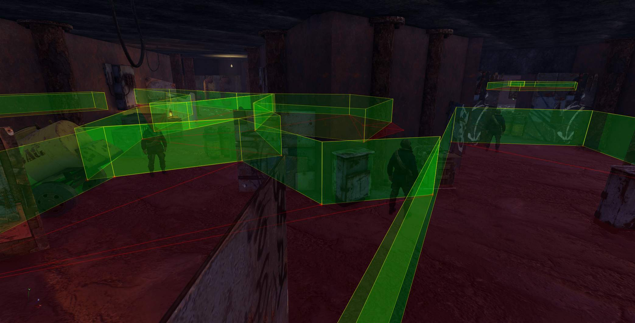
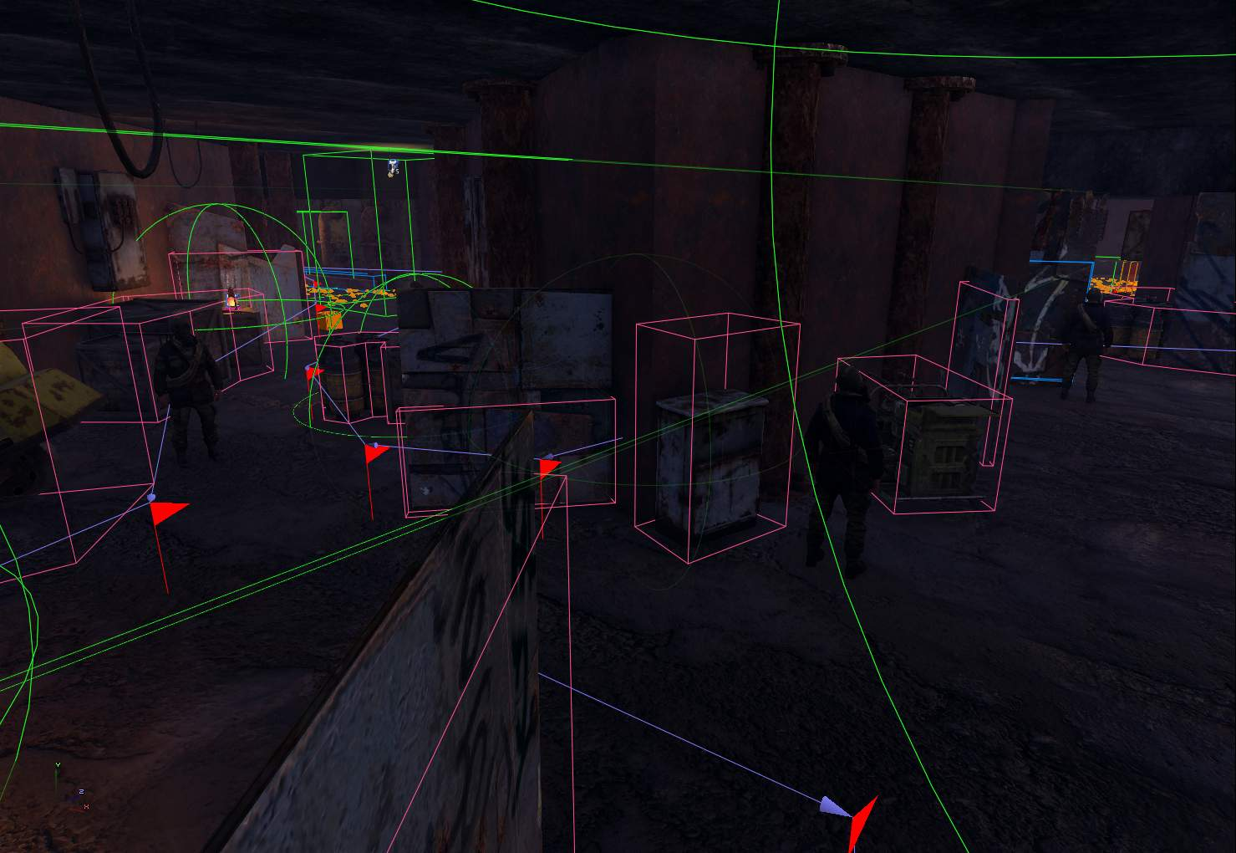

- Broken crafting system leads to broken workbenches – Because the base crafting systems are broken within the in SDK, the workbenches used to craft items and ammo from resources is disabled by default which was not made explicitly clear.
- VS and restrictors – Visual scripts are often dependent on restrictors, but these restrictors often have pre set triggers which requires more custom code to get this to work with VS’s, example of this is the level end that does not seem to properly trigger the ending. This was described as an issue and designed around but prefab code does not work due to this logic.
Blue is VS and the green is restrictor collision box.
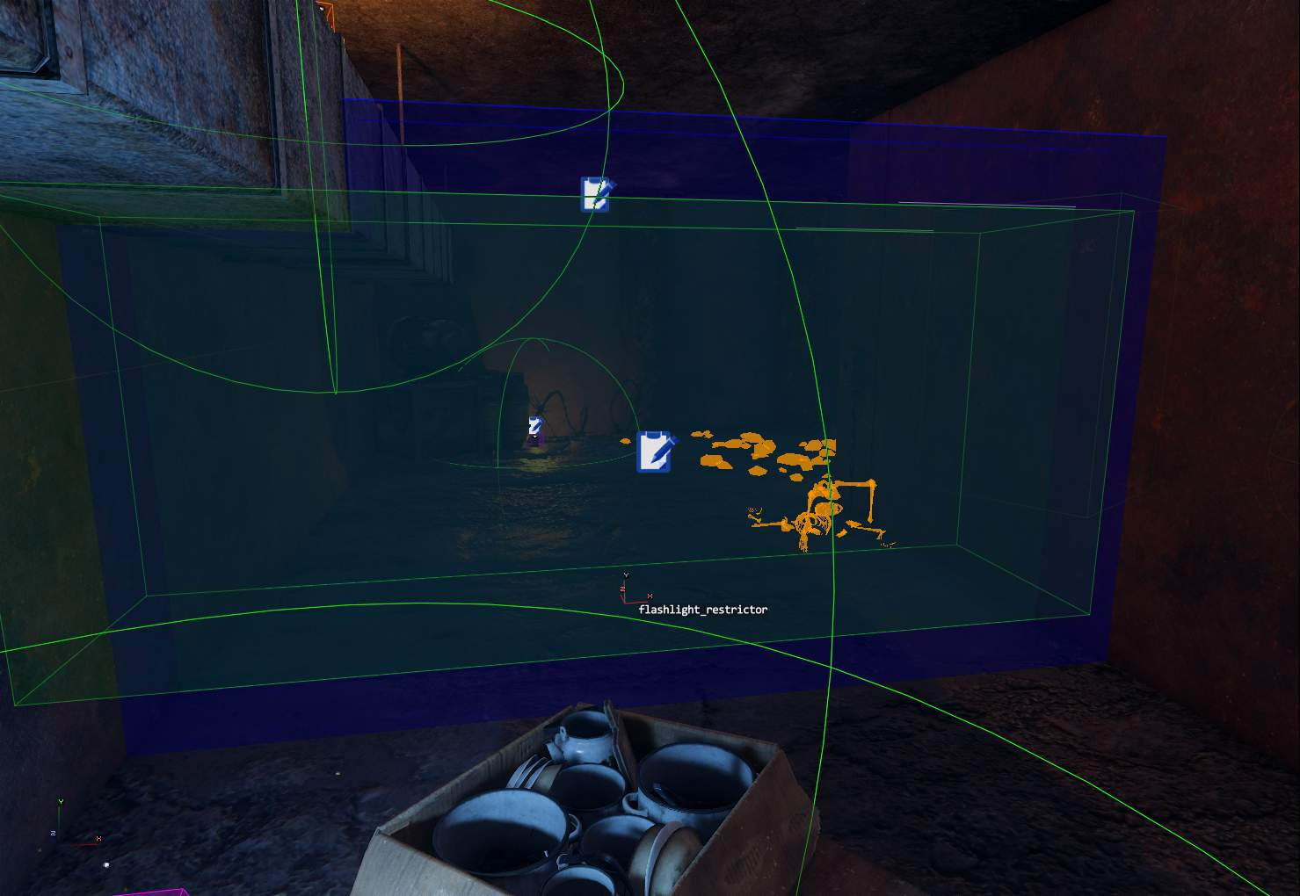
- Broken character setup – Adding a weapon to the character before the level starts is impossible as the weapon is not identified by the SDK and documentation for creating this is outdated and unusable. This results in this project and the community having to add the weapon in front of the player on begin play and just making it obvious.
- Broken loot prefabs – Boxes that can be interacted do not give loot to the player and due to its collision also do not allow for manual loot to be placed inside, resulting in predictable boxes.
- HOTFIX with base game content – the SDK installation is broken by default and requires the user to hotfix the engine themselves without little to no tutorials on this.
Content folder needs to be duplicated into custom mod folder.

- Tweaked QTE doors to work with door animations – after walking through a door, the animation of the player readying their weapon causes the script of the jumpscare QTE to break since the player is being affected by another prefab. This resulted in doors being extended to fix this issue as the distance between door and enemy allows the door prefab to fully end.
- Broken tutorial hints – tutorial hints VS code and restrictors to trigger this are broken, resulting in limited player knowledge before playing the level.
- Leaked shadow vis – shadow rendering increases when looking in a certain direction within the game world, which can affect performance negatively.
- Can’t delete skybox – compared to unreal and hammer, the skybox itself cannot be deleted, which results in having to change the time of day and changing how slowly the day progress to create a nighttime setting.
- Lack of content drawer – lack of a content browser results in extremely slow mesh placements as a model viewer needs to be used with hundreds of folders to comb through.

Evidence of inefficient model viewer
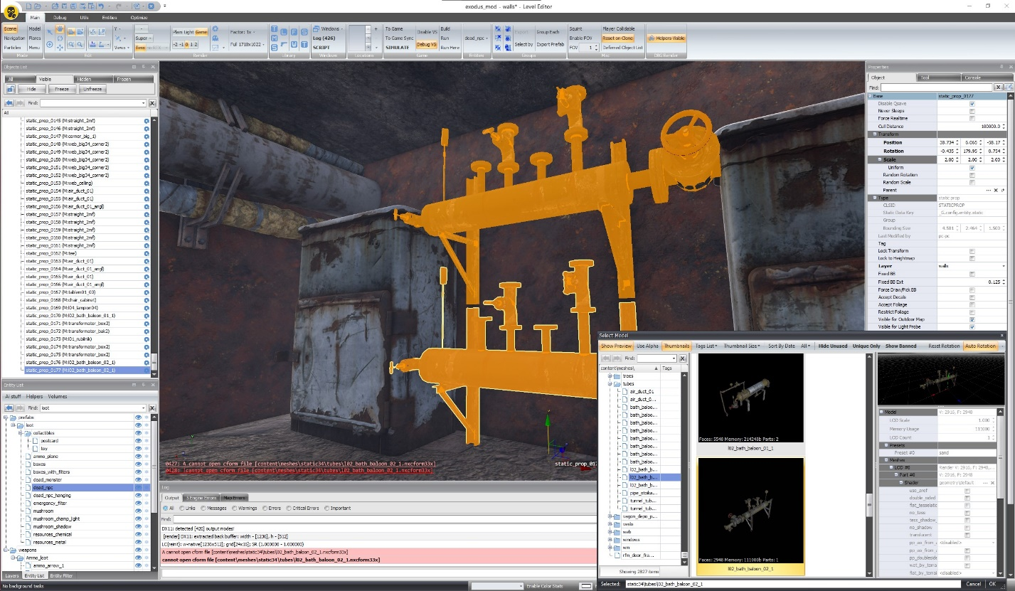

4A’s redeemable qualities

- Scale tools – all editable meshes/geometry uses a unique scaling system that displays a transparent plane cut up into thirds. The user can then drag the corners to scale non-uniformly, or click on the middle of each face to scale in only axis which allows for quick and fun scaling.
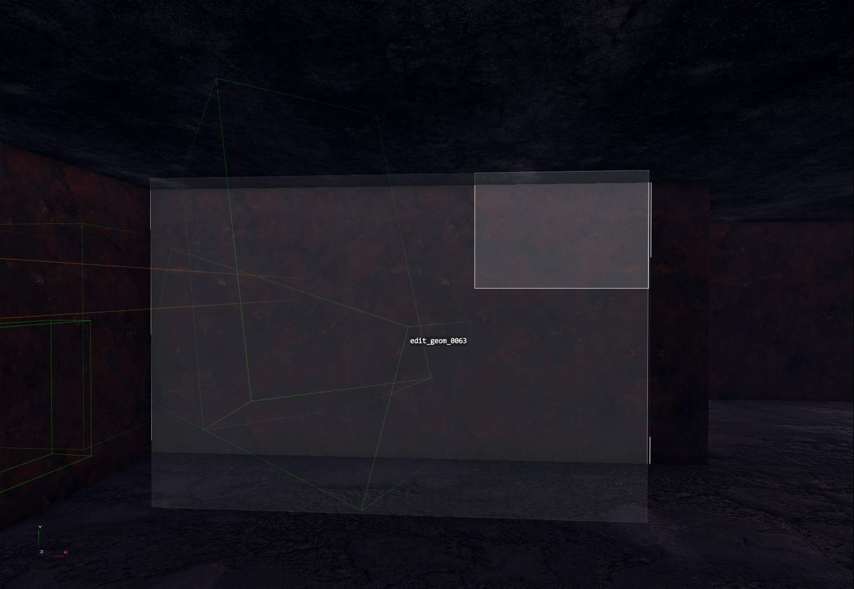
- Naming and layering – Elements can be placed into group which can be hidden within the game world in a more efficient way then unreal. When naming, because capital letters and spaces are not allowed, capitals are treated as lowercase and spaces are converted into _.

Blue indicates VS with code.
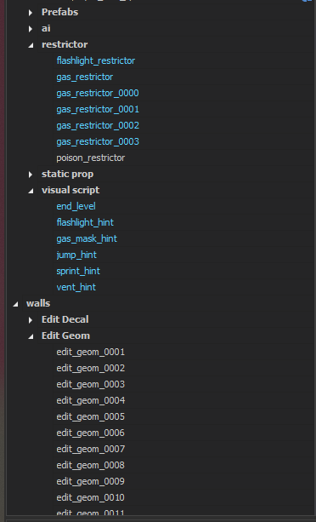
- Accurate preview – jumping into an editor and crafting lighting shows a realistic preview to the build version as well as working AI and scripts.
- Good editor performance - FPS was at a constant high from start to finish when building the level, in contrast to previous projects in Hammer and unreal.
- Proper lighting - lighting is realistic and allows for extensive control to create affordance and visual setpieces, can also be expanded upon by having lights turn off and on with triggers and restrictors.

Final Results
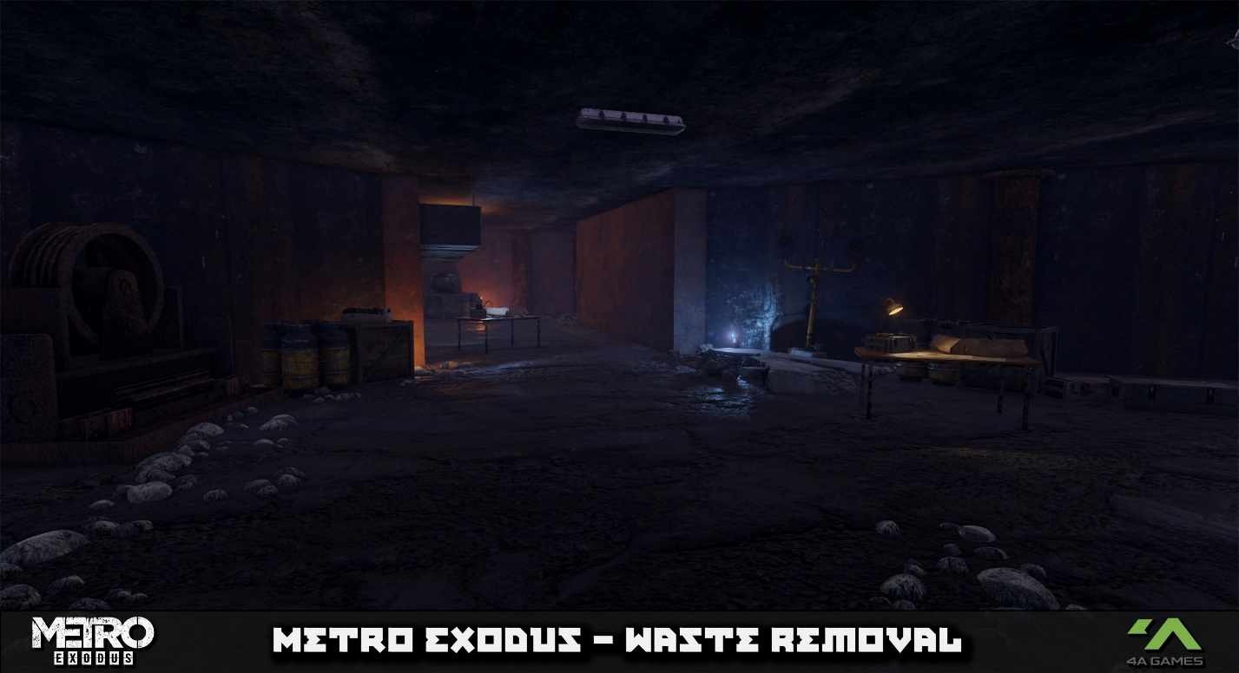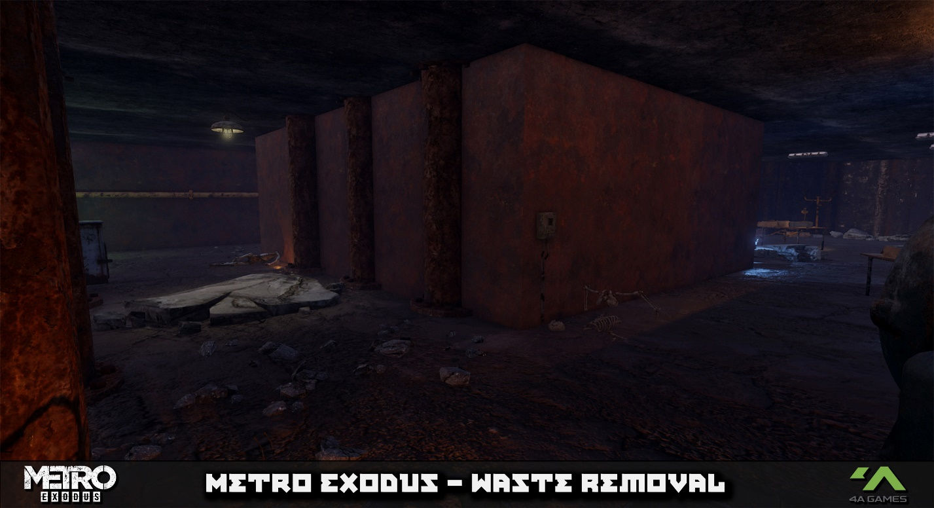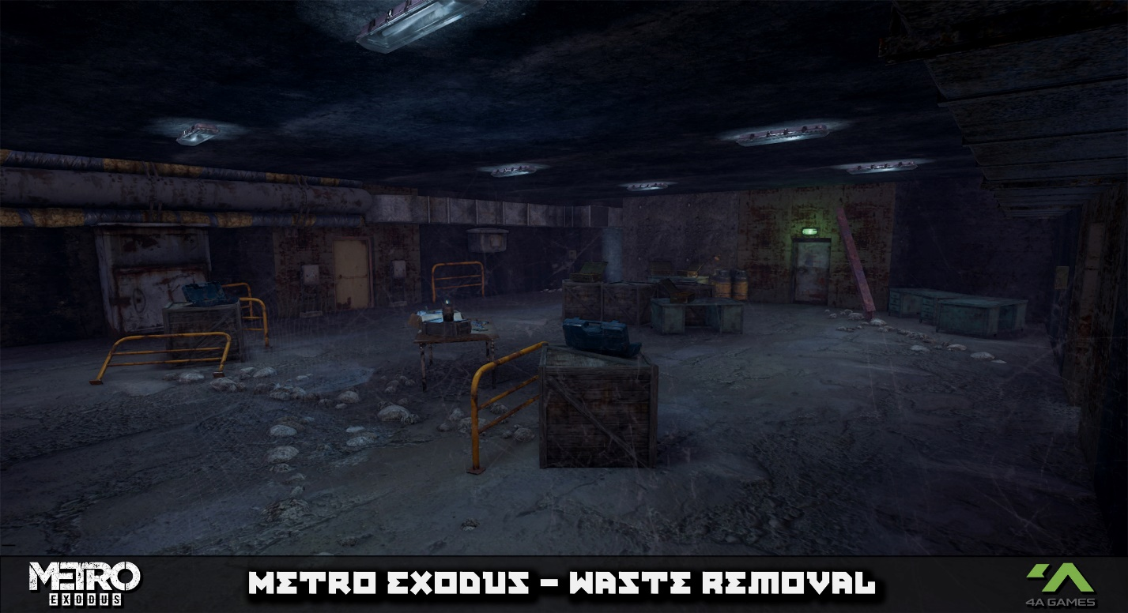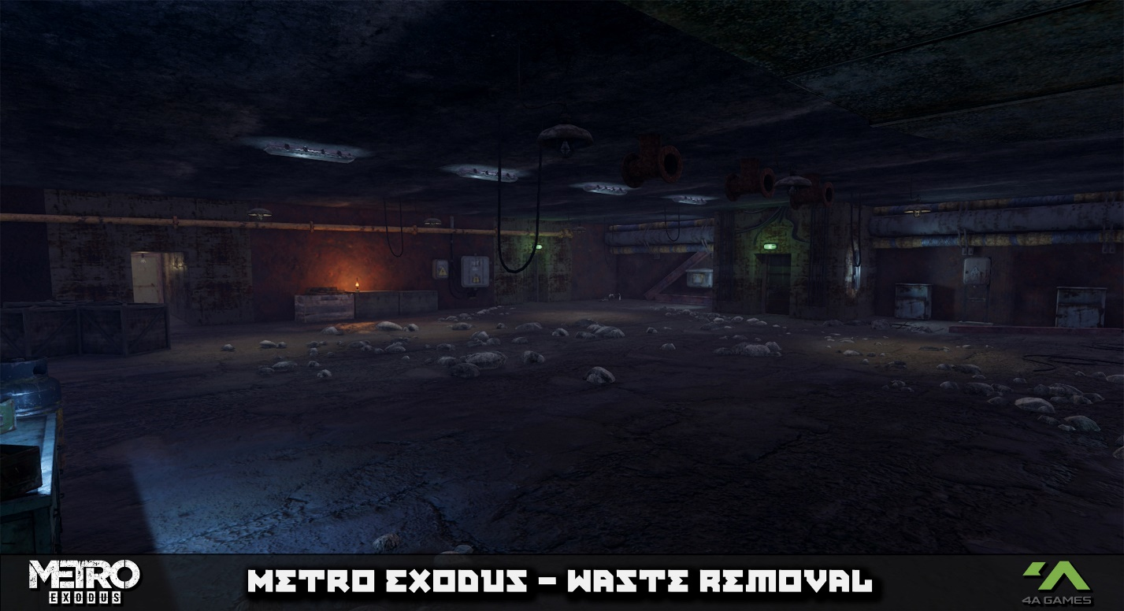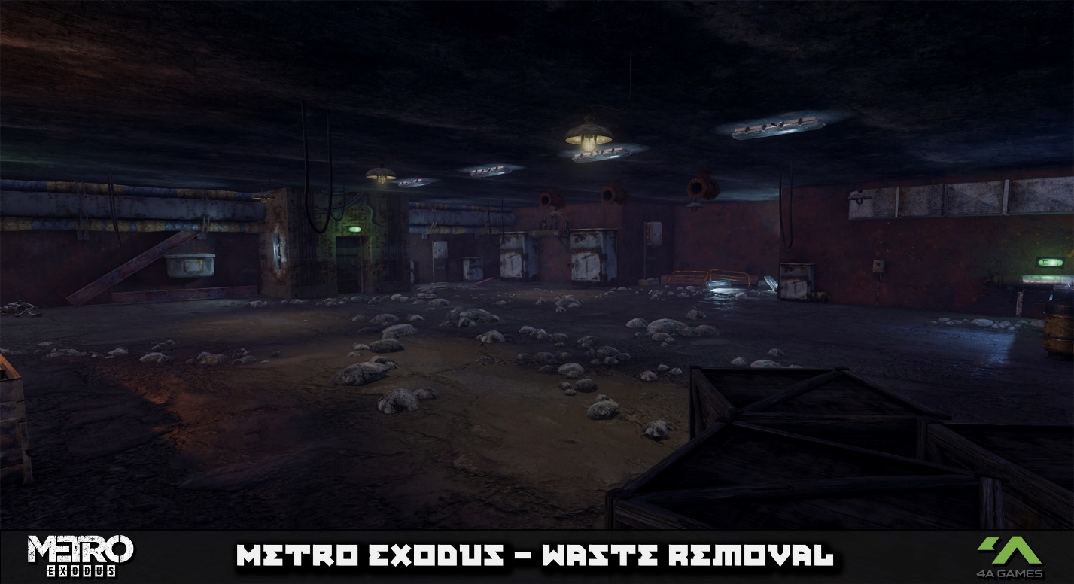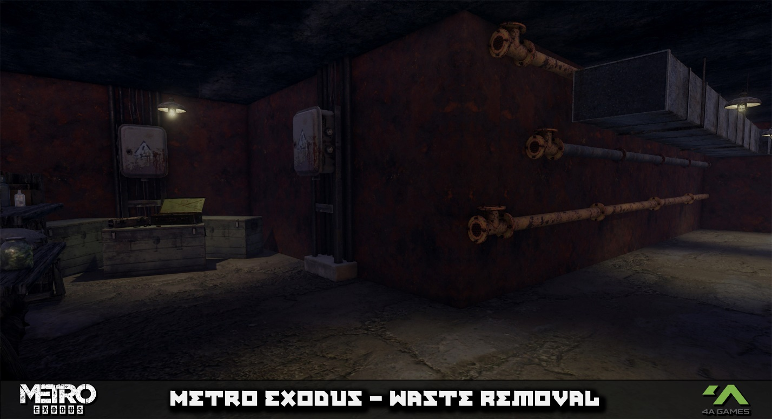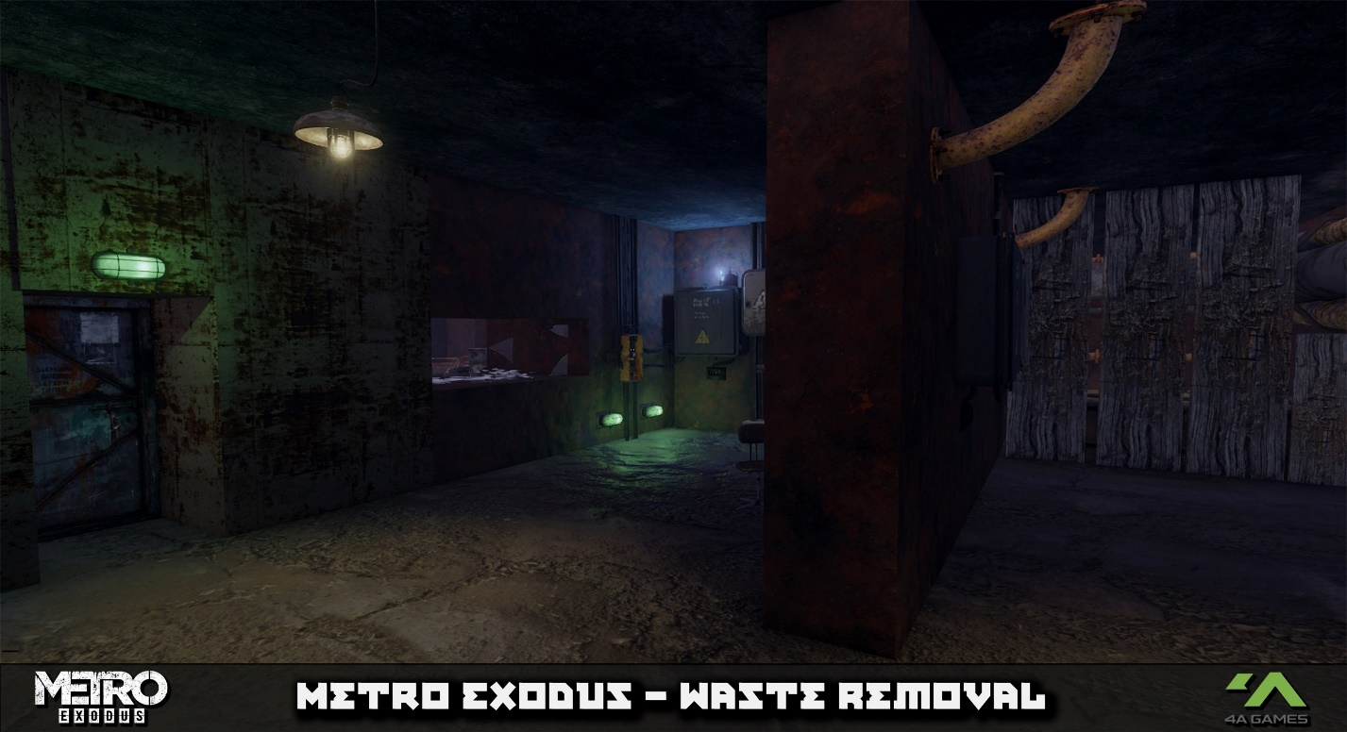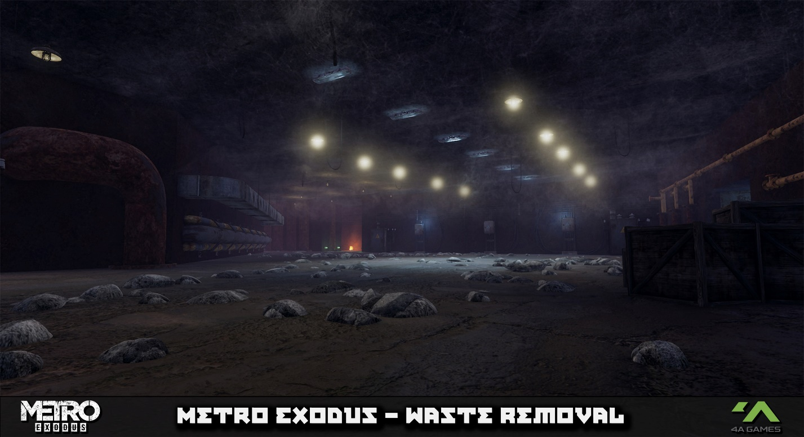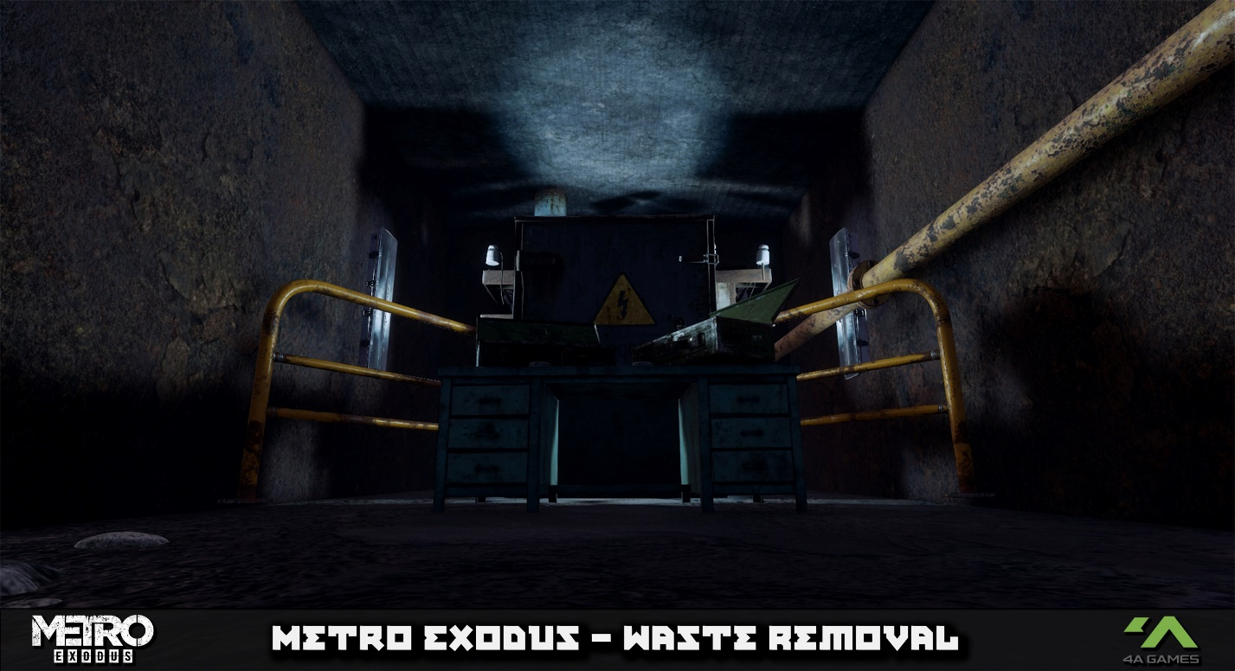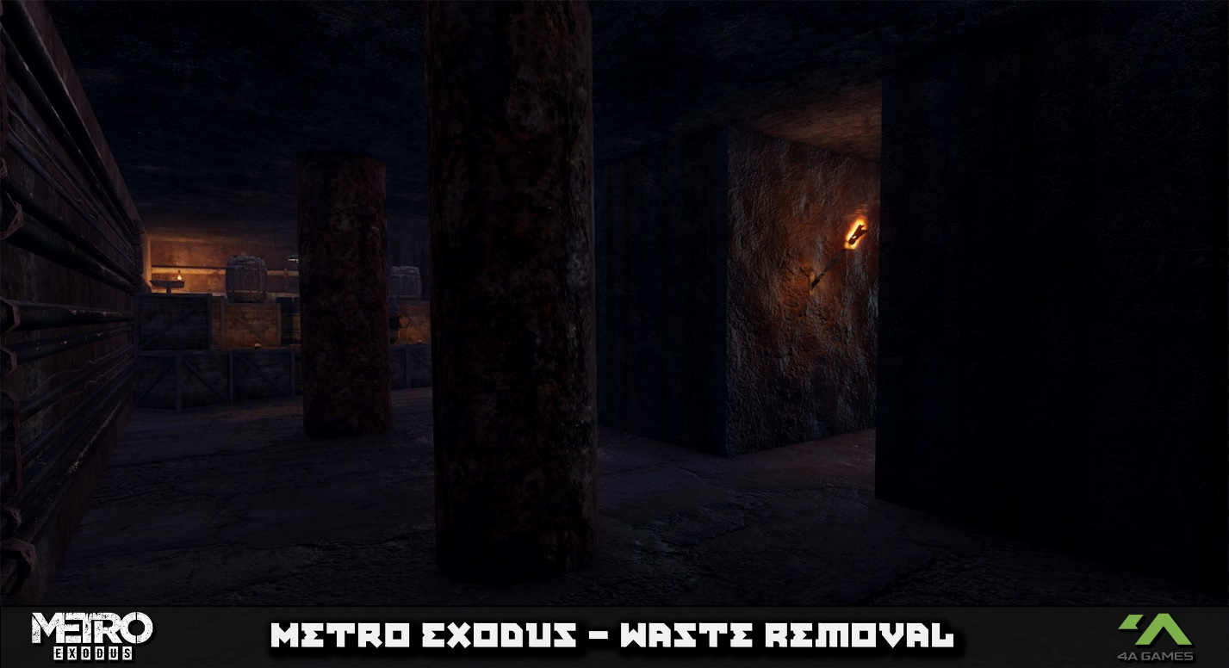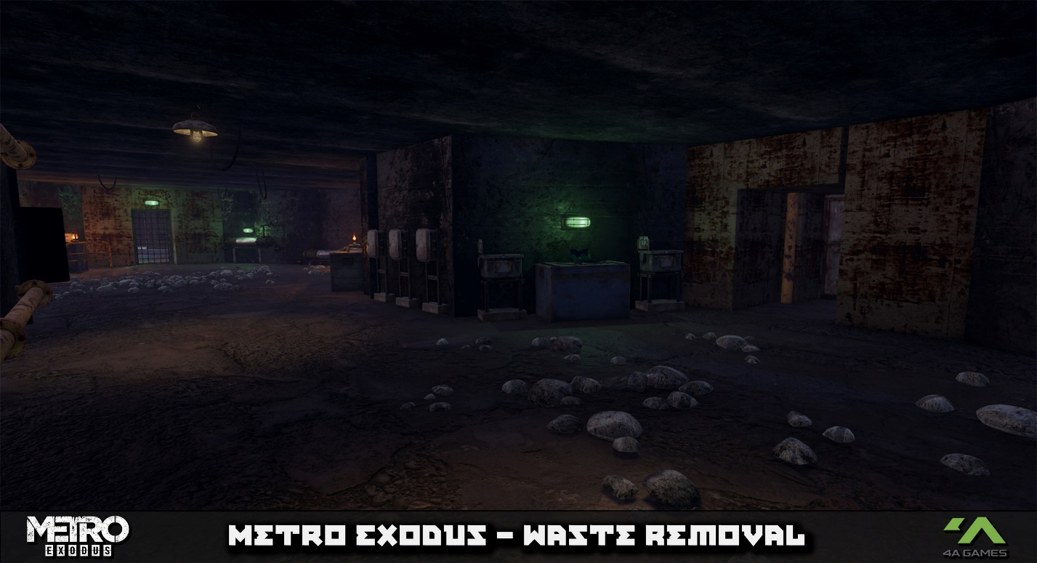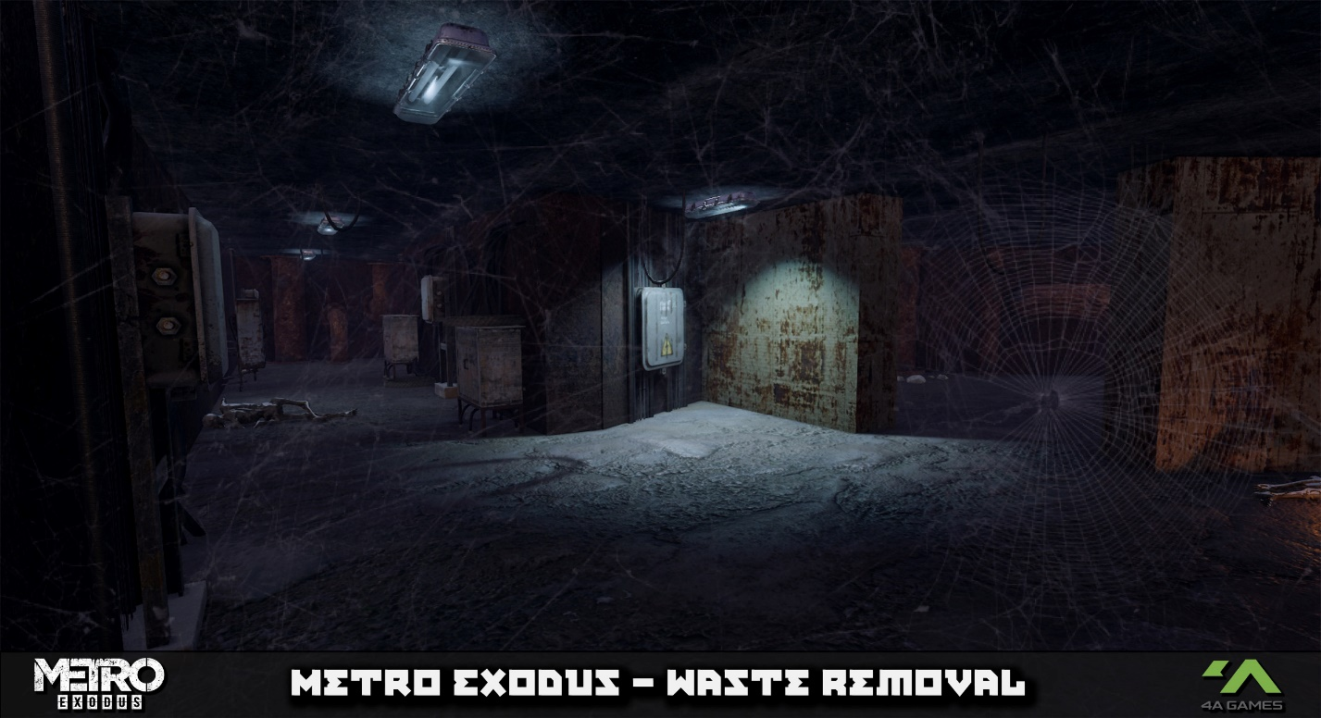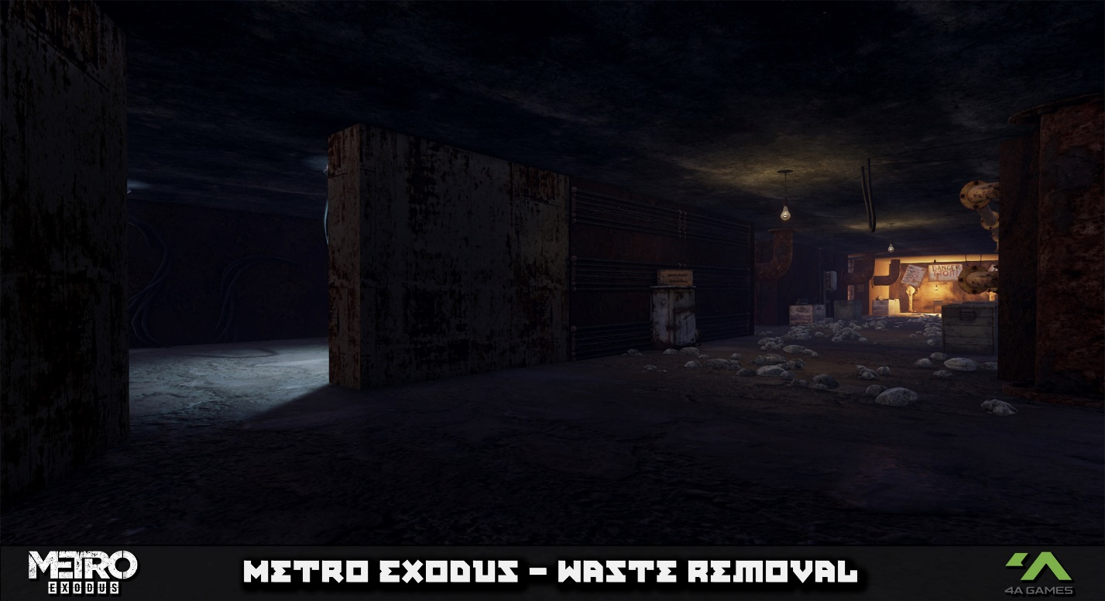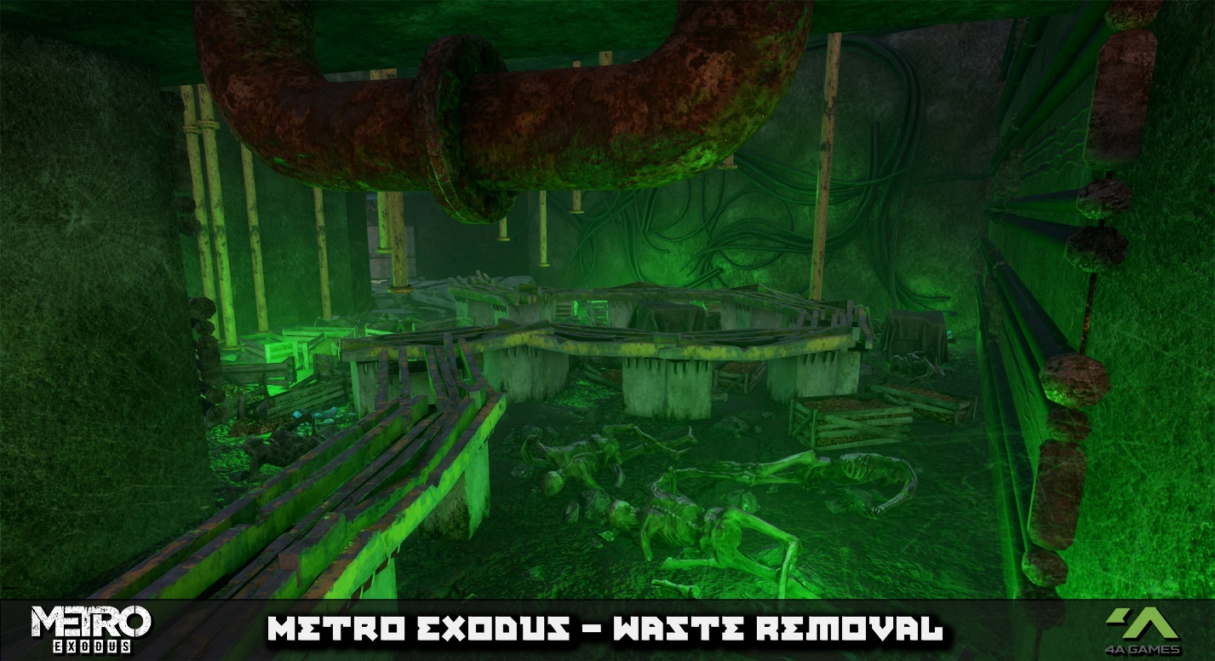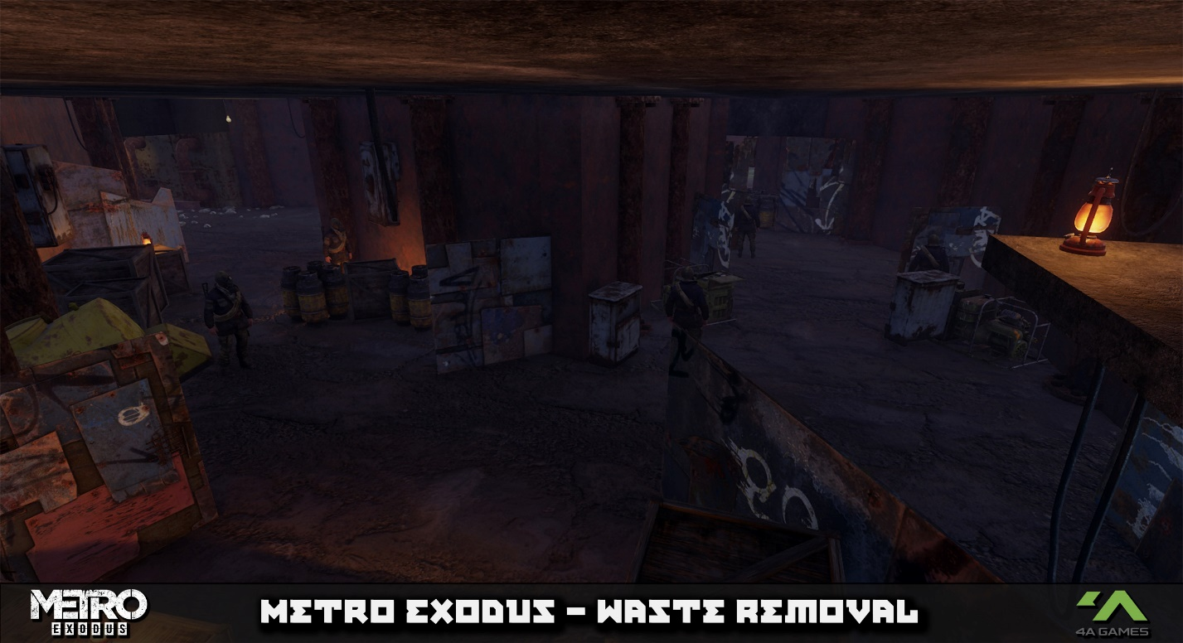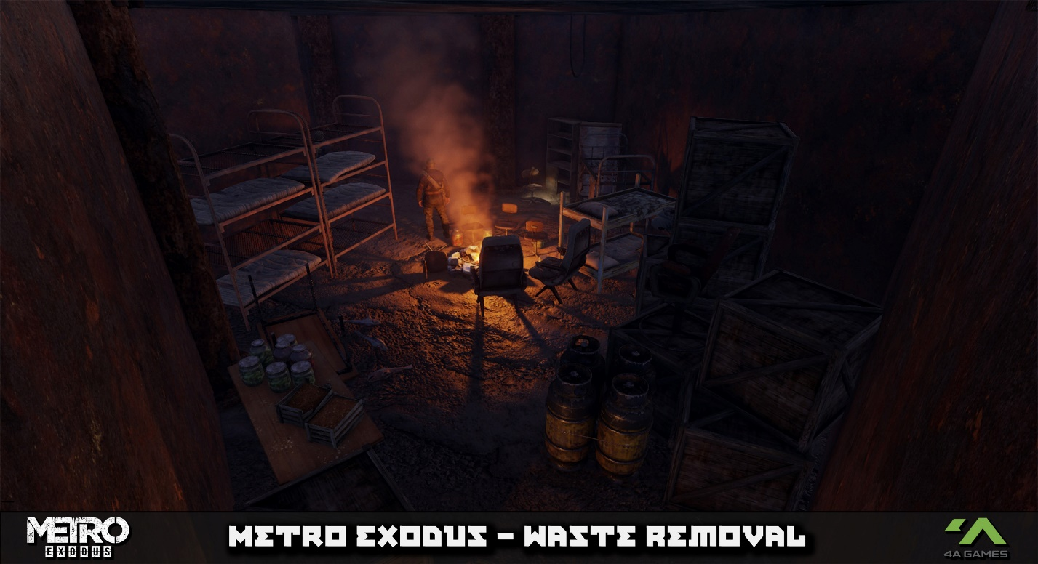
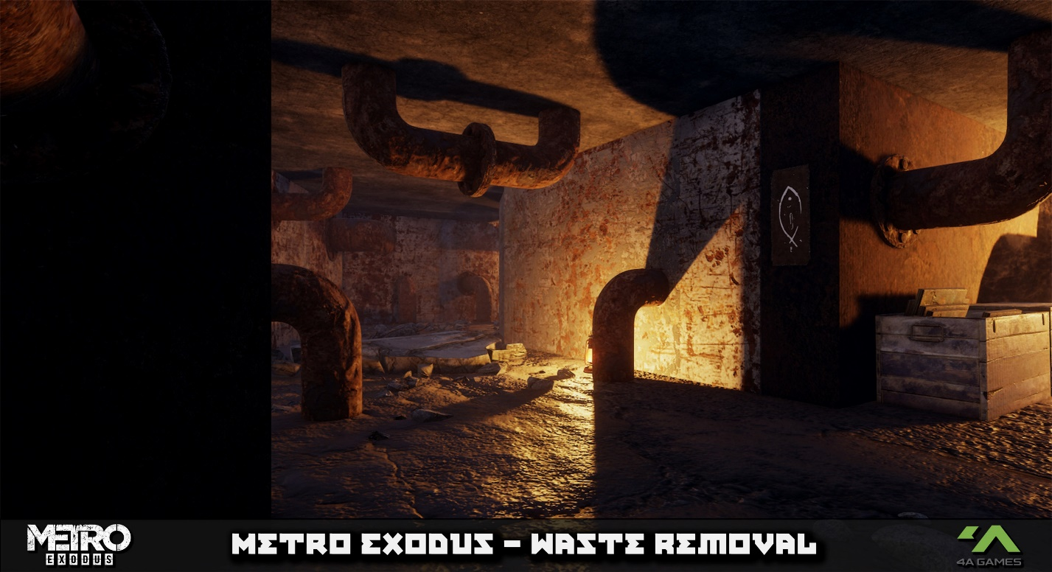
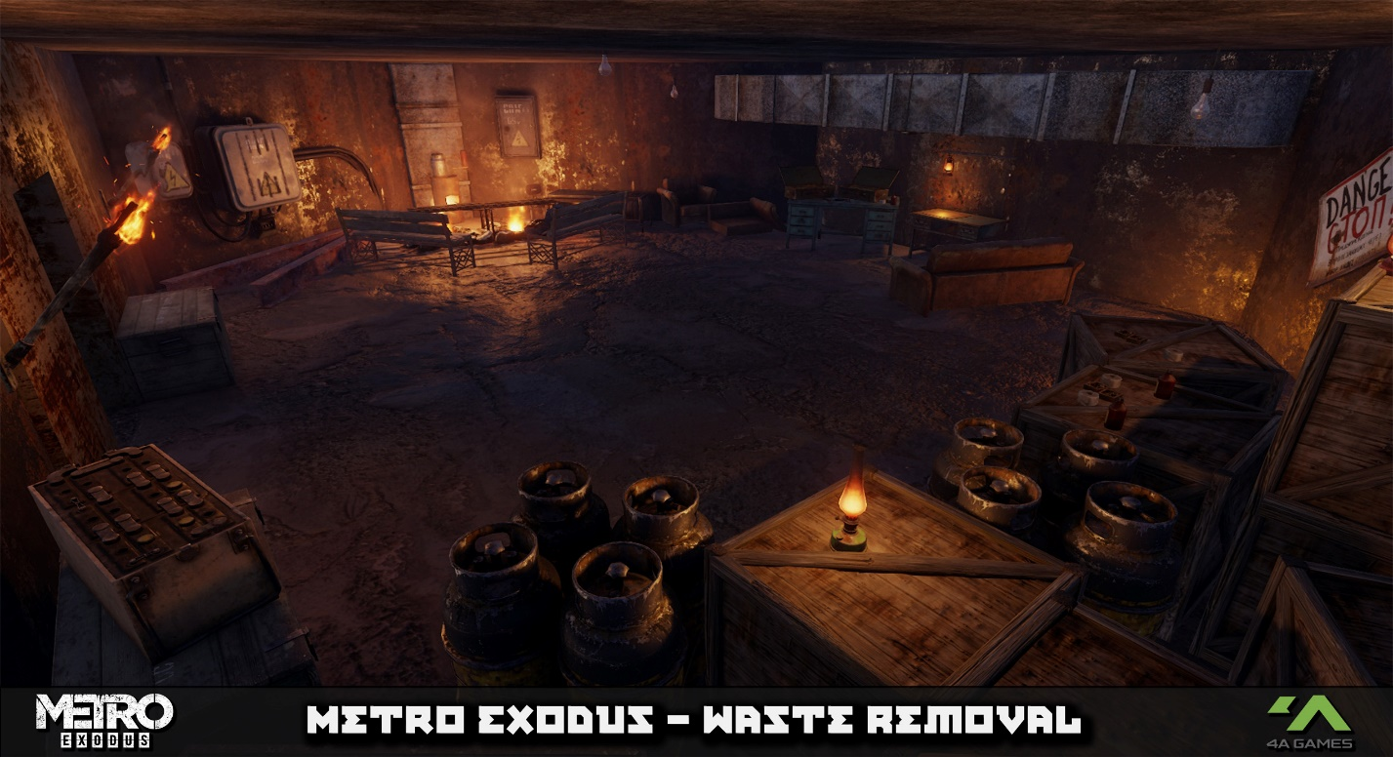

Balance

Considerations
Considerations towards balance will be to ensure that enough ammo is provided to the player throughout the level to ensure that they can deal with challenges ahead in a way they perceive as fair. Another consideration brought up by technical issues is that the weapon’s provided to the player must be clear and well presented at the beginning of the level to ensure they don’t soft lock themselves early on.
As for balancing of loot, this should be plentiful enough so the player feels rewarded but not so much in that they can craft overpowered weaponry which renders the level too easy and boring. This can be done by rewarding large amounts of “power ammo” but not include power weapons throughout the level or by rewarding large number of craft able materials for ammo and filters which makes the level fairer and avoids balancing issues.
Gas mask Filters will be strewn about in a moderate quantity after its introduction to make sure players are not cheated by the mechanic but are not too prepared for this in advance as it ruins the moment and brings down the tension. This can be done by placing them among main AND side routes as well as in the sight of the player during transitional crawl spaces.
Balancing of combat engagements is done by adding in large amount of cover that new players can use to fairly push up with as seen in the first combat room. Barriers have also been placed to prevent players from simply walking to the end of the room and ambushing enemies in a boring and unfun way. Balancing of future engagements are done with adding in the crawl space that can be interacted with at any time should players wish to backtrack and use it if the first few enemies are too much.

Expected Issues
One expected issue is the scale of the map, as a good scale that fits 4A’s conventions slightly differs from mine. In rooms such as tight corridors that lead out to bigger areas, the majority of this is just for visuals with the actual gameplay being limited to only a portion of said room, whereas Waste Removal is the opposite.
Another expected issue is the idea of the gas mask mechanic not being implemented properly due to unclear documentation and shoddy visual scripting techniques.
A third expected issue is perhaps the cooking/building of the level to be ran independently from the editor as this is a new technique that has not been used throughout the project, to avoid inflating the already large install. This could be an issue if the editor does not like meshes clipping into each other, or if the skybox will cut into the interiors lighting similar to that of unreal.
The 4th issue is AI navigation either breaking due to prop placement, or being alerted too early in the level when the player tackles the destructible debris which may make them push the player to early or not giving a chance for the player to surprise them.
5th issue is players might be confused when reaching the safe room if the code to end level doesn’t work properly as players might wander back thinking they missed something.

User Testing

Testing Plan and Considerations
Because 4A mainly relies on internal QA when testing level design, the SDK is setup as such, being able to quickly jump into the level but not so much share it outside of the editor. The result is that the levels made within the SDK are a lot more tedious to test externally as this results in having to build the level and upload it to a specific website for other users to then manually drag into their installs to work. This is worsened by the fact there is under 30 people in the community which makes the likelihood of someone playtesting rare.
The result is that testing the final level will result in too long of a delay to garner valuable feedback on so therefore it will be skipped for this level. Feedback and progress have been made throughout and shown informally with good reports so far. Considerations for future testing plans are listed in CRITICAL ANALYSIS.

Final thoughts and Critical Analysis
Overall, the level was a neat challenge to work on, both in terms of level design and technically with this level being the most advanced piece I’ve created in a project outside of full unreal projects. The level met the standards set and was useful in teaching about learning new editors and using traditional documentation.
As for critical analysis, documentation and diagrams wise, a lot of these are high quality and do meet my standards, however there was a failure to do a variety of research before starting the project and relied mainly on previous game knowledge. Whilst this did work well, this step should have been done earlier to have the plan set in stone and to be able to show others more clearly for better feedback.
Another critique is that the AI is broken despite being properly set up with enemies glitching through meshes. Whilst this seems more likely of an engine issue, if this stage was done earlier with more time left then this could have potentially been patched.
This could be fixed upon by simply testing scale in the initial blockout phase and comparing it to real world standards.
Furthermore, certain scripts such as doors sounds and later QTE’s are broken due to using the switch to activate the locked door earlier on in the level. This could be fixed by having the rest of the level deloaded and then loading this in when the door is being opened to avoid the trigger, but this stage would take tremendous amounts of scripting effort and skill to achieve.
If research was done into how the SDK conducts QA, then testing plans could have been constructed earlier to get more efficient and useful feedback, upping the quality of the final level.
Additionally, some design theory such as side routes leading back into main combat segments and loot paths offering more intractability to make the level feel more fleshed out. Rules of thirds could also be expanded upon for other elements besides combat whilst adhering to the levels placement within the game. Despite this small optional tweaks, the rest of the level is well designed and suits quite nicely with 4A standards.
But despite all this, the level came out meeting expectations and left sufficient time to work on other elements such as documentation. Whilst more polish could be added on, the level functions well with advanced systems and offers a multitude of different paths, multiplicative mechanics and better pacing then past projects. This all comes together for a nice, fun and immersive level to play that fits the design quality that 4A has set.

Sources and References
4A (2023) Editor Documentation - Exodus SDK. Available at: https://exodus-sdk.atlassian.net/wiki/spaces/ESDK/pages/1714585662/Editor+Documentation (Accessed: 02 January 2024).
GitBook (2024) The Level Design Book. Available at: https://book.leveldesignbook.com/ (Accessed: 29 January 2024).
Thanks for reading - Alex

